November 2016 Update of HSI
Enhancements and Bug Fixes of Note:
- Grace Date. A grace date has been added for situations where something about a structure changes and triggers a new activity or inspection be completed. An example of this is when a channel NBI rating is decreased from greater than 6 to 6 or less during an inspection. The rating of 6 or less triggers the need for a regularly scheduled underwater profile to be taken. The grace date is the date when the activity must be completed by. The grace date does not apply to the date regularly scheduled inspections and activities must be completed. These events must be completed within the regularly scheduled interval (24 months, 48 months, etc.). A policy memo describing the grace date in greater detail is being developed.
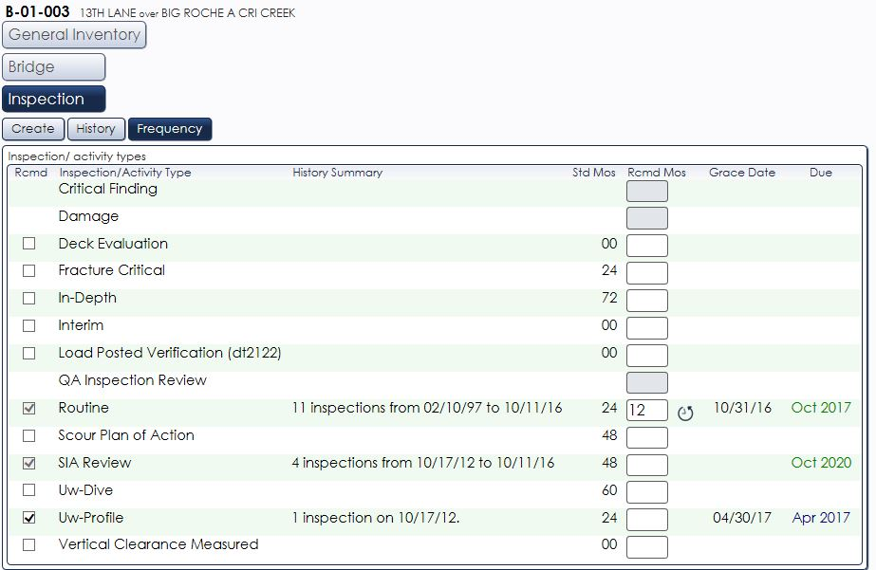
For this structure, an initial UW Profile was completed in 2012 and not required since then. The channel NBI rating decreased during the 2016 routine inspection and a regularly scheduled UW Profile is now required to be completed by the grace date.
- In the past, there has been limited follow-up with inspectors when a bridge has been flagged for rerating during an inspection. In the future inspectors will receive an email from HSI notifying them after the bridge has been reviewed.
- Home page bugs such as losing rows and/or columns and missorting have been fixed.
- A bug where inspection element total quantity updates were not saved has been fixed.

- Inspectors can edit C-structure heights and widths.
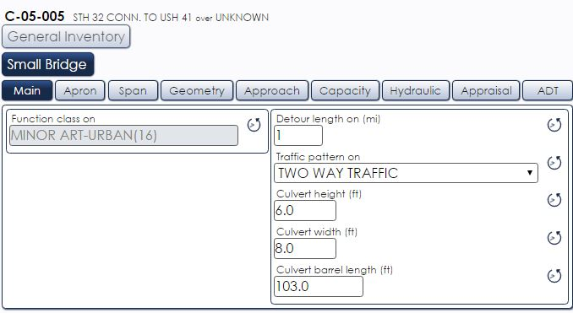
- Inspection media for new and field inspections will be copied forward more consistently.
- Smarter sorting of embedded numeric values (i.e. USH 50 will now be before USH 151).
- Users can now select multiple values when using the assist > extended criteria.
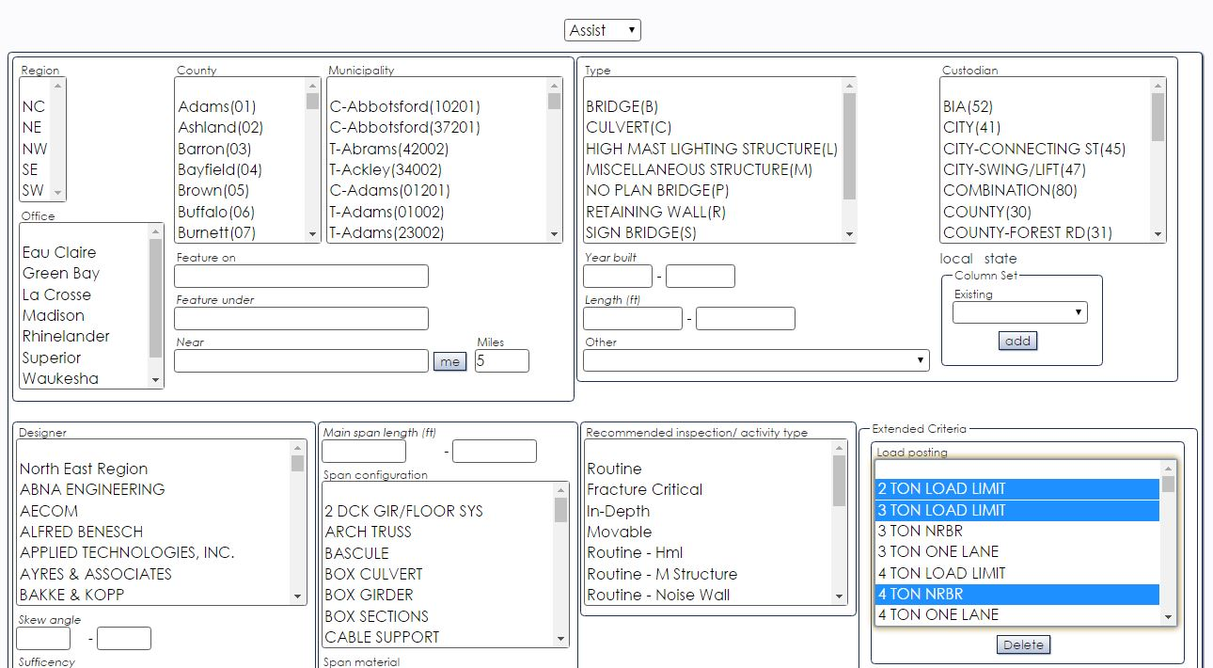

- Users can now edit and delete column sets. Column sets can be used to display specific structure data and can be created under the “Assist” feature.
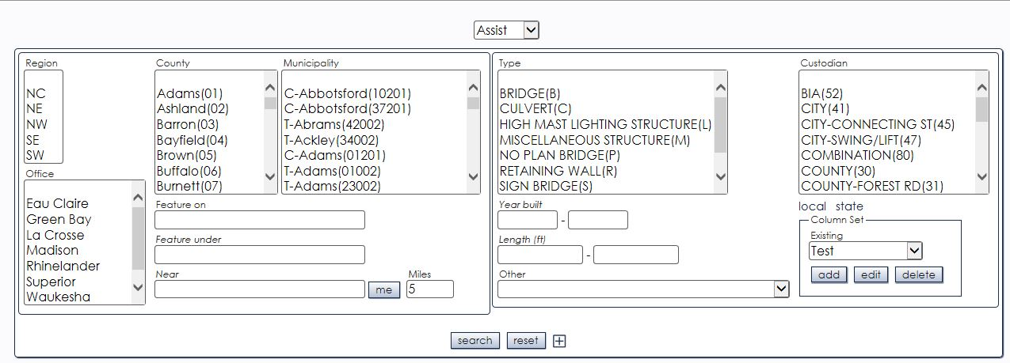
- A bug where users could not open inspections that merge pdfs has been fixed. This occurred when viewing open inspections or when selecting inspections from the History tab.
We are aware a bug still exists where the user receives an error message when selecting the auto-open on completion checkbox in an open inspection. However, the completed inspection is accessible for review under the History tab.
- Users can now select the frequency they receive the DaysOpen subscription.
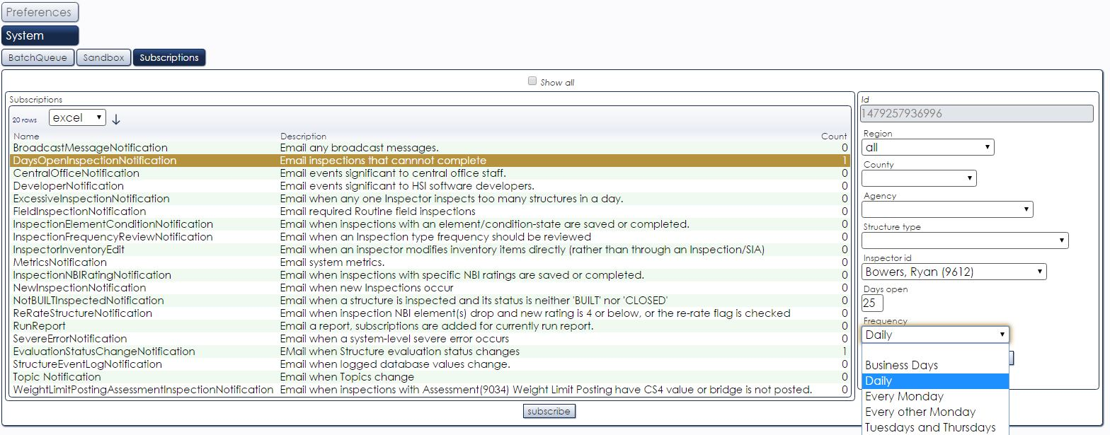
- A list of additional bug fixes and enhancements can be found at Go > Help > Topic > Release Notes.

