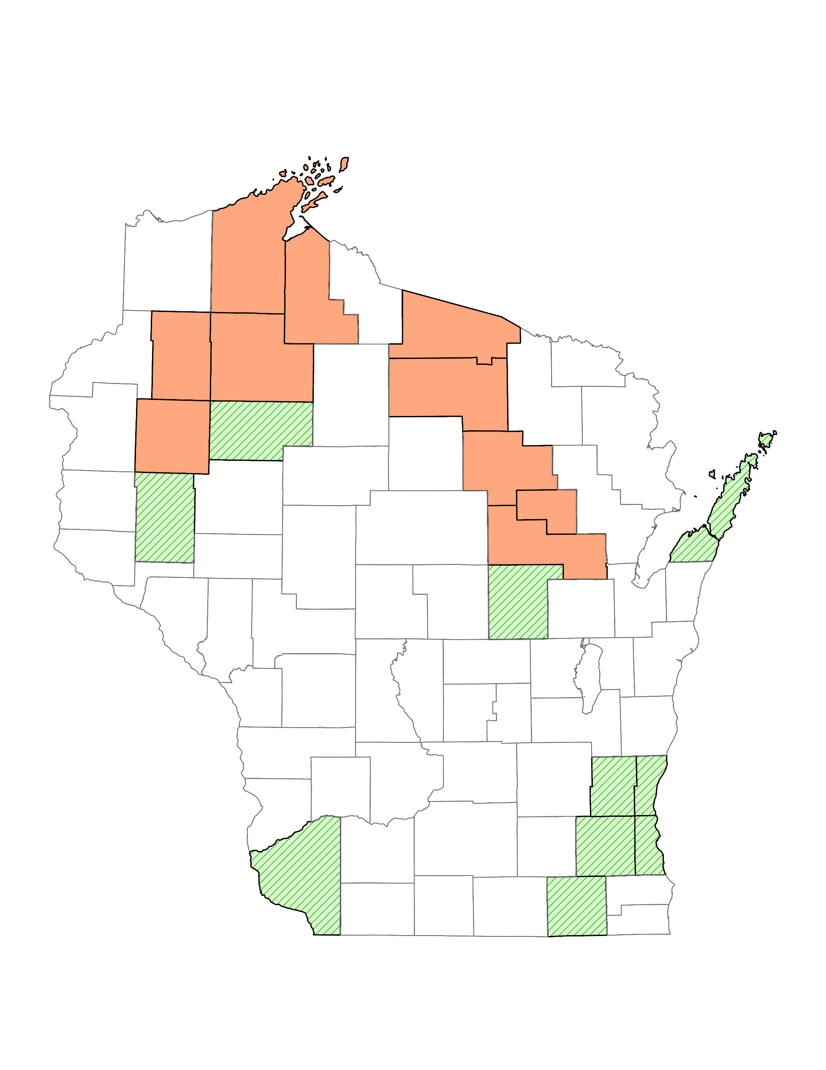
Wisconsin Department of Transportation
Bureau of Transit, Local Roads, Railroads & Harbors

Wisconsin Public Transit Systems 2026
Red Cliff Band
Superior
to Duluth, MN
Bad River Band
Bay Area Rural
Transit
to Ironwood, MI

Lac du Flambeau Tribe
Namekagon and
Lac Courte Oreilles Transit
Oneida Vilas Northwoods
Transit

Menominee
Tribal &
Countywide
Transit
Rusk County
New Richmond
Merrill
Hudson
Medford
Marinette
to Escanaba, MI
Wausau
Dunn
County
Chippewa Falls
to the Twin Cities in MN
Eau Claire
Door
County
River Falls
Shawano
Marshfield
Stevens Point
Oneida
Nation
Clintonville
Green Bay
Waupaca
County
Wisconsin
Rapids
Plover
Appleton
Black River
Falls
Oshkosh
Manitowoc
Onalaska
Tomah
Berlin

c
Fond du Lac
Sheboygan
Mauston
Ripon
to the Rochester, MN and the Twin Cities, MN
La Crosse
Viroqua
Waupun
Portage
Fixed Route Service
Shared Ride Taxi (SRT)
Tribal Public Transit
County-wide Transit
Multi-County Transit
Intercity Bus Service*
Commuter/Shuttle Service
Legend
Ozaukee County
Reedsburg
Baraboo
Beaver Dam
West Bend
Washington Co.
Sauk
Prairie
Richland Center

Hartford
Watertown
c
c

Madison Area
Milwaukee County
Waukesha
County
Prairie du
Chien
Lake Mills
c
Waukesha
Grant
County
Stoughton
Jeffersonn
Fort
Atkinson
c
Racine
c
c

c
c

Platteville
Edgerton
Whitewater
c
Kenosha
c
c

Janesville
Beloit
Walworth
County
Monroe
to Dubuque, IA
Western Kenosha
County
9/4/2026
This map identifies the general coverage areas of public transit systems within Wisconsin.
*Intercity Bus Service that is funded by WisDOT Transit. Additional routes are available.

