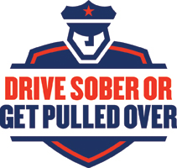 |  | Drive Sober or Get Pulled Over  MEDIA OUTREACH  From the Wisconsin Department of Transportation (WisDOT)  Division of State Patrol  Bureau of Transportation Safety
Local news outlets play an important role in the success of the Drive Sober or Get Pulled Over campaign. We rely on the media to help us educate the public about the consequences of impaired driving.

Television and radio messages about the dangers of impaired driving are broadcast statewide as law enforcement agencies step up enforcement. Although paid advertising is a major part of the enforcement strategy, it is also critical that you encourage local news outlets to help convey our message.

To help with media outreach efforts, the Wisconsin DOT Bureau of Transportation Safety created the following materials that you are encouraged to customize:

- Two sample (fill in the blank) news releases to announce your agency’s participation in this year’s campaign and report enforcement results after the annual initiative.

- Fact sheet, which may be distributed to the media or used as talking points for media interviews and other outreach events.

- Social media messages for outreach and engagement with your community.

These media materials are also available on the WisDOT website.

