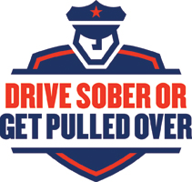

- Add your agency’s letterhead
- Customize the message for your community
- Check your local paper’s op-ed limits (Suggested length: 200 words or less)

Dear Editor:
As families and friends begin to plan holiday get-togethers, the [your agency] encourages everyone to add safety to your event checklist.
Five people never made it home for the holidays last year. There were 470 crashes involving an impaired driver in Wisconsin during the holiday season. Everyone has a role in helping us prevent tragedies like these: never get behind the wheel after drinking and step in to stop a friend from driving while impaired.
For those who choose to take this risk, the [your agency] is committed to getting those impaired drivers off the roads. We are joining the Drive Sober or Get Pulled Over enforcement campaign from December 15 through New Year’s Day. You’ll see more officers out working to keep the community safe.
Please don’t be a driver who gets pulled over this holiday season. Use the many options available to get a safe ride home: mass transit, a taxi, a rideshare service, or choose a designated driver.
It is our goal to prevent impaired driving all year long, so these efforts will continue as we ring in 2024. Thank you for helping us keep Wisconsin roads safe.
[Signed by your agency’s leader]

