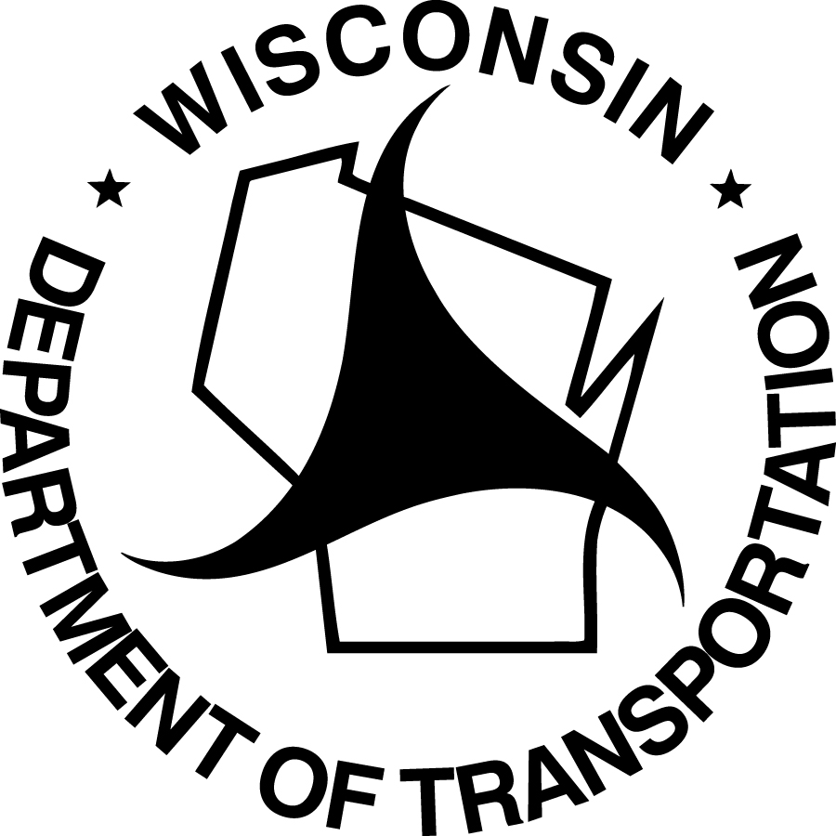
RAILROAD BUY AMERICA CERTIFICATION
Wisconsin Department of Transportation
DT2325 5/2023 OMB memo M22-11, 23 U.S.C. Section 313 & 23 CFR 635.410

For compliance with the Buy America requirements in OMB memo M22-11, the RAILROAD shall provide and certify the information requested below.

Railroad Company Name  (Area Code) Telephone Number |  | Railroad Company Address, City, State and ZIP Code  Street Address  City, State  ZIP Code
Project Description – Include |  | WisDOT Project ID(s) XXXX-XX-XX
Railroad Subdivision:
Railroad Milepost:
Crossing Number:
Roadway Name:
Other:
The above named RAILROAD has used the following products in the construction of the above referenced project per OMB memo M22-11.
MANUFACTURER / SUPPLIER  ADDRESS, CITY, STATE, ZIP CODE | PRODUCT DESCRIPTION | QUANTITY* | UNIT (LF, TON, EACH, ETC.) | HEAT NUMBER/  MILL/FABRICATOR**
ABC Steel Supply, 123 N Main St, Madison, WI 53707
*Only list actual quantities delivered to the project site.
**List heat number and mill or fabricator information in the table or attach manufacturer or supplier certifications
Use DT2325A for additional items.
See the back of this form for general guidance on “Buy America” documentation for railroad work.

RAILROAD STATEMENT OF CERTIFICATION
The undersigned certifies that only domestic steel, iron and construction materials, as identified in OMB memo M22-11, were permanently incorporated into the construction portion of the project.
To be considered domestic, all steel and iron used, and all products manufactured from steel and iron must be produced in the United States. This includes smelting, coating, bending, shaping, and all other manufacturing processes performed on the product. Coating includes all processes which protect or enhance the value of the material to which the coating is applied.
To be considered domestic, all construction materials used must meet the WisDOT Buy America requirements as described in CMM 228.5.
This requirement does not preclude a minimal use of foreign steel and iron provided the cost of such materials does not exceed 0.1 percent (0.1%) of the contract price or $2,500, whichever is greater. Attached to this certification are invoices and other available documentation substantiating a claimed exemption.
All construction materials must be produced in the United States. No exemption (0.0%) is allowed.

Number of additional pages attached |  | RAILROAD COMPANY
Number of additional pages attached |  | X
Number of additional pages attached |  | (Authorized Signature) | (Date – m/d/yyyy)
Number of additional pages attached |  | (Title)
Number of additional pages attached |  | (Print Name)
RAILROAD BUY AMERICA CERTIFICATION (continued)
Wisconsin Department of Transportation DT2325

GENERAL GUIDANCE
Note: This certificate must be submitted to the WisDOT REGIONAL RAILROAD COORDINATOR for each project containing steel, iron and construction materials before payment will be processed. The RAILROAD is responsible for providing the Certificate of Compliance to WisDOT, and no invoice(s) will be processed until the certificate(s) is/are provided.
All manufactured products (as defined in CMM 228.5) are covered under a previous waiver from 1983, and are currently exempt from Buy America requirements.
Domestic steel and iron certification documents showing each fabrication process as completed within the United States must be retained by the RAILROAD for a minimum of three years after the date of WisDOT final payment for the project. The certification documents must be made available to WisDOT upon request.
This certificate must be completed and signed by the RAILROAD. In signing, the RAILROAD attests to the accuracy of the information provided.

