APPLICATION/PERMIT
TO CONSTRUCT, OPERATE AND MAINTAIN UTILITY FACILITIES
ON WISCONSIN DEPARTMENT OF TRANSPORTATION RAILROAD PROPERTY
Per Chapter Trans 29 Wis. Adm. Code
DT2036 1/2006
Local Description – Quarter Section, Township, Range, etc. - To each copy of the application attach one copy of the representative site plan, drawing or sketch showing location |  |  |  |  |  |  | Proposed Work Location  City Town Village  of:
 |  |  |  |  |  |  | County
Applicant Name and Address |  |  |  |  |  |  | Construction Start Date
 |  |  |  |  |  |  | Construction Completion Date
 |  |  |  |  |  |  | Applicant Work Order (if any)
Type of Facility |  |  |  |  |  | Type of Construction |  |  | Direction
Gas  Petroleum  Electric | Telephone/Communication  CATV  Water |  | Sanitary Sewer  Storm Sewer  Other: |  |  | Underground  Overhead |  |  | Transverse  Longitudinal
Method of Installation

It is understood and agreed that approval is subject to the applicant’s full compliance with pertinent statutes, as well as any rules and regulations of other jurisdictional agencies, which may be more restrictive.
Is AFFIDAVIT to be used? If Yes, calculate and submit fees as required per Trans 29.07(3) and then complete and submit the affidavit section below within 10 days after the utility facility has been installed or modified.
Yes No
An administrative fee in the amount of accompanies this application. Any additional fee necessitated by mandatory daily inspections, or by follow-up inspections needed for corrections or changes shall be paid by applicant within 30 days after written notification from the department. Make all checks payable to - Wisconsin Department of Transportation.
 |  |  |  |  | (Authorized Representative) |  |  |  | (Date)
Utility Owner Notification Area Code – Telephone Number |  |  |  |  | (Title)
 |  |  |  |  | (Authorized Representative Area Code - Telephone Number)
PERMIT APPROVAL
The foregoing application for utility installation or modification is approved by signature(s) of the authorized representatives listed below.
(Railroad) |  |  |  |  | (Transportation Region)
(Transit Commission)
The Transportation Region investigated the proposed utility site on |  |  |  |  | (Transportation Railroads & Harbors Representative)
 |  | (date) and concluded that the
work proposed should have no, or negligible, environmental effect.
 |  |  |  |  | Permit Number |  |  | Issuance Date
(Inspector Signature)
I certify that I am a professional engineer, duly registered to practice engineering in Wisconsin, and that the utility installation or modification has been carried out in accordance with this application, Chapter Trans 29, Wis. Adm. Code, all other applicable rules or standards, and sound engineering practices.
 |  | (Date)
 |  | State of Wisconsin )
(Signature) |  | ) ss.  County )
(Registration Number) |  | On the above date, this instrument was acknowledged before me by the named person(s).
 |  | (Signature, Notary Public, State of Wisconsin)
 |  | (Print or Type Name, Notary Public, State of Wisconsin)
 |  | (Date Commission Expires)
Applicant desires to proceed under Section 29.07(3) of Trans 29, as the utility facility, to be installed or modified on department railroad property, which is also within a
City Town Village County Highway or Street Right of Way
PLAN VIEW
Drawing or Sketch for Overhead Crossing of Railway

Provide information in accordance with TRANS 29.04(5) and show physical location of center of utility to center of nearest intersecting railroad grade crossing in feet, N, S, E, or W.

Proposed Work Location  City Town Village of | Section , Town North, Range

PLAN VIEW
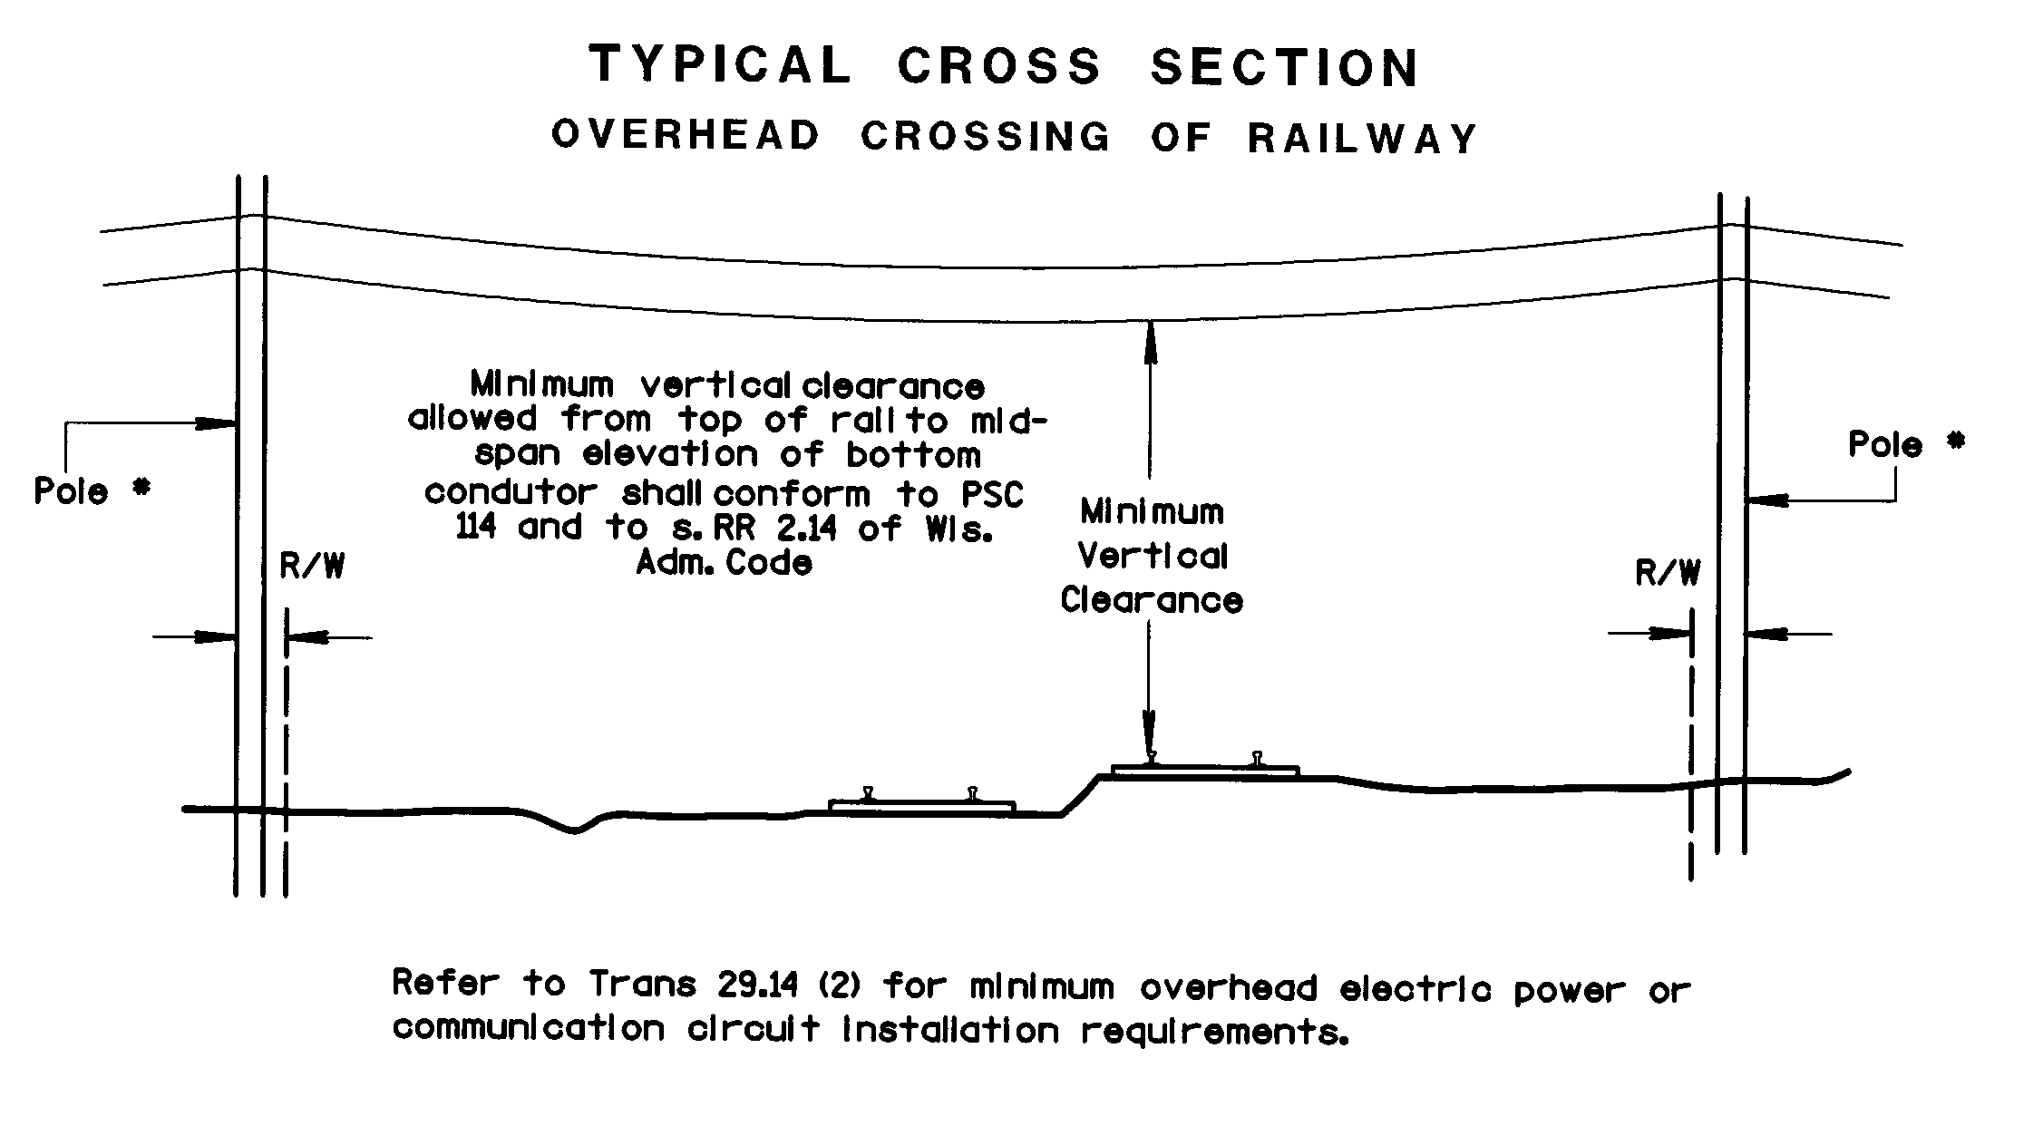
Drawing or Sketch for Utility Crossing (Uncased) Under Railway

Provide information in accordance with TRANS 29.04(5) and show physical location of center of utility to center of nearest intersecting railroad grade crossing in feet, N, S, E, or W.

Proposed Work Location  City Town Village of | Section , Town North, Range

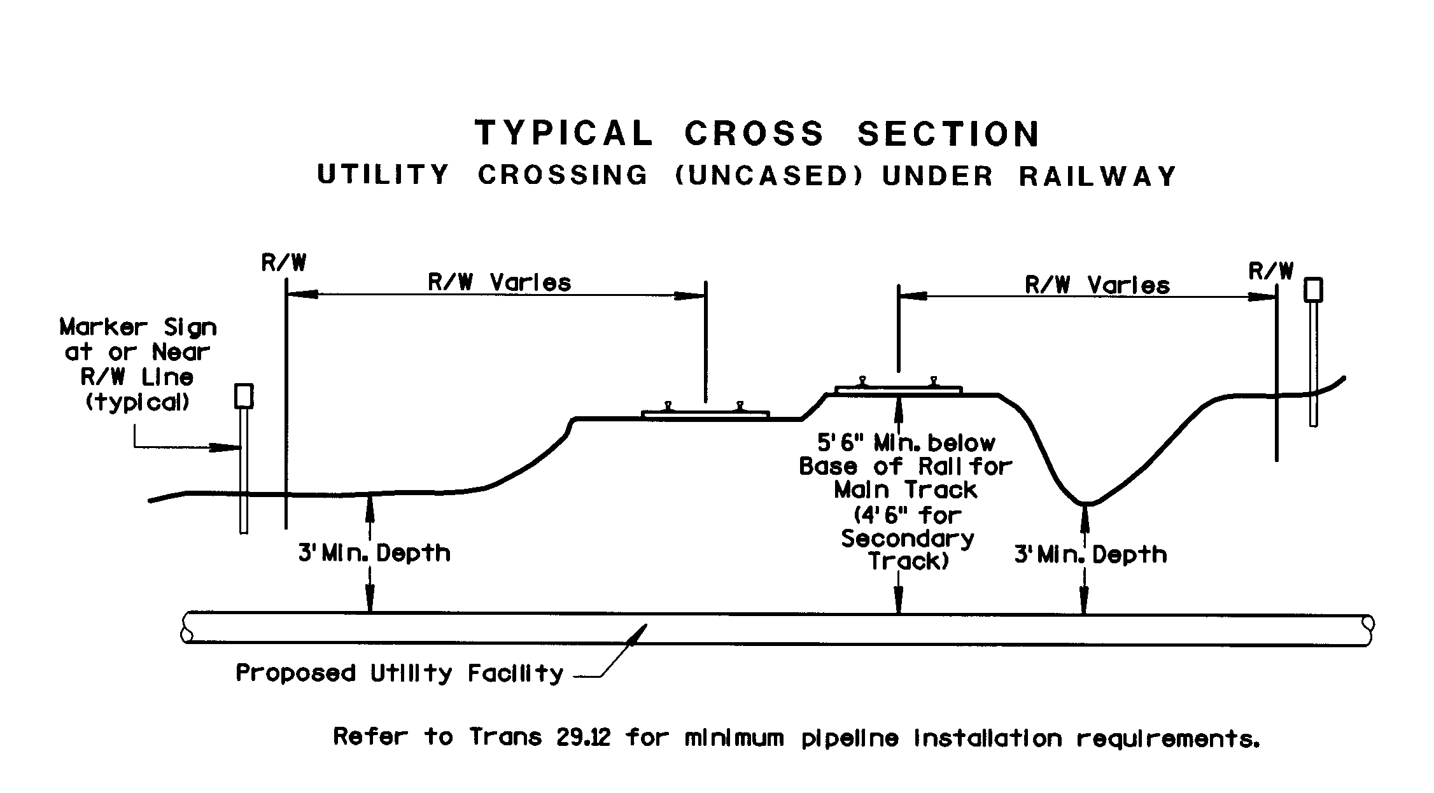

PLAN VIEW
Drawing or Sketch for Utility Crossing (w/Casing) Under Railway

Provide information in accordance with TRANS 29.04(5) and show physical location of center of utility to center of nearest intersecting railroad grade crossing in feet, N, S, E, or W.

Proposed Work Location  City Town Village of | Section , Town North, Range

