RAILROAD CROSSING REPORT Wisconsin Department of Transportation
DT1589 4/2011 (Replaces ED705)

1. Railroad Project ID | 2, Operating Railroad
3. Companion Construction Project ID | 4. Companion Hwy Constr. Letting Date | 5. Engineering ID
6. Road Name | 7. Official DOT/AAR Crossing Number
8. Highway Number/Town Road/Street Name | 9. Railroad Subdivision and Milepost
10. County | 11. Town/City/Village of
Attach sketch of crossing including track centers, approach grades and obstructions to view of approaching trains.
EXISTING DEVICES AT CROSSING
Provide information for both approaches | Northbound/Eastbound |  | Southbound/Westbound |  | Comments
 | YES | NO | YES | NO
12. Stop Signs
13. Cross Bucks
14. Wig Wag Signals
15. Flashing Light Signals |  |  |  |  | 8" 12" INC LED
16. Cantilever Signals |  |  |  |  | 8" 12" INC LED
17. Gates
18. Crossing Illuminated
19. Flagging
20. Bell |  |  |  |  | M E
21. Sidelights
22. Stop Bar |  |  |  |  | Distance From Crossing
23. Public Road Intersection
24. Humped Crossing Sign
25. Railroad Advance Warning Signs
26. RXR Pavement Markings
27. Advisory Speed Signs

OTHER CROSSING INFORMATION
28. Total No. of Tracks |  | 29. No. of Main Line Tracks |  |  |  |  | 30. No. of Other Tracks |  |  |  |  | 31. Angle of Crossing
 |  |  |  |  |  |  |  |  |  |  |  | ( ) LHF |  |  |  |  |  |  |  | ( ) RHF
32. Total No. of Lanes |  | 33. No. of Through Lanes |  |  |  |  | 34. No. of Parking Lanes |  |  |  |  | 35. No. Exclusive Use Lanes |  | 36. No. Sidewalks |  |  |  |  | 37. SidewalkWidth |  | 38. Pavement Width |  | 39. Curb |  |  |  | 40. Roadway Width
 |  |  |  |  |  |  |  |  |  |  |  |  |  |  |  |  |  |  |  |  |  |  | Y N
41. Crossing Surface Type |  |  |  |  |  |  | 42. Length of Existing Crossing |  |  |  |  | 43. Crossing Surface Condition
Average Daily |  |  | 6 a.m.-6p.m.  Number |  | 6p.m.-6a.m.  Number |  |  |  | Timetable Speed |  |  | Maximum Typical Train Speed |  |  |  |  |  |  |  |  |  |  |  | ADT |  | 50. Year
44. Passenger Trains |  |  |  |  |  |  |  |  | MPH |  |  | MPH |  |  | 47. Highway ADT (present) |  |  |  |  |  |  |  |  | ( )
45. Freight Trains |  |  |  |  |  |  |  |  | MPH |  |  | MPH |  |  | 48. Highway ADT (design) |  |  |  |  |  |  |  |  | ( )
46. Switching Moves |  |  |  |  |  |  |  |  | MPH |  |  | MPH |  |  | 49. Posted Speed Limit
SIGHT DISTANCES
Stopping Sight Distances |  |  |  |  |  |  |  | Quadrant Sight Distances |  |  |  |  |  |  |  |  |  | Clearing Sight Distances
Distances at which crossing warning |  |  |  |  |  |  |  | View of trains from stopping distance |  |  |  |  |  |  |  |  |  | View of trains at 25 ft from nearest rail
devices first visible (WDV) [1] and |  |  |  |  |  |  |  | 54. Quadrant |  | Sight Distance [3] |  |  |  |  |  |  |  | 57. Quadrant |  |  |  | Sight Distance [4]
vehicle stopping distances (VSD) from |  |  |  |  |  |  |  |  |  | 55. Actual |  |  | 56. Req’d |  |  |  |  |  |  |  |  | 58. Actual |  |  | 59. Req’d
crossing based on speed [2]
51. Approach | 52. WDV |  |  | 53. VSD
60. Obstructions, Comments |  |  |  |  |  |  |  |  |  |  | 61. Diagram (Label Quadrants)
 |  |  |  |  |  |  |  |  |  |  | ++++++++++++++++++.++++++++++++++++++

62. By | 63. Title | 64. Date

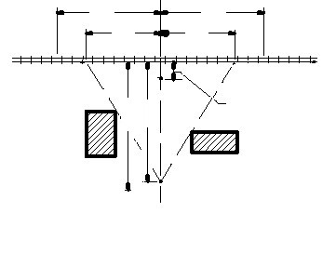
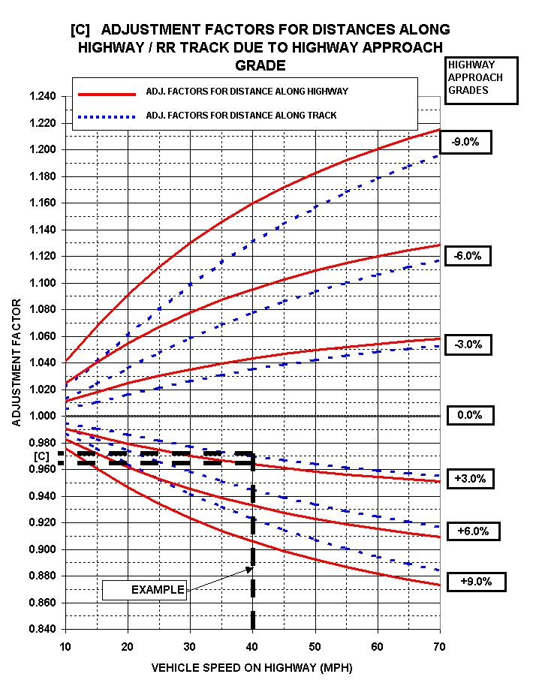
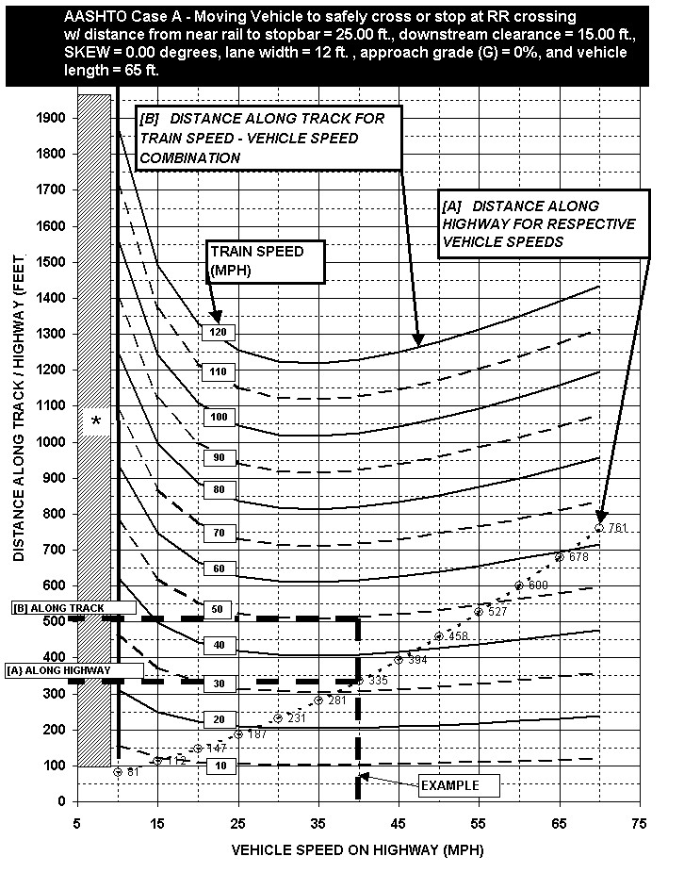
Applies to right-angle single track crossings with vehicle speeds between 10 and 70 mph and train speeds between 10 and 120 mph. Crossings that do not meet these criteria require special consideration.
See:
- AASHTO (2001). A Policy On Geometric Design Of Highways And Streets. 4th edition. Pages 735-743. Washington, DC.
- FHWA publication “Guidance on Traffic Control Devices at Highway-Rail Grade Crossings” for guidance on calculating clearing sight distance.
* Crossings with a stop condition or where vehicle speeds are less than 10 mph are to be reviewed with the Grade Crossing Safety Engineer.

EXAMPLE
To evaluate an existing condition to determine if visual contact with a train is adequate to safely decide whether to STOP or PROCEED.
Given a 40 mph Posted Highway Speed on a 3% upgrade with an approaching 50 mph Train requires:
[A] 335’ Distance Along The Highway
[B] 513’ Distance Along The Track
[C] Apply Grade Adjustment Factors to both distances:
- Adjusted Distance Along The Highway = 335 x 0.965 = 323’ (required [2] – see item 53)
- Adjusted Distance Along The Track = 513 x 0.97 = 498’ (required [3] – see item 56)

Figure 1
[1]
[4]
[4]
[3]
[3]
[2]
25’
NEAR RAIL
[1] see item 52
[2] see item 53
[3] see items 55 and 56
[4] see items 58 and 59
ILLUSTRATION FOR ONE APPROACH

INSTRUCTIONS

5. Enter the ID number the government agencies (DOT, local) are using for surveys, plans, etc. (preliminary engineering).

12. – 20. Under each of the two approaches, indicate if the item exists. Under the “Comment” column, enter any pertinent information such as “too low,” “poor condition,” etc.

13. Also include reflectorization information.

15. – 16. Also check off the lamp size and whether the lamps are incandescent (INC) or light emitting diodes (LED).

18. Also, under the “Comment” column, enter the distance from the crossing. NOTE: Crossing Illumination should be within 150 feet of the crossing before being included.

19. Also record “yes” in the approach where the flagger is normally located. Flaggers may select a favored approach due to geometrics or obstructions.

20. Also record whether bell is mechanical (M) or electronic (E).

21. – 27. Under each of the approaches, indicate if the item exists and at what distance it is located from the crossing. Measure the distance along the roadway from the near side of the near rail to the closest point of the item to the crossing.

22. NOTE: Record intersection(s) entering within the vehicle safe stopping distance (as shown on Figure 1 of the nomograph), and describe the intersection traffic control under 63.

27. Also enter the posted advisory speed.

28. Enter the total number of tracks located between the Railroad Crossing Warning Devices.

31. Enter the most severe track angle in the crossing and check the appropriate box for left-hand-forward (LHF) or right-hand-forward (RHF). “Angle” is measured between the roadway centerline and the track centerline in the quadrant common to both. Boxes would be blank for a 90-degree crossing angle.

32. Enter the total number of paved lanes (driving, parking, bypass, etc.) through the crossing.

33. Enter the number of “through” driving lanes.

34. Enter the number of lanes available for parking (either marked or unmarked) through the crossing.

35. Enter the number of “exclusive use” lanes pullout (bypass, stopping, etc.) through the crossing.

36. Enter the number of sidewalks.

37. Enter the width and location of sidewalk(s) - distance from edge of pavement or face of curb to the inside edge of each sidewalk.

38. Enter the total pavement width between edges of pavement or between faces of curbs. Measure perpendicular to the roadway centerline.

39. Indicate if curb and gutter are constructed on the crossing approaches by checking the (Y) box “yes” or the (N) box “no.”

40. Enter the total roadway width, between outside shoulder points, backs of curbs, or outside edges of sidewalks. Measure perpendicular to the roadway centerline.

41. Enter crossing surface type (rubber, concrete, flange and guard timber, etc.).

42. Enter the total length of crossing (width of roadway as defined in 38 as measured along the track centerline).

43. Record the assessment of the crossing surface condition (material not covering total roadway, timbers failing, etc.).

44. – 46. Record the number of scheduled trains between the indicated hours, and record the timetable speed for each type or train. Obtain the information from the operating railroad.

51. Enter the crossing approach.

52. Enter the actual distance from the crossing at which the crossing warning devices are first visible.

53. Enter the required vehicle safe stopping distance, refer to discussion in Figure 1.

54. Enter the quadrant.

55. Enter the actual sight distance available at the vehicle safe stopping distance. Record obstructions in 60.

56. Enter the required sight distance, refer to discussion in Figure 1.

57. Enter the quadrant at a distance 25 feet from the crossing.

58. Enter the actual sight distance at a distance of 25 feet from the crossing.

59. To be calculated after review with Grade Crossing Safety Engineer, only if necessary to evaluate required clearing sight distance [4].

60. Indicate obstructions and any comments for each quadrant.

61. Show the roadway centerline, and label the crossing angle, the quadrants, and the north arrow.

62. Identify the person to be contacted for additional information or clarification.

63. Record the contact person's title.

64. Enter the date the information was obtained.

NOTE: Train information must be secured from the operating railroad.

