**General Instructions**

* A connection is a driveway, public or private road, or a trail or trail crossing that physically “connects” to a STH or runs parallel within STH right-of-way. Use one form for each STH connection. For shared connections, all property owners must have their own permit. The form serves as an ***application*** for a connection between a property and a STH. If approved, the completed form initially becomes a permit, which **only** allows the applicant to ***work*** in STH right-of-way. When the connection is finished (including all restoration) and passes WisDOT inspection, the form then becomes a ***permit*** for the connection or ***documents*** a previously authorized access point under Wis. Stat. § 84.25.
* If a property has any legal restrictions that prohibit access to a STH, WisDOT cannot approve a STH connection for the restricted site. **Do not submit this form to apply for a permit where legal restrictions prohibit highway access.**
* If submitting by mail, complete, sign, and date ***two copies*** of this form. Send one copy with an original signature to the appropriate Region office and ***keep*** the other for your records. For a list of Region office addresses, staff contacts, and boundary maps, go to: [https://wisconsindot.gov/Pages/doing-bus/real-estate/permits/connections.aspx](http://apwmad0p7106:37108/Pages/doing-bus/real-estate/permits/connections.aspx)
* Next to the signature line, provide a telephone number(including area code)where you can be called between 8:00 AM and 4:30 PM Monday through Friday. Provide an email address if you have one. Below question 27 on page 2, note if there are times of the day and/or days of the week that are more convenient for WisDOT to call you.
* Fill out all required information. Processing may be delayed, or a form returned if information is missing.
* ***Include with your application*** ***a copy of the property deed and any title work for the property***. Also provide a copy of any certified survey map or maps for the property, if applicable.
* If this is for an existing WisDOT approved connection that you are planning to alter, relocate, or remove, provide a copy of any documentation (for example, a prior WisDOT approved permit or authorization, etc.).
* Copies of Wis. Stat. § [86.07(2)(a)](https://docs.legis.wisconsin.gov/document/statutes/86.07(2)(a)) and Wis. Adm. Code Ch. [Trans 231](https://docs.legis.wisconsin.gov/code/admin_code/trans/231), which regulate STH connection permits, are either enclosed (if this form was mailed to you) or available on the website listed above. Contact your local government officials for other ordinances and permit requirements that may also apply.
* Once connection work is finished, including all required restoration, contact the same Region office that issued your permit to arrange for an inspection. Upon meeting a satisfactory inspection, WisDOT will approve a final document.

## Specific Instructions for Each Question

1. **Applicant Name and Mailing Address**: Provide the full name of the property owner or person requesting the connection. For a public road, this must be a unit of government. Also provide the street name and number and/or PO box number, city, state, and ZIP code. The address may be used to mail the application/permit to the applicant.
2. **Property Owner Name and Mailing Address (if not applicant)**: Provide the full name and address.
3. **If Not Property Owner, Reason for Request?** Permits are typically issued to property owner(s) but may be issued to prospective buyers. For example, if you are not the current property owner but plan on purchasing the property, then provide a copy of the ***accepted*** “Offer to Purchase” document with your application.
4. **Highway Number(s)**: Provide the STH route number that the connection will attach to. Provide all route numbers if two or more STHs run concurrently.
5. **County**: Provide the county name where the connection is located.
6. **City – Village – Town**: Check the appropriate box and provide the name.
7. **Side of the Highway**: Check the appropriate box for the side of the highway of the connection location.
8. **Located within the**: This information may be obtained from a property tax bill or by contacting the appropriate municipal or county clerk. If you cannot obtain this information, leave the section blank and WisDOT will complete it. Choose from:

|  |  |  |  |
| --- | --- | --- | --- |
| Quarter: NE, NW, SE, or SW | Section: 1-36 | Town: 1-51 | Range: 1-20W or 1-29E |

1. **Fire or Street Number (if applicable):** Provide the fire or street number if one has been assigned to the property or provide it as soon as it is assigned. A Government Lot number may be inserted if there is no fire or street number.
2. **Name of Nearest Side Road from Location**: Provide the full name of the nearest intersecting road to the connection. Note that this may be directly across from your proposed location.  
     
   **Distance and Direction from the Side Road**: Estimate the approximate distance (in feet or miles) by starting at the nearest side road and going along the STH until you reach the center of the connection location. Select north, south, east, west, or across (or N, S, E, W, A) for the direction.
3. **How far is the location from the nearest non-side road connection (driveway or trail crossing)** **on the same highway?** A non-side road connection may be on either side of the highway. For questions 10 and 11, the distance may be estimated by driving (0.1 mile equals 528 feet).
4. **Proposed activity**: Check only ***one*** of the four activity boxes:

* ***Construct New:*** to construct a new connection. This may include the removal of one or more connections. If you are required to do this, or if you are relocating a connection, submit ***one*** form with ***Construct New*** checked and WisDOT will generate a corresponding form with ***Remove Existing*** checked for each connection that will be removed.
* ***Remove Existing:*** to remove a legal, nonconforming, or illegal connection.
* ***Allow Existing:*** to obtain a valid WisDOT permit for an existing connection **OR** document an authorized access point previously approved under a Wis. Stat. § 84.25 project.
* ***Alter Existing:*** to physically modify, replace, or change the use* of a permitted or authorized connection whose location will not change. This includes work beyond routine maintenance such as surface paving, widening, culvert replacement, grading and drainage, and highway improvements.  
    
  **Choose all applicable items from alter list:** Select items that correspond with your activities from the drop-down lists located on any of the six lines to the right. If you have a printed copy of the form, they are shown in the text box on the right.

Widen

Pave surface

Replace culvert

Change existing use

Grading or drainage

Highway improvements

**\*Note:** “Change the use” means any modification that results in a change in the number or types of vehicles using a connection between private property and the roadway. This often results from a property use change when a single residence is replaced with multiple residential use or commercial use, property is subdivided to accommodate additional residences or businesses, or the type of business conducted on a property changes from a business that attracts a modest number of vehicles to one that attracts a large number of vehicles, for example, a typical farm operation hosting tourist or wedding activities or a small office being converted into a fast food restaurant with a drive-up.

1. **Proposed use**: Each connection serves a specific use. Check the ***one*** box that ***best*** defines the use. A rural-type highway typically has a ditch. An urban-type highway typically has curb and gutter.  
   * ***Rural – Commercial/Industrial:*** a retail, wholesale, industrial, ag-related, or non-profit business, or residential facility with more than four units (apartments, hotels, etc.), next to a rural-type highway.
   * ***Rural – Residential:*** single and multiple family homes of 1-4 units (25 or fewer trips per day expected) next to a rural-type highway.
   * 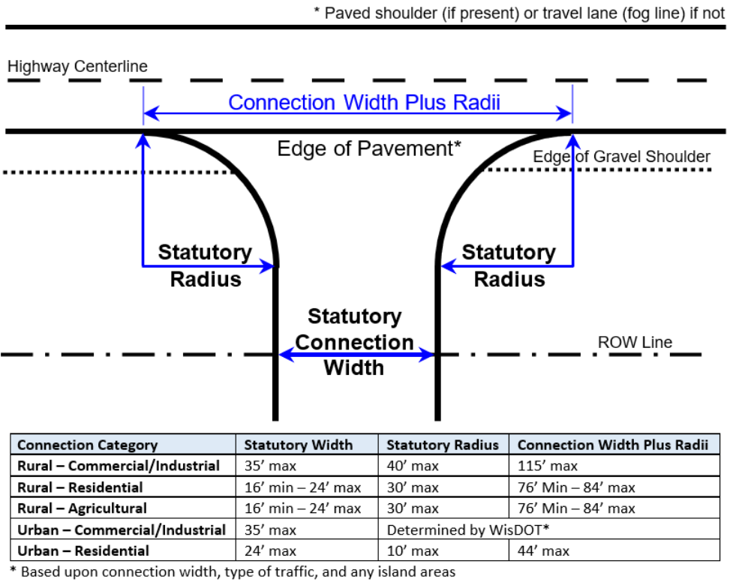***Rural – Agricultural:*** a field for planting, maintaining, and/or harvesting crops or tending livestock, or land for recreational and hunting use, next to a rural-type highway. This use may serve farm buildings but may not serve residential buildings.
   * ***Urban – Commercial/Industrial:*** a retail, wholesale, industrial, ag-related, or non-profit business, or residential facility with more than four units (apartments, hotels, etc.), next to an urban-type highway.
   * ***Urban – Residential:*** single and multiple family homes of 1-4 units (25 or fewer trips per day expected) next to an urban-type highway.
   * ***Public Road:*** a road, street, highway, etc. that connects to a STH for public travel and use and is maintained by a local unit of government.
   * ***Trail or Trail Crossing:*** a bike, snowmobile, etc. trail that is parallel to and/or crosses a STH.
   1. **Proposed Width**: Provide the proposed width of the connection as measured at the right-of-way line. Minimum and maximum widths are regulated in Wis. Adm. Code Ch. [Trans 231](https://docs.legis.wisconsin.gov/code/admin_code/trans/231). See the graphic above for details.
   2. **Proposed Surface**: Choose from grass, gravel, asphalt, or concrete. The question refers only to the part of the connection within STH right-of-way. It may or may not be the same as the surface on your property.
   3. **Proposed Trips Per Day**: Estimate how many trips will be made daily by vehicles going in and out of the connection. One vehicle going in and out of the connection equals two trips. “Seasonal” means a connection used only a few times during the year, for example, a field or hunting lands entrance.  
        
      **Peak hour traffic count**: For any connection that will generate 100 or more trips in any hour, 50 or more trips exiting in one hour, or 750 trips in an average day, provide the number of vehicles using the connection during the peak hour.
   4. **Is the property zoned?** Check yes or no. **In either case, provide the appropriate documentation from the jurisdictional zoning authority**. This may be obtained from the local zoning administrator or clerk of the town, village, city, or county where the property is located. Typically, a simple statement from the authority on its letterhead is sufficient for documentation, or WisDOT can provide a form if needed.
   5. **Explain how the land is currently being used**: Use the descriptions listed in question 13 as a guide.
   6. **Are you aware of any plan to change the zoning or land use for the property?** Check yes or no. **If yes, explain** the circumstances regarding the change. For example, “construct new house” or “proposed development.”
   7. **Is this connection for the property that was also part of a land division or assemblage created on or after 2/1/99?** Check yes or no. **If yes, explain**. For example, the connection is for property that is being created from a larger piece of property. A land division can be splitting one property into two or more properties, or it can be an assemblage, which is the joining of properties or portions of properties to make a different property.
   8. **Do you own other property abutting the highway that is next to the property that this connection will serve?** Check yes or no. **If yes, explain**. The land may abut either side of the highway or both sides.
   9. **Does the property abut other public roads?** Check yes or no. **If yes, provide all road names**.
   10. **Are there any existing connections to any road serving this property?** Check yes or no. The road may be public or private. **If yes, how many?** Provide the total number of connections including any field entrances.
   11. **Are there any restrictions limiting the number, use, or location of connections to the property?** Check yes or no. **If yes, explain**. *See question 25 for details.* Provide all documents related to the access restrictions.
   12. (A) **Are there any access easements across the property, or does any other property obtain access to a state trunk highway by crossing the property?** (B) **Are there any easements or arrangements that allow the property to access a public road by crossing another property?** An access easement is typically defined as granting another party the right of vehicular access across a property. *Access easements or access restrictions may be documented on a subdivision plat, certified survey map, deed, covenant, agreement, plat, map, or existing permit (WisDOT or non-WisDOT issued). They may be recorded or unrecorded.* An easement may also exist for the property to access a public road across another property. Carefully review these documents when applying for a STH connection permit.   
         
       **If you answered yes to 25A and/or 25B, explain. See the instructions for what information to provide.** Include the following items:
2. A description of the other property along with the names and contact information for its owner(s).
3. Explain the access arrangement between the property described in question 26 and the other property. Include copies of any easements, deeds, covenants, plats, certified survey maps, letters or correspondence evidencing the arrangement. If the access arrangement exists purely by longstanding use or oral agreement, provide as much detail as possible about the location of the allowed access and the use or agreement involved.
4. State whether the other property will use the connection requested in this permit application.
5. If the other property will not use the applied-for connection, explain how that property will access a public road.
6. If the property abuts a public road (question 22) and will not use access to that public road, explain why.
7. If the property has an access easement across another property to a public road, explain why a STH connection is also needed.
   1. **Provide all property tax identification numbers that will be using the connection**: This information may be found on the property tax bill or a county (or city) land records website.
   2. **List the proposed work start and finish dates for construction of the connection.** Insert each date.The time between dates must include completed right-of-way restoration. **If the permitted work has not begun by the Approved Work Start Date, the permit is null and void.** If the work has been started but is not completed by the Approved Work Finish Date, no additional work shall be done unless an approved Work Extension Date or a subsequent permit is obtained from WisDOT. To request either one, contact the WisDOT office that issued the original permit.

Time extensions and subsequent permits are not automatically approved. A site review may be required to determine if conditions have changed since the original permit was approved. WisDOT strongly recommends finishing construction of an approved connection as soon as possible. Once construction has started, it should be finished within ***30 days*** to minimize traffic disruption.   
  
Expiration of the permit does not absolve the permittee from responsibility for complying with all permit requirements, including right-of-way restoration. **Check *Not Applicable* if work is not needed with this permit**. For example, if the application is only to obtain a permit for an existing connection.

**Instructions for Public and Private Road Connections and Trail Connections**

***A) For all public and private road connections:***

* + - The proposed road must conform to local road standards found in Wisconsin Statutes and WisDOT’s [Facilities Development Manual](http://apwmad0p7106:37108/Pages/doing-bus/eng-consultants/cnslt-rsrces/rdwy/fdm.aspx)
    - Provide a copy of the:
  + General location map. The county GIS site may be used for this.
  + Plat, if applicable
  + Traffic Impact Analysis (TIA), if required by WisDOT or local unit of government
  + Pictures of the proposed intersection from all four directions
    - Provide highway plans for the STH and proposed road showing the:
  + Designated right-of-way widths (If applicable, see Wis. Stat. § [82.50](https://docs.legis.wisconsin.gov/statutes/statutes/82/iv/50) for Town Road Standards)
  + Land ties and/or reference points
  + Proposed geometrics including surface type(s), lane width(s), approach grades (in all directions), turn lanes, bypass lanes, return radii, etc.
  + Drainage patterns and drainage structures including culvert size, endwalls, and extensions, if needed
  + Closest connections (other roads, driveways, trail crossings) in both directions along the STH from the proposed road, and along the proposed road from the STH
  + Cross-sections of all road improvements every 50 feet showing the original ground, proposed finished pavement elevations, ditches, and right-of-way line. Cross-sections along the local road should be provided at least 100’ from the STH right-of-way line.
  + Pavement marking plan including new or restored markings, if needed
  + Erosion control and restoration plans
  + Traffic control plans during construction

***B) For all public road connections:***

* + The applicant must be the appropriate unit of government
  + Provide a copy of the:
  + Resolution from the appropriate government board or council documenting approval of the proposed road
  + Executed deed showing the transfer of property from the landowner to the appropriate unit of government

***C) For all private road connections:***

* Provide a copy of:
  + Proof of insurance, if requested by WisDOT
  + A road maintenance agreement, if such an agreement has been developed and implemented by a group of property owners, businesses, association, etc.

***D) For all trail connections:***

A trail connection may be a longitudinal trail in STH right-of-way and/or trail crossing of the STH.

* The applicant should be a unit of government or property owner. WisDOT may consider allowing a recreational group (for example, a snowmobile club) to be the applicant, but prefers a unit of government.
* For a trail crossing in which you are not the property owner, provide written permission from the property owners on each side of the highway that the connection can be attached to their property
* Provide a copy of an ordinance designating the trail or trail crossing
* As determined by WisDOT, provide a copy of the resolution or agreement that details the maintenance of the trail, or enter into a Memorandum of Agreement with WisDOT that details trail responsibilities such as maintenance, signing, costs, etc.