
APPLICATION/PERMIT FOR ATV SIGN INSTALLATION ON STATE TRUNK HIGHWAY
Wisconsin Department of Transportation (WisDOT)
10/2019 s. 23.33(8)(e), 86.07(2)(a), 86.19, and other applicable Wis. Stats.

INSTRUCTIONS: Answer the items in the blanks below and on page 2. Submit application as a Word document. Include a copy of the municipal and/or county ATV ordinance(s) for review. WisDOT does not approve ATV ordinances but checks them to verify compliance with applicable state statutes.

1. Municipality or County Name, Address, City, State and ZIP Code |  |  |  | 2. Contact Person  Name:  Title:  Phone:  Email: | 3. Municipal and County ATV Sign Locations (List all that apply)  Town:  Village:  City:  County:
4. ATV Sign Messages, ID Numbers, and Sizes
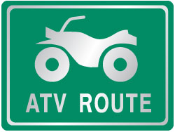 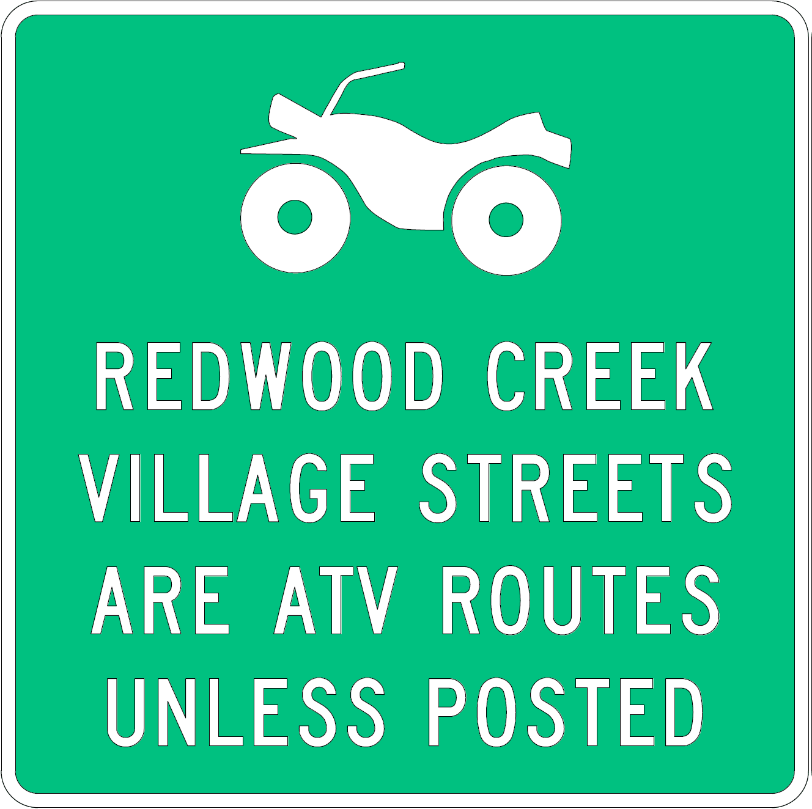 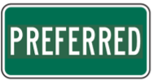 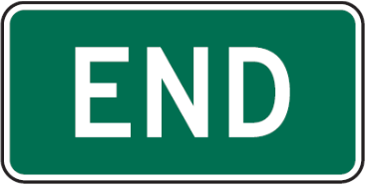 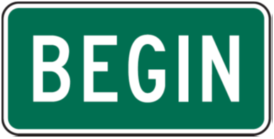 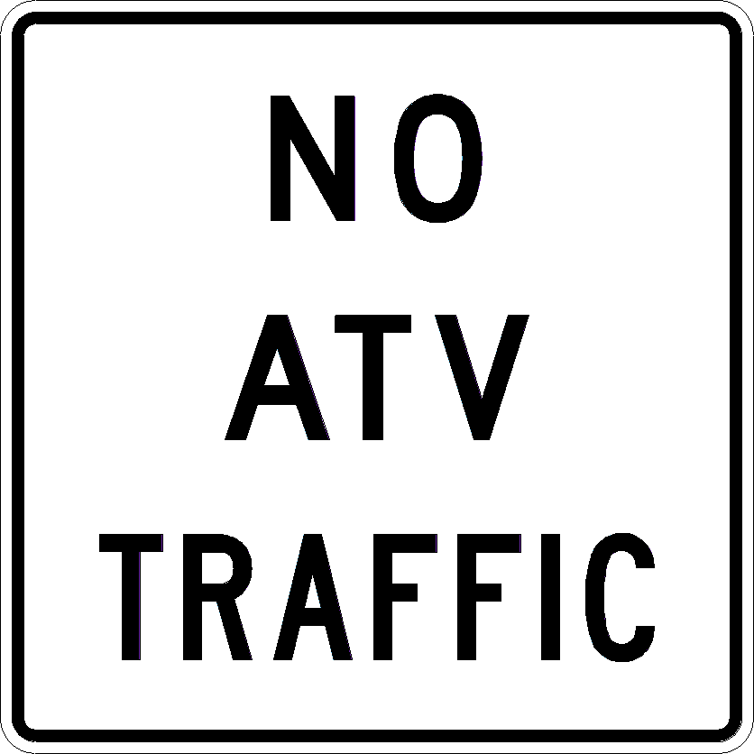
D11-10 D11-10A D11-10P MK4-6 MK4-14 M7-2 M7-6 R5-51
M7-5
M7-1
24” x 18” 36” x 36” 24” x 12” 24” x 12” 24” x 12” 12” x 9” 24” x 24”
5. Specific ATV Sign Location and Message Information (For b, list only one number if there are two or more concurrent routes. For c, list the direction used with the highway route signs, which may or may not be the direction the highway travels at the proposed location.)
a) Sign  1.  2.  3.  4.  5.  6.  7.  8. | b) Highway | c) Cardinal Direction  __________  __________  __________  __________  __________  __________  __________  __________ | d) Sign ID Number  _______  _______  _______  _______  _______  _______  _______  _______ | e) Proposed Location (Name of nearest intersecting road, municipal or county boundary, etc. – Provide map or sketch on page 2)

It is understood and agreed that approval is subject to the applicant’s full compliance with the pertinent Statutes, as well as any codes, rules, regulations, and other jurisdictional agencies’ permit requirements. Applicant shall comply with all permit provisions, superimposed notes, and detail drawings that WisDOT may add. Any alteration of this form by the applicant is prohibited and may be cause to revoke this permit. When approved, the permit does not transfer any land; nor give, grant or convey any land right, right in land, nor easement in WisDOT right-of-way. It is not assignable or transferrable. All costs associated with this permit are the permittee’s responsibility unless otherwise noted.

 |  |  |  | X
(Sign Contractor Company Name, If applicable) |  |  |  | (Applicant or Authorized Representative Signature)  (If Computer-filled, Brush Script Font) |  |  | (Date)
(Contractor Representative/Title) |  | (Area Code/Phone No. – Office) |  | (Printed Name) |  | (Title)
(Area Code/Phone No. – Cell) | (Email Address) |  |  | (Area Code/Phone No.) | (Email Address)

NOTE: ANY PERMIT ISSUED IS REVOCABLE.

For Official Wisconsin DOT Use Only – Do Not Answer Items Below
Permittee shall notify the WisDOT representative listed below 3 days before starting any work:  Region contact, title, office address, area code/phone no., and email address  Wisconsin DOT  __________  __________  __________  @dot.wi.gov | See Supplemental Permit Provisions (Page 3)  Lane Closure System notification required  ATV ordinance(s) reviewed by WisDOT access staff  Insurance or performance bond required  Permit issued in conjunction with:  Permit voids and supersedes permit(s) , issued | Date Application Received
 |  | Date Application Complete
 |  | Permit Issuance Date
 |  | Permit Extension Date
 |  | Permit Number
(WisDOT Authorized Representative Signature – If Computer-filled, Brush Script Font)

APPLICATION/PERMIT FOR ATV SIGN INSTALLATION ON STATE TRUNK HIGHWAY (continued)
Wisconsin Department of Transportation

5f) Provide location map or sketch of the proposed sign installations. Label the signs using numbers 1-8 listed in 5a. Insert a .jpg file or other graphic file directly into this document by clicking on the icon below. Submit a separate map or sketch separately if unable to place it into this form.


INDEMNIFICATION

The Applicant shall save and hold the State, its officers, employees, agents, and all private and governmental contractors and subcontractors with the State under Chapter 84 Wisconsin Statutes, harmless from actions of any nature whatsoever (including any by Applicant itself) which arise out of, or are connected with, or are claimed to arise out of or be connected with any of the work done by the Applicant, or the construction or maintenance of facilities by the Applicant, pursuant to this permit or any other permit issued by the State for location of property, lines or facilities on highway right-of-way, (1) while the Applicant is performing its work, or (2) while any of the Applicant's property, equipment, or personnel, are in or about such place or the vicinity thereof, or (3) while any property constructed, placed or operated by or on behalf of Applicant remains on the State's property or right-of-way pursuant to this permit or any other permit issued by the State for location of property, lines or facilities on highway right-of-way; including without limiting the generality of the foregoing, all liability, damages, loss, expense, claims, demands and actions on account of personal injury, death or property loss to the State, its officers, employees, agents, contractors, subcontractors or frequenters; to the Applicant, its employees, agents, contractors, subcontractors, or frequenters; or to any other persons, whether based upon, or claimed to be based upon, statutory (including, without limiting the generality of the foregoing, worker's compensation), contractual, tort, or whether or not caused or claimed to have been caused by active or inactive negligence or other breach of duty by the State, its officers, employees, agents, contractors, subcontractors or frequenters; Applicant, its employees, agents, contractors, subcontractors or frequenters; or any other person. Without limiting the generality of the foregoing, the liability, damage, loss, expense, claims, demands and actions indemnified against shall include all liability, damage, loss, expense, claims, demands and actions for damage to any property, lines or facilities placed by or on behalf of the Applicant pursuant to this permit or any other permit issued by the State for location of property, lines or facilities on highway right-of-way in the past or present, or that are located on any highway or State property or right-of-way with or without a permit issued by the State, for any loss of data, information, or material; for trademark, copyright or patent infringement; for unfair competition or infringement of personal or property rights of any kind whatever. The Applicant shall at its own expense investigate all such claims and demands, attend to their settlement or other disposition, defend all actions based thereon and pay all charges of attorneys and all other costs and expenses of any kind arising from any such liability, damage, loss, claims, demands and actions.

Any transfer, whether voluntary or involuntary, of ownership or control of any property constructed, placed or operated by or on behalf of the Applicant that remains on the State's property or right-of-way pursuant to this permit shall not release Applicant from any of the indemnification requirements of this permit, unless the State is notified of such transfer in writing. Any acceptance by any other person or entity, whether voluntary or involuntary, of ownership or control of any property constructed, placed or operated by or on behalf of the Applicant that remains on the State's property or right-of-way pursuant to this permit, shall include acceptance of all of the indemnification requirements of this permit by the other person or entity receiving ownership or control.

Notwithstanding the foregoing, a private contractor or subcontractor with the State under Chapter 84 Wisconsin Statutes, that fails to comply with sections 66.0831 and 182.0175 Wisconsin Statutes (2017-2018), remains subject to the payment to the Applicant of the actual cost of repair of intentional or negligent damage by the contractor or subcontractor to any property, lines or facilities placed by or on behalf of the Applicant pursuant to this permit or any other permit issued by the State for location of property, lines or facilities on highway right-of-way, and remains subject to payment to the Applicant for losses due to personal injury or death resulting from negligence by the contractor or subcontractor.

Notwithstanding the foregoing, if the State, or its officers, employees and agents, fail to comply with sections 66.0831 and 182.0175 Wisconsin Statutes (2017-2018), the State or its officers, employees and agents, remain subject to the payment to the Applicant of the actual cost of repair of willful and intentional damage by the State, or its officers, employees and agents, to any property, lines or facilities placed by or on behalf of the Applicant pursuant to this permit or any other permit issued by the State for location of property, lines or facilities on highway right-of-way, and remain subject to payment to the Applicant for losses due to personal injury or death resulting from negligence by the State, its officers, employees and agents.

No indemnification of private contractors or subcontractors with the State under Chapter 84 Wisconsin Statutes, shall apply in the event of willful and intentional damage by such private contractors or subcontractors to the property, lines and facilities of the Applicant located on the highway right-of-way pursuant to this permit or any other permit issued by the State for the location of property, lines or facilities on highway right-of-way.

SUPPLEMENTAL PERMIT PROVISIONS

Pursuant to Wisconsin Statutes and once approved by WisDOT, this permit allows performance of the specific work described over which WisDOT has permit authority. The permittee shall abide by these general provisions, and any supplemental and/or special provisions. (ROW = right-of-way)
- The permit authorizes only the described work of and for the permittee indicated in question one. It does not grant authority for any other work either by present or future installation.
- The municipality or county agrees to pay for all sign materials and installations costs along with costs to replace the signs when they have the reached the end of their useful life, or repairs if they become damaged when the cost is not recoverable from the person(s) who caused the damage.
- Install the signs in the specified permit location. Move any sign found to be otherwise located to the correct location upon WisDOT order. Any sign located other than as approved in this permit is at permittee’s sole risk. Accordingly, if the same is undetected or is suffered to remain in variance to the permit, the permittee shall hold the State, its employees, agents and officers harmless and free of any cost, claim or liability associated with any accidental damage to such sign that may result from a highway construction, maintenance, traffic control, or ROW management project or function.
- Warning signs, devices and methods shall be in place and fully functional prior to starting any permitted work within highway ROW and shall protect the public until all permitted work is complete. Warning signs and devices shall conform to the appropriate sizes, designs and configurations specified in the Wisconsin Manual of Uniform Traffic Control Devices, current edition. All personnel shall wear retro-reflective safety vests while working in the highway ROW.
- Secure the work site and associated traffic control zone against any hazard to the public. This includes vehicles, equipment and materials. Any permit violation, particularly any failure to maintain a safe work site and traffic control zone, shall require permittee’s immediately cure, and may result in WisDOT stopping further work, removing permittee from the highway ROW, or permit revocation.
- Perform all permitted work without obstructing or closing any part of a traffic lane or fully closing any road unless authorized by WisDOT.
- Keep a complete copy of the permit (which may be electronic) at the job site at all times the permitted work is ongoing with a project manager, site supervisor or lead worker familiar with the permit and all of its details and requirements. Failure to comply with any part of this permit is the permittee’s responsibility.
- Coordinate the permitted work and in no case interfere with any ongoing highway improvement project.
- Determine the location of, and protect or cause to protect from any damage, any existing utility facilities near the permitted work area. All notifications to other facility owners are the permittee’s responsibility.
- Construction methods and restorations shall be in accordance with applicable parts of WisDOT’s Standard Specifications for Highway and Structure Construction, current edition.
- Comply with all applicable regulations and codes, including, but not limited to, the U.S. Department of Labor, Occupational Safety and Health Administration, 29 CFR Part 1926 for construction safety precautions and operations.
- Implement erosion control best management practices (BMPs) prior to and at all times during work operations. Provide and maintain erosion control BMPS to protect all restored areas upon completion of the permitted work until the replacement vegetation achieves sustained growth.
- Comply with appropriate laws, rules, policies, etc. when on tribal or federal lands. Provide documentation as needed when on WisDOT ROW to prove compliance or coordination with the:
  - Wisconsin Historical Society to avoid/mitigate any potential cultural resource (archeological, historical, burial site, etc.) impacts per Wis. Stat. s. 44.40.
  - Department of Natural Resources to avoid/mitigate any potential site erosion, wetland, waterway and endangered/threatened species impacts.
- Do not keep vehicles/equipment/materials related to this permit within the ROW limits except as are actively engaged in the work operation.
- Cure faults related to work or facilities under this permit that, in WisDOT’s opinion, obstruct highway drainage or in any other manner adversely affect highway maintenance or operation, and restore the ROW as directed by and to WisDOT’s satisfaction.
- Collect any brush, trash or waste materials resulting from the permitted work, and dispose of said materials off the ROW in accordance with applicable solid waste disposal regulations.
RESTORATION
- Pay for all restoration costs, and restore any:
  - Curb, gutter, sidewalk, driveway, gravel base, ballast, shoulder material, or other highway ROW element/facility disturbed by the permitted work to the qualities, grades, compactions and conditions specified in WisDOT’s Standard Specifications for Highway and Structure Construction, current edition.
  - Other highway facilities disturbed by the permitted work or associated operation. This includes natural highway facilities, including but not limited to living snow fence, headlamp screens, and other highway safety features.
  - Turfed ROW area disturbed by the permitted work with fine-graded topsoil having a depth of not less than four inches and reseeded to perennial grass or sodded to WisDOT’s satisfaction.
  - Item in (a) – (c) without undue delay. WisDOT may issue a notice setting a specific time to complete the restoration if it is not done without delay. If the permittee fails to satisfactorily complete the restoration within the time established, WisDOT may arrange for the restoration to be completed and bill the permittee accordingly.
- Send an email notice within 10 calendar days to the Region Office person who signed this permit upon completion of the work and restoration.
TREE & VEGETATION MANAGEMENT
- Do not cut, trim or damage any trees/vegetation to facilitate the installation or maintenance of the permitted facility except as authorized by the owner of such tree/vegetation.
- Do not cut or prune oak trees between April 15 and October 15 to prevent Oak Wilt Disease from spreading unless a thick coat of asphalt base tree paint is applied immediately after any cut, pruning wound, or abrasion made between those dates. Cleanly cut the exposed ends of any roots encountered during grading or trenching with suitable pruning tools immediately after exposure. Adhere to any applicable laws, including local ordinances if they are stricter than WisDOT specifications.
WORK RESTRICTIONS
21. WisDOT has placed restrictions on work times or lane/shoulder closures based on various special events, oversize freight movements, or daily peak or holiday travel times as detailed on page . Review the restrictions with the WisDOT representative identified with this permit.
WISDOT INSPECTIONS
22. Contact the Region Office person who signed this permit to arrange for a WisDOT representative to inspect the work site. Perform no work under this permit prior to his/her arrival.
23. Contact the Region Office person who signed this permit before completing the permitted work to arrange for a WisDOT representative to inspect the work before the permittee’s employees or contractor leaves the site.

