WisDOT Transit Sub-Recipient Vehicle Disposal Guide – Fall 2026

Introduction
Vehicle disposal requests and processes are now completed through the Transit Management System (TMS).
TMS website: https://wisdot.us-1.smartsimple.com/
If you do not have access to TMS, please email your program manager –
Public Transit – public.transit@dot.wi.gov
Specialized Transit - specialized.transit@dot.wi.gov

When to Dispose My Vehicle?
WisDOT is responsible for approving the disposal of a subrecipient/organization’s federally funded transit assets. Assets must have met or exceeded their useful life metrics (noted in Appendix A) in years or mileage.
Federal rule allows the disposal of an asset which has not reached the end of its useful life, subject to prior WisDOT approval, under the following conditions:
(1) it is no longer safe to transport passengers and cannot be repaired in a satisfactory manner
(2) it is not in a safe operating condition and estimates for repairs are high in comparison to the value of the vehicle
(3) the estimate for repairs considerably exceeds the value of the vehicle.

Request to Dispose of Vehicle
Begin by searching for the vehicle that needs to be disposed of by going to your “Assets” tab in TMS
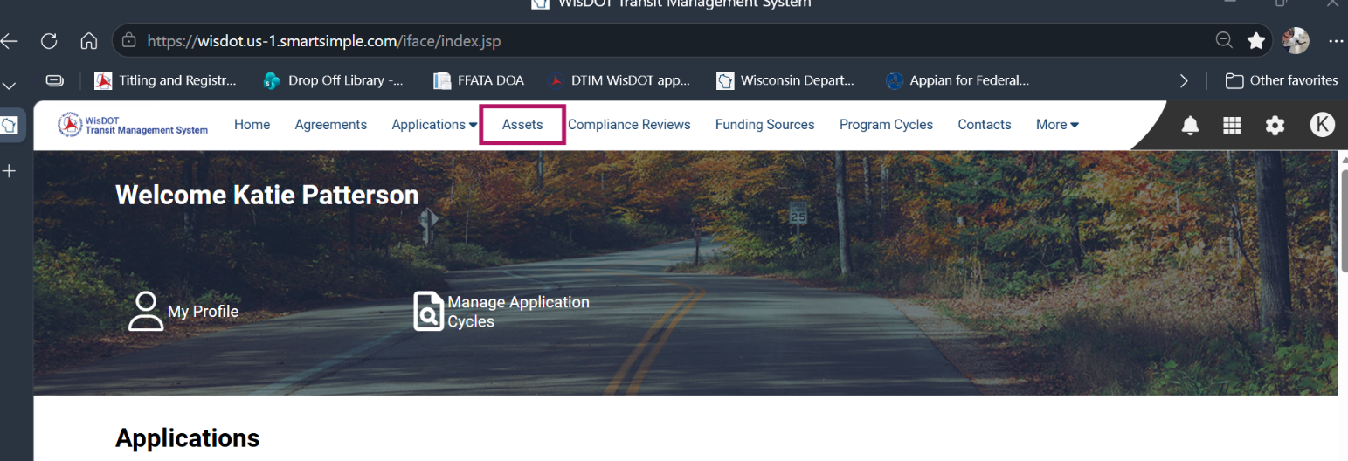A list of your vehicles should populate in the Asset Module.
Find the correct vehicle and click on “open”
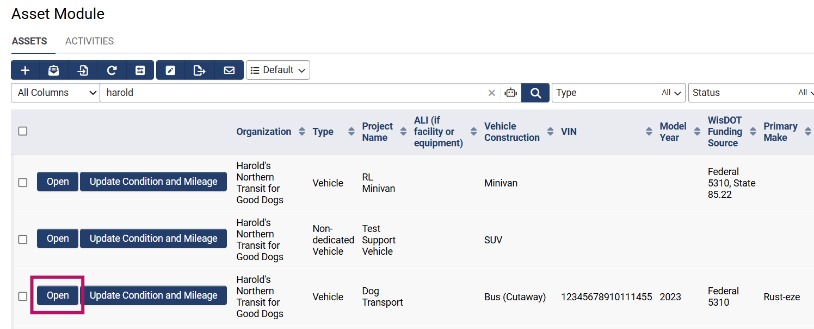
Find the “Active” tab in the vehicle record. 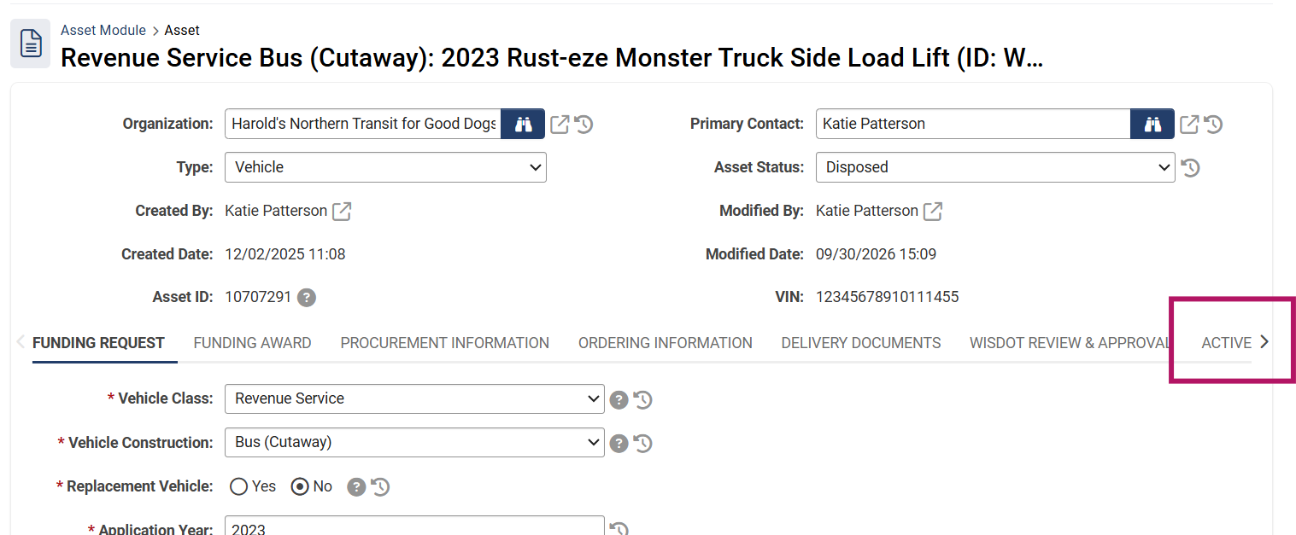Scroll to the bottom of the page and enter the most recent information under the “Vehicle Condition and Issues” and “Disposal Request Information” headers. Try to be as descriptive as possible, especially if the vehicle has yet to surpass its useful life. Useful Life Information is in Appendix A.
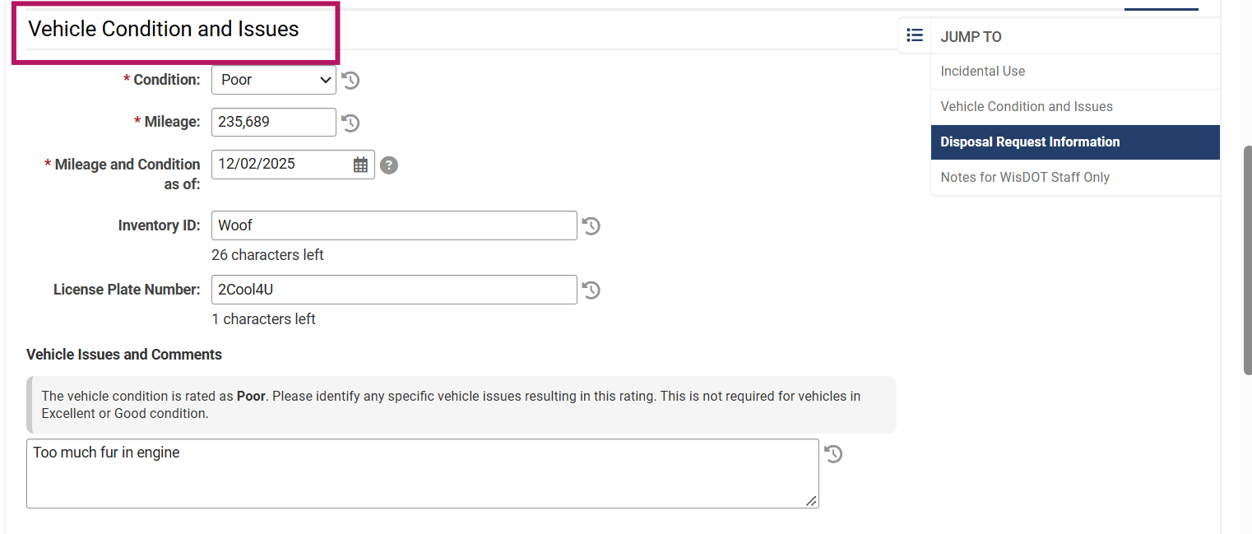
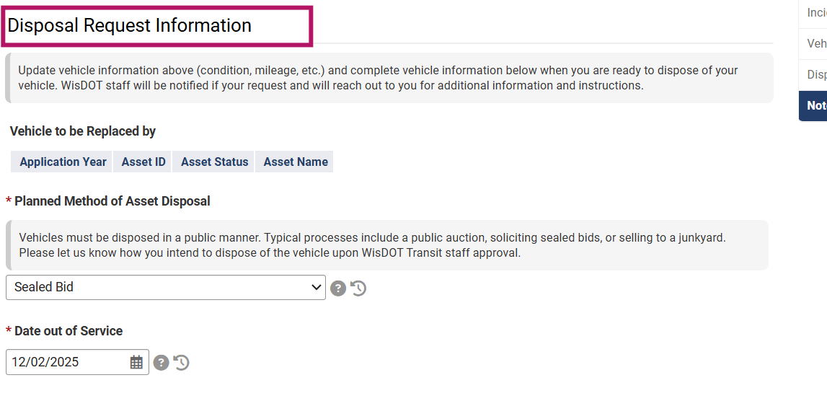The “Vehicle to be Replaced by” will only populate if your organization has applied to WisDOT for a replacement vehicle via an application.
You can “safe the draft” if you are not ready to submit the request right away. When you are ready, select the “submit disposal” button.
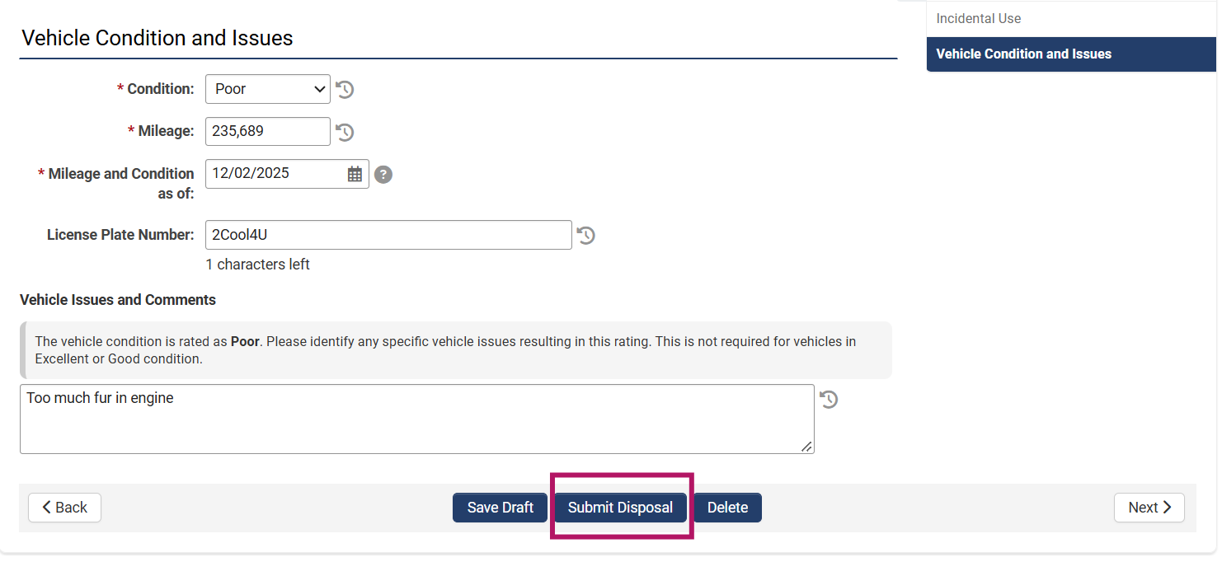A message will pop up to confirm you are ready to start the disposal process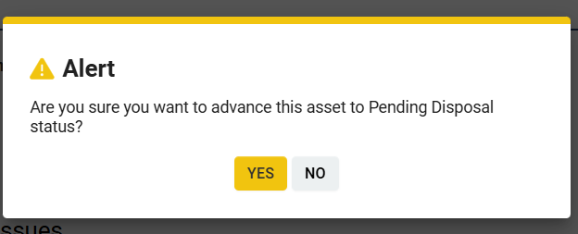
Once “yes” is selected, an automatic email will alert the Program Managers that your vehicle is ready to be reviewed for disposal. In an internal process, they will approve the disposal or send you a note with any follow up questions. If approved, the WisDOT lien will be released on the vehicle, and an automatic email will be generated through TMS that your vehicle is ready for sale or to be junked.

Sale or Junking of Vehicle
Vehicle disposal options vary and are dictated mainly by vehicle conditions and local government preferences. The vehicle must be sold using a public sale method.
For instance, a vehicle may be offered for bid in a local public auction sponsored by the subrecipient or other licensed seller, or it may be advertised by soliciting bids in a local newspaper.
If you are selling to a scrap or junk yard, you must try to get multiple offers for the vehicle to make the process as fair and equitable as possible.
If the vehicle has been involved in a collision and has been declared a total loss, it may have to be sold as scrap.
Using retired vehicles as ‘back-up’ or selling to a preferred party is not allowed.

Final Steps of Disposal
Once the vehicle has been sold, you will need to enter the proceed amount into TMS. There should be a tab called “Vehicle Sale Process” in the Asset Module once WisDOT has approved the vehicle for disposal. 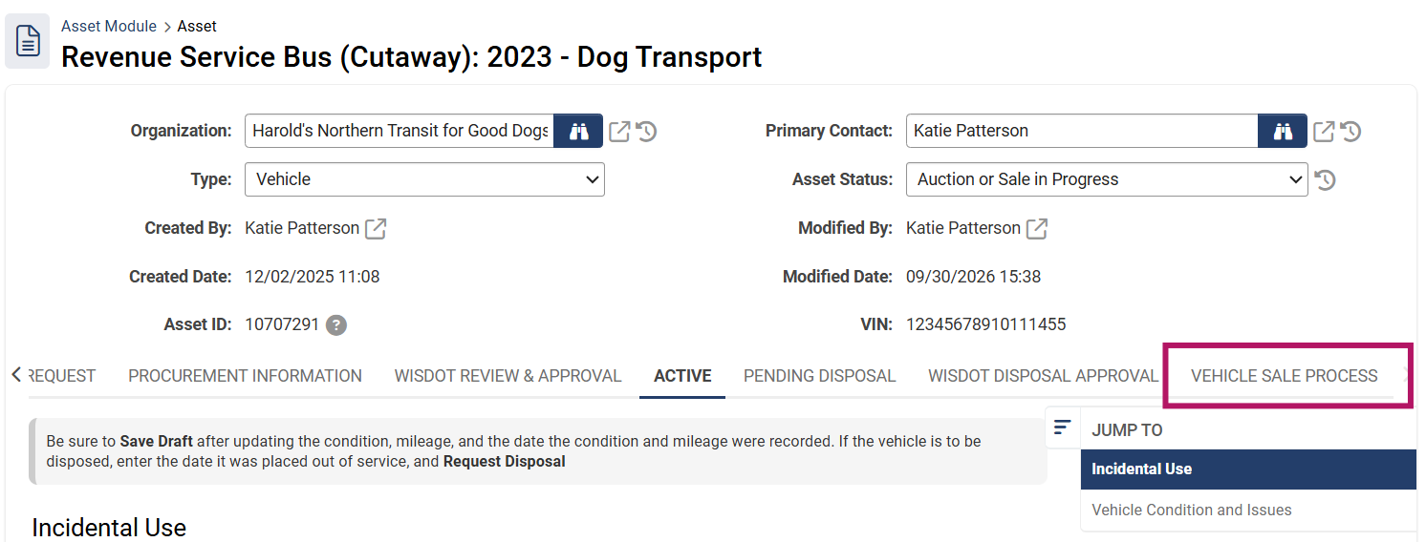Under “Vehicle Sale Process” enter the date of sale and proceed amount from the vehicle, and upload any receipts, bills of sales, and/or documentation related to the sale or junking of the vehicle.
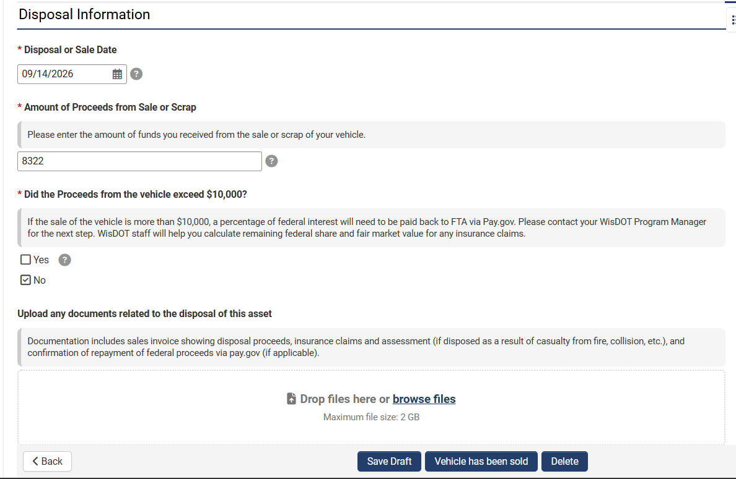
If the vehicle proceeds are over $10,000, please make a note and your Program Manager will walk you through the next steps. A portion of those funds may need to be repaid to the Federal Transit Administration through pay.gov. Your program manager will confirm this for you.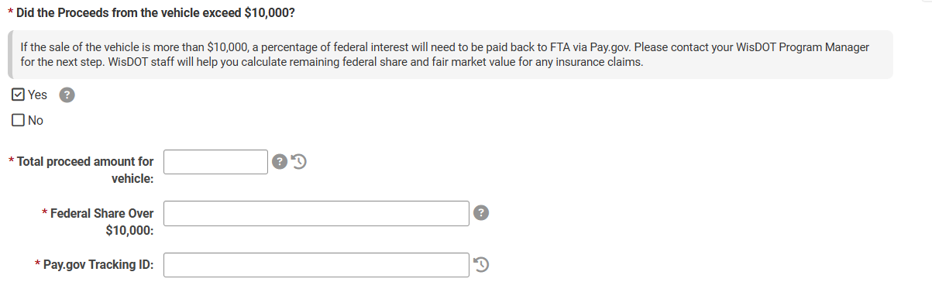
Once complete, select the “Vehicle has been sold” button and TMS will generate an automatic email you the Program Managers for final review. Unless they contact you with additional questions, the process is now complete
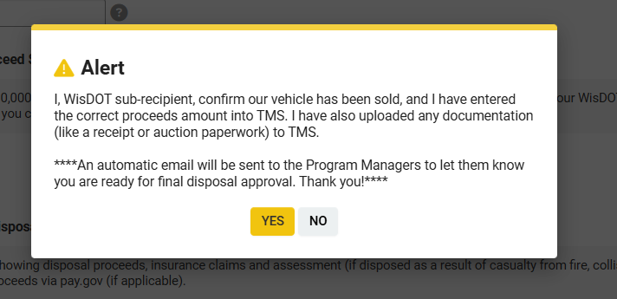

Asset Inventory
Once the disposal process is finalized, the vehicle in your asset inventory should have a status of “disposed”. 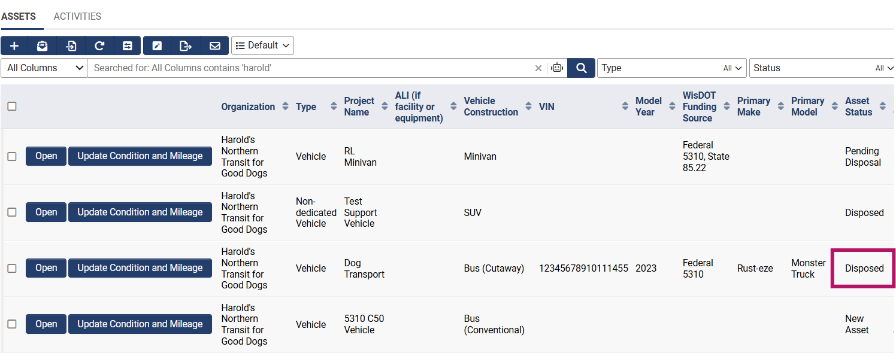

Questions?
Please contact Katie Patterson katherine.patterson@dot.wi.gov or 608-264-7335 for any questions.

Appendix A

Useful Life Standards for Vehicles
Construction | Useful Life Category | Vehicle Class from FHWA | Vehicle Weight (GVWR) | Years | Mileage
Automobile | Light Duty Vehicle | Class 1-3 | Less or = 14,000 lbs. | 4 | 100,000
Minivan | Light Duty Vehicle | Class 1-3 | Less or = 14,000 lbs. | 4 | 100,000
SUV | Light Duty Vehicle | Class 1-3 | Less or = 14,000 lbs. | 4 | 100,000
Van (full sized or bariatric) | Light Duty Vehicle | Class 1-3 | Less or = 14,000 lbs. | 4 | 100,000
Pickup Truck | Light Duty Vehicle | Class 1-3 | Less or = 14,000 lbs. | 4 | 100,000
Cutaway Bus | Light-Duty Bus | Class 1-3 | Less or = 14,000 lbs. | 5 | 150,000
Cutaway Bus (large) | Medium-Duty Bus | Class 3-6 | Between 10,001 and 26,000 lbs. | 7 | 200,000
Conventional Bus | Heavy-Duty Bus | Class 6-8 | More than 26,001 lbs. | 12 | 500,000
School Bus | Heavy-Duty Bus | Class 6-8 | More than 26,001 lbs. | 12 | 500,000
If you are unsure where your vehicle’s category might fall under, you can check the FHWA class here by entering the VIN at the website – https://vpic.nhtsa.dot.gov/decoder/

