Reimbursement Request Process
- Reimbursement requests may be submitted for eligible LSSIP projects not more frequently than quarterly, following the state fiscal calendar year (July 1 – June 30). Project Sponsors are permitted to submit one reimbursement per quarter for eligible engineering and/or construction expenses and each reimbursement may include one or multiple invoices.

Q1 | July, August, September
Q2 | October, November, December
Q3 | January, February, March
Q4 | April, May, June

- Invoices must be itemized; non-itemized statements are not acceptable. All invoices must clearly identify all LSSIP expenses and match amounts submitted in the reimbursement request. Additional documentation can be submitted to support, but not replace, actual invoices.
- A project reimbursement of eligible expenses is counted towards a quarter based on the date the request is submitted by email to DOTLSSIPWebSystem@dot.wi.gov. Reimbursement requests may be for costs that Project Sponsors have incurred or expended, meaning portions of the project do not need to be completed prior to requesting reimbursement. Incurred costs are items that a Project Sponsor has become obligated to pay for, even if payment hasn't happened yet, while expended costs have been paid prior to the reimbursement request.
- Project Sponsors may pay invoices in advance or, if timing permits, defer payment until after receiving reimbursement funds. Once a reimbursement request is submitted, additional requests cannot be submitted or processed until the following quarter.
- If WisDOT or a federal or other state agency having jurisdiction determines that any material or work is deficient for whatever reason, Project Sponsor shall require the replacement of whatever materials, or the correction of whatever work is necessary to cure the deficiency. Project Sponsors shall not use any WisDOT grant funds as provided for in LSSIP to pay for the replacement or correction required. There may be exceptions to the list of eligible and ineligible improvements. To confirm eligibility, contact the LSSIP Statewide Program Manager for more information.
- Should any element of cost billed on an invoice be questioned by WisDOT as to its eligibility, WisDOT will hold reimbursement for that cost item until questions concerning the cost item are resolved to the satisfaction of WisDOT.
- LSSIP projects will be reimbursed at 90% of incurred costs up to the initial project award amount total or 90% of the final project costs, whichever is less. The total of all approved reimbursements cannot exceed 90% of the total eligible project costs. Project Sponsors are responsible for all costs beyond the maximum award amount. The funding scenarios shown below illustrate the end cost shares based on final project costs.

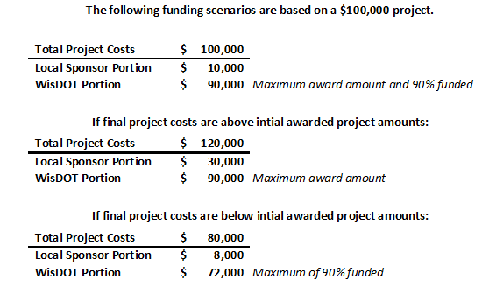
- Project Sponsors must use email DOTLSSIPWebSystem@dot.wi.gov to submit reimbursement requests and include the required documentation as outlined below based on the project scenario or phase.
- Some documents are only required for the first reimbursement and will be kept on file to reference for subsequent reimbursement requests.
- Documents Checklist for:
  - Every Reimbursement
    - Reimbursement Request Form (DT1713)
    - Engineer Attestation (DT2369)
    - Invoice(s)
  - First Construction Reimbursement
    - All documents above
    - Advertisement for Bid and Affidavit of Publication
    - Board Meeting Minutes or Bid Tab/Bid Award Notice
    - If Applicable:
      - Approved Exception to Standards Form
      - Miscellaneous (e.g. DNR/Historical Society Permits)
  - Project Completion Reimbursement
    - Reimbursement Request Form (DT1713)
    - Engineer Certification
    - Final Invoice(s)

- Every reimbursement request must include an attestation by a certified engineer in order to be considered for reimbursement. The attestation shall confirm that the work contained in the reimbursement request was executed in accordance with the project scope, all applicable Wisconsin Administrative Code (Trans Code) and statutory requirements, and commonly accepted industry standards.
- If the Project Sponsor has a certified engineer on staff, that individual can provide the attestation. If not, Project Sponsors may contract an outside firm to provide an attestation. Any fees incurred during this contracting process would be eligible for reimbursement, provided those fees occurred after receipt of an executed SMA for the project.
- Following WisDOT approval and payment authorization, and in the absence of any issues, a Project Sponsor should expect reimbursement within 30 business days. Program noncompliance can jeopardize reimbursement.
- The reimbursement request process flow is shown below.

Contact Information
For further questions regarding the Local Small Structures Improvement Program, please contact:
- Merrill Mechler-Hickson, Local Programs & Finance Section Chief, via email at merrill.mechlerhickson@dot.wi.gov or via phone at (608) 261-8977.
- Nou Ye Yang, LSSIP Statewide Contract Manager, via email at nouye.yang@dot.wi.gov or via phone at (608) 267-7345.

Appendix A: Sample Advertisement for Bid and Affidavit of Publication

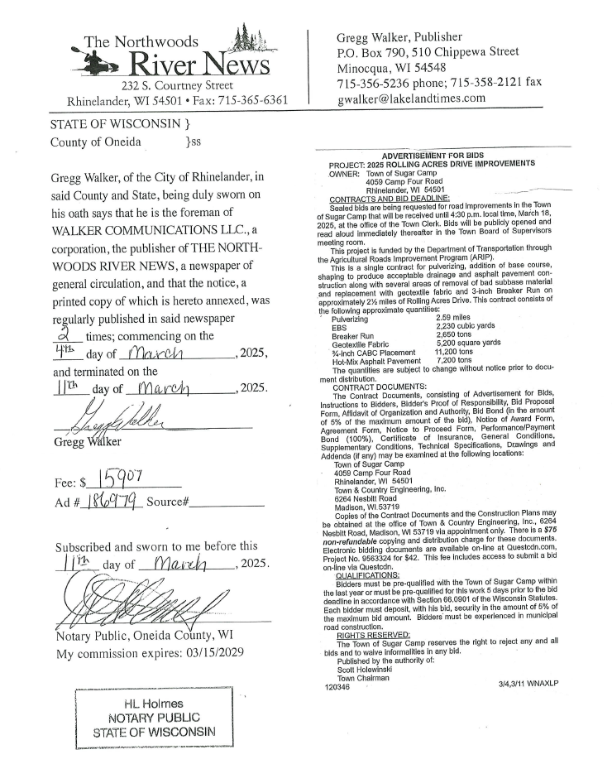

Appendix B: Sample Engineer Attestation (DT2326)

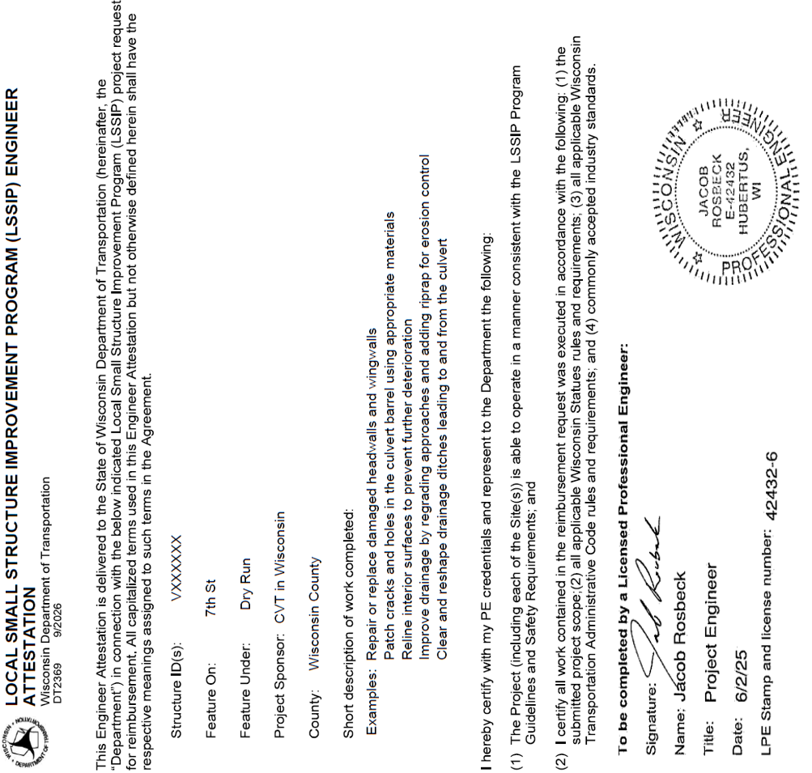

Appendix C: Sample Engineer Certification

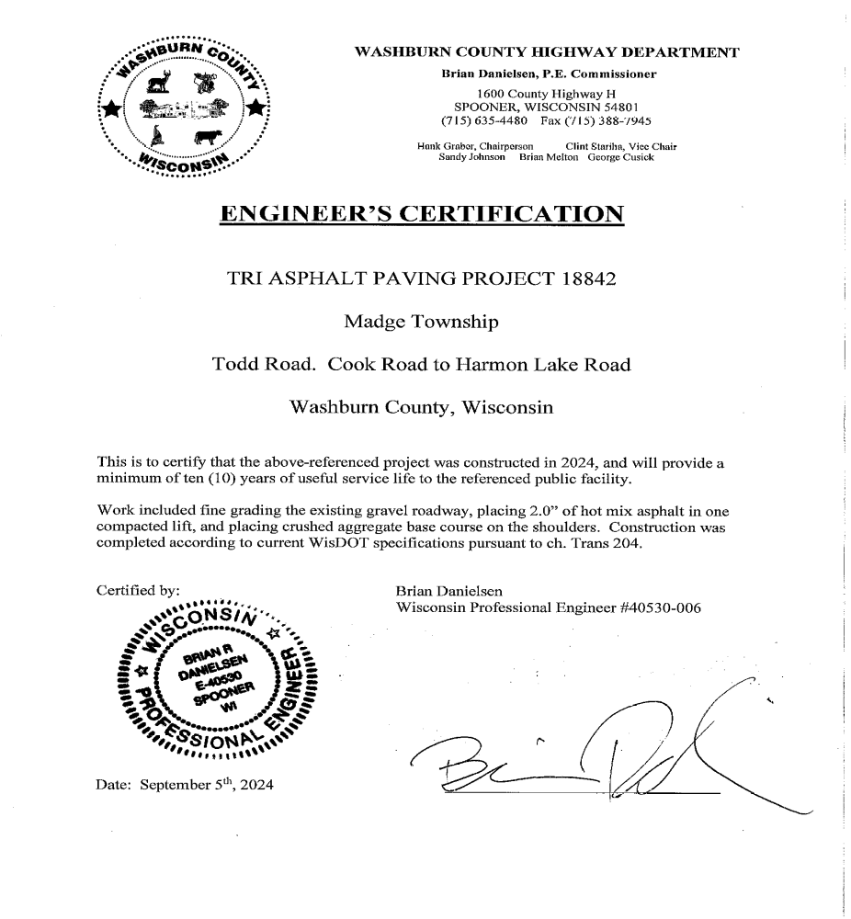

Appendix D: Sample Reimbursement for Request Form (DT1713)

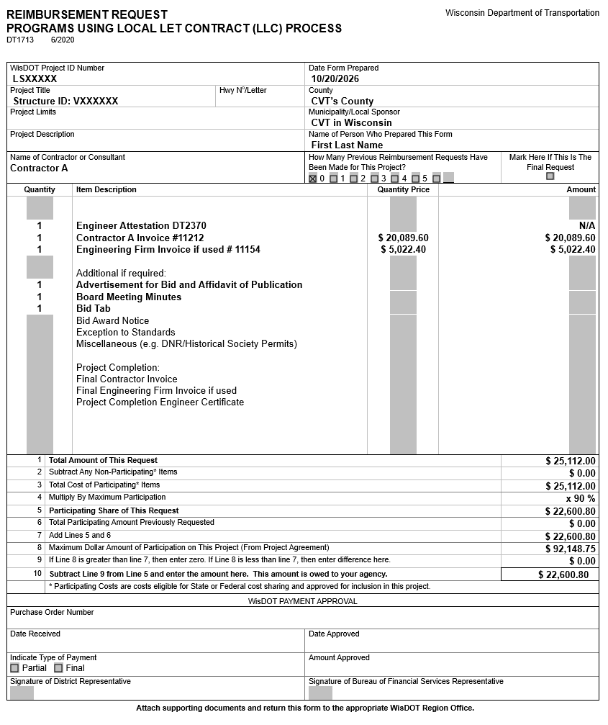

Appendix E: Sample Reimbursement for Request Form (DT1713)

For Project Completion

