***DELETE ALL DESIGNER NOTES FROM YOUR SPECIAL PROVISIONS***

***Use this SPV for HMA PWL QMP core only projects. Include the following companion specifications with this SPV:***

1. ***STP-460-040 HMA Percent Within Limits (PWL) Test Strip***
2. ***HMA Pavement Percent Within Limits (PWL) QMP, Core Only Project (460-050 core only)***
3. ***Appendix A, Core Only Project (460-055 core only)***

***Designers should not specify joint heaters, echelon paving, wedge joint removal, or other specified joint treatments when including this SPV.***

***When estimating the quantity Incentive Density HMA Pavement Longitudinal Joints, multiply the length of the applicable joints – as defined in Section 1A herein – by 2 (for both sides of the joint) and then multiply by $0.10 (average incentive is anticipated to be about half of the $0.20 maximum incentive).*** ***The unit price should be a fixed cost of $1.00 in AWP.***

1. **HMA Pavement Longitudinal Joint Density, Core Only Project;  
   Incentive Density HMA Pavement Longitudinal Joints, Item SPV.0055.XXX.**

**A Description**

This special provision incorporates longitudinal joint density requirements into the contract and describes the data collection, acceptance, and procedure used for determination of pay adjustments for HMA pavement longitudinal joint density. Pay adjustments will be made on a linear foot basis, as applicable per pavement layer and paving lane. Applicable longitudinal joints are defined as those between any two or more traffic lanes including full-width passing lanes, turn lanes, or auxiliary lanes more than 1500 lane feet, and those lanes must also include the 460.2005 Incentive Density PWL HMA Pavement bid item. This excludes any joint with one side defined as a shoulder and ramp lanes of any length. If echelon paving is required in the contract, the longitudinal joint density specification shall not apply for those joints. Longitudinal joints placed during a test strip will be tested for information only to help ensure the roller pattern will provide adequate longitudinal joint density during production. Longitudinal joint density test results collected during a test strip are not eligible for pay adjustment.

Pay is determined according to standard spec 460, HMA Pavement Percent Within Limits QMP special provisions, and as modified within.

**B Materials**

Compact all applicable HMA longitudinal joints to the appropriate density based on the layer, confinement, and mixture type shown in Table B-1.

TABLE B-1 MINIMUM REQUIRED LONGITUDINAL JOINT DENSITY

|  |  |  |  |  |
| --- | --- | --- | --- | --- |
| Layer | Percent of Target Maximum Density | | | |
| Unconfined | | Confined | |
| LT and MT | HT | LT and MT | HT |
| Lower (on crushed/recycled base) | 88 | 89 | 89.5 | 90.5 |
| Lower (on Concrete/HMA) | 90[1] | 90[1] | 91.5[1] | 91.5[1] |
| Upper | 90 | 90 | 91.5 | 91.5 |

[1] Minimum reduced by 1.0 percent for a 1.25-inch-thick No. 5 mix lower layer constructed on a paved or milled surface.

**C Construction**

*Add the following to standard spec 460.3.3.2:*

(5) Establish companion density locations for each applicable joint. Each companion location shares longitudinal stationing with the QV mainline density location within each sublot and is located transversely with the center of the core 6-inches from the final joint edge of the paving area. Sublot and lot numbering remains the same as mainline densities, however, in addition to conventional naming, joint identification must clearly indicate “M” for inside/median side of lane or “O” for outside shoulder side of lane, as well as “U” for an unconfined joint or “C” for a confined joint (e.g., XXXXX-MC or XXXXX-OU).

(6) Each joint shall be measured, reported, and accepted under methods, testing times, and procedures consistent with the program employed for mainline density, i.e., PWL.

(7) For single density test results greater than 3.0% below specified minimums per Table B-1 herein, perform the following:

1. Testing at 50-foot increments both ahead and behind the unacceptable site
2. Continued 50-foot incremental testing until test values indicate higher than or equal to -3.0 percent from target joint density.
3. Materials within the incremental testing indicating lower than -3.0 percent from target joint density are defined as unacceptable and will be handled with remedial action as defined in the payment section of this document.
4. The remaining sublot average (exclusive of unacceptable material) will be determined by the first forward and backward 50-foot incremental tests that reach the criteria of higher than or equal to -3.0 percent from target joint density.

Note: If the 50-foot testing extends into a previously accepted sublot, remedial action is required up to and inclusive of such material; however, the results of remedial action must not be used to recalculate the previously accepted sublot density. When this occurs, the lane feet of any unacceptable material will be deducted from the sublot in which it is located, and the previously accepted sublot density will be used to calculate pay for the remainder of the sublot.

(8) Joint density measurements shall be recorded in the HMA PWL Production Spreadsheet.

(9) Placement and removal of excess material outside of the final joint edge, to increase joint density at the longitudinal joint testing location, shall be done at the contractor’s discretion and cost. This excess material and related labor will be considered waste and will not be paid for by the department. Joints with excess material placed outside of the final joint edge to increase joint density or where a notched wedge is used will be considered unconfined joints.

(10) When not required by the contract, echelon paving may be performed at the contractor’s discretion to increase longitudinal joint density and still remain eligible to earn incentive. The additional costs incurred related to echelon paving will not be paid for by the department. If lanes are paved in echelon, the contractor may choose to use a longitudinal vertical joint or notched wedge longitudinal joint as described in SDD 13c19 HMA Longitudinal Joints. Lanes paved in echelon will be considered confined on both sides of the joint regardless of the selected joint design. Place the joint between echelon paved lanes at the centerline or along lane lines.

(11) When performing inlay paving below the elevation of the adjacent lane, the longitudinal joint along the adjacent lane to be paved shall be considered unconfined.

**D Measurement**

(1) The department will measure each side of applicable longitudinal joints, as defined in Section A of this special provision, by the linear foot of pavement acceptably placed. Measurement will be conducted independently for the inside or median side and for the outside or shoulder side of paving lanes with two applicable longitudinal joints. Each paving layer will be measured independently at the time the mat is placed.

**E Payment**

*Add the following as 460.5.2.4 Pay Adjustment for HMA Pavement Longitudinal Joint Density:*

(1) The department will administer longitudinal joint density adjustments under the Incentive Density HMA Pavement Longitudinal Joints and Disincentive Density HMA Pavement Longitudinal Joints items. The department will adjust pay based on density relative to the specified targets in Section B of this special provision, and linear foot of the HMA Pavement bid item for that sublot as follows:

**PAY ADJUSTMENT FOR HMA PAVEMENT LONGITUDINAL JOINT DENSITY**

PERCENT SUBLOT DENSITY PAY ADJUSTMENT PER LINEAR FOOT

ABOVE/BELOW SPECIFIED MINIMUM

Equal to or greater than +1.0 confined, +2.0 unconfined $0.20

From 0.0 to +0.9 confined, 0.0 to +1.9 unconfined $0

From -0.1 to -1.0 $(0.20)

From -1.1 to -2.0 $(0.40)

From -2.1 to -3.0 $(0.80)

More than -3.0 *REMEDIAL ACTION [1]*

*[1]* Remedial action must be approved by the engineer and agreed upon at the time of the pre-pave meeting and may include partial sublots as determined and defined in 460.3.3.2(7) of this document. If unacceptable material is removed and replaced per guidance by the engineer, the removal and replacement will be for the full lane width of the side of which the joint was constructed with unacceptable material.

(2) The department will not assess joint density disincentives for pavement placed in cold weather because of a department-caused delay as specified in [standard spec 450.5.2(3).](http://wisconsindot.gov/rdwy/stndspec/ss-04-50.pdf#ss450)

(3) The department will not pay incentive on the longitudinal joint density if the traffic lane is in disincentive. A disincentive may be applied for each mainline lane and all joint densities if both qualify for a pay reduction.

(4) Inlay paving operations will limit payment for additional material to 2 inches wider than the final paving lane width at the centerline.

The department will pay incentive for longitudinal joint density under the following bid items:

|  |  |  |
| --- | --- | --- |
| ITEM NUMBER | DESCRIPTION | UNIT |
| SPV.0055.XXX | Incentive Density HMA Pavement Longitudinal Joints | DOL |

The department will administer disincentives under the Disincentive Density HMA Pavement Longitudinal Joints administrative item.

**Appendix**

**WisDOT Longitudinal Joint – Core Density Layout**

Each mainline QV density location must have a companion longitudinal joint density location for applicable joints. This companion location shares the longitudinal stationing for each QV mainline density location and is located transversely with the center of the core 6-inches from the final joint edge of the paving area.

**For HMA Pavement Percent Within Limits QMP projects**, this appears as follows:

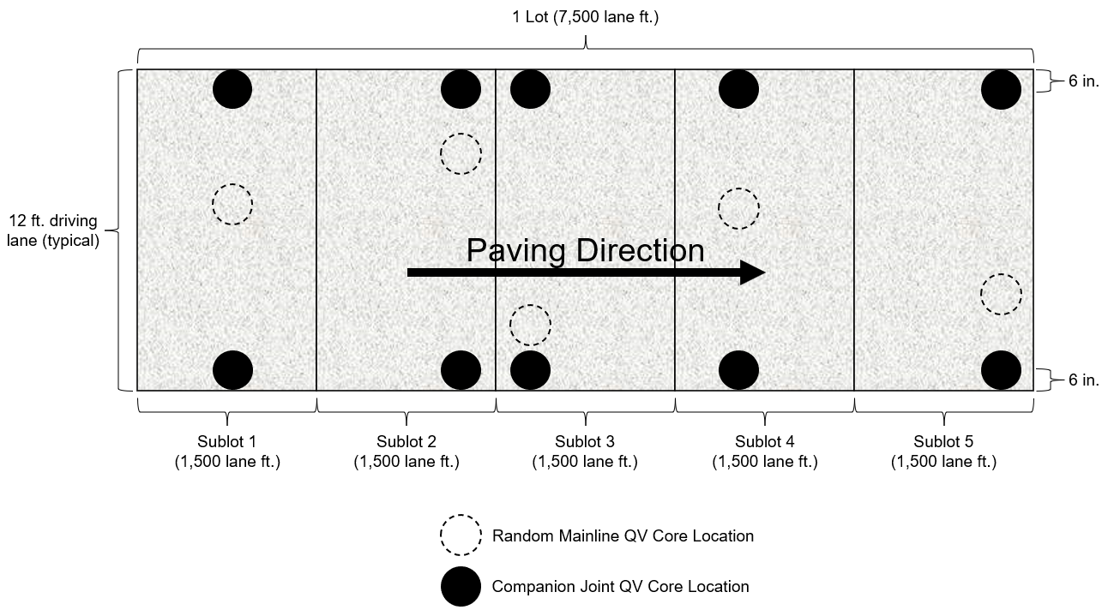

**Further Explanation of *PAY ADJUSTMENT FOR HMA PAVEMENT LONGITUDINAL JOINT DENSITY* Table**

|  |  |  |  |  |  |
| --- | --- | --- | --- | --- | --- |
|  | **Confined** | | | |  |
|  | **Lower Layer (On Base)** | | **Upper Layer** | |  |
|  | **LT/MT** | **HT** | **LT/MT** | **HT** | **Pay Adjust** |
| Mainline Target (SS 460-3) | 91.0 | 92.0 | 93.0 | 93.0 | - |
| Confined Target (mainline - 1.5) | 89.5 | 90.5 | 91.5 | 91.5 | - |
| Equal to or greater than +1.0 | > 90.5 | > 91.5 | > 92.5 | > 92.5 | $0.20 |
| From 0.0 to +0.9 | 90.4 - 89.5 | 91.4 - 90.5 | 92.4 - 91.5 | 92.4 - 91.5 | $0 |
| From -0.1 to -1.0 | 89.4 - 88.5 | 90.4 - 89.5 | 91.4 - 90.5 | 91.4 - 90.5 | ($0.20) |
| From -1.1 to -2.0 | 88.4 - 87.5 | 89.4 - 88.5 | 90.4 - 89.5 | 90.4 - 89.5 | ($0.40) |
| From -2.1 to -3.0 | 87.4 - 86.5 | 88.4 - 87.5 | 89.4 - 88.5 | 89.4 - 88.5 | ($0.80) |
| More than -3.0 | < 86.5 | < 87.5 | < 88.5 | < 88.5 | REMEDIAL ACTION |
|  |  |  |  |  |  |
|  | **Unconfined** | | | |  |
|  | **Lower Layer (On Base)** | | **Upper Layer** | |  |
|  | **LT/MT** | **HT** | **LT/MT** | **HT** | **Pay Adjust** |
| Mainline Target (SS 460-3) | 91.0 | 92.0 | 93.0 | 93.0 | - |
| Unconfined Target (Mainline -3.0) | 88.0 | 89.0 | 90.0 | 90.0 | - |
| Equal to or greater than +2.0 | > 90.0 | > 91.0 | > 92.0 | > 92.0 | $0.20 |
| From 0.0 to +1.9 | 89.9 - 88.0 | 90.9 - 89.0 | 91.9 - 90.0 | 91.9 - 90.0 | $0 |
| From -0.1 to -1.0 | 87.9 - 87.0 | 88.9 - 88.0 | 89.9 - 89.0 | 89.9 - 89.0 | ($0.20) |
| From -1.1 to -2.0 | 86.9 - 86.0 | 87.9 - 87.0 | 88.9 - 88.0 | 88.9 - 88.0 | ($0.40) |
| From -2.1 to -3.0 | 85.9 - 85.0 | 86.9 - 86.0 | 87.9 - 87.0 | 87.9 - 87.0 | ($0.80) |
| More than -3.0 | < 85.0 | < 86.0 | < 87.0 | < 87.0 | REMEDIAL ACTION |