Public Involvement Handout

(Highway)
(Municipal to Municipal)
(Specific Project Termini)
(County)

Project ID: (6110-26-00)



Handout date: Month Year
This handout and other items are available on this project’s design website at
Website URL here (Check link before sending for review)

Thank you for your interest in this project. We look forward to your feedback.

Purpose of handout
The Wisconsin Department of Transportation (WisDOT) is in the process of developing plans for proposed improvements on xx miles of xxhighwayxxx in XXX County The purpose of this handout is to provide information regarding the proposed improvements, describe the potential impacts it would have on the community, and offer an opportunity for public comment.

Public input/comments
Your comments assist us in developing a project that will serve the needs of the traveling public
as well as the needs of the local community and are welcomed and appreciated throughout the design process. Included at the end of this handout, as well as on the project website, is a comment form that may be used for written comments regarding the proposed improvements. You are encouraged to fill out this form and return using the pre-paid mailer attached. Comments may also be submitted via email or phone to any of the contacts listed below.

Project location
xHighwayx from xterminix in/near xcity/village/townx to xterminix in/near xcity/village/townx in XXX County. Please include location map. Map can be centered without text wrapping or left with text wrapping to the right (Example below)
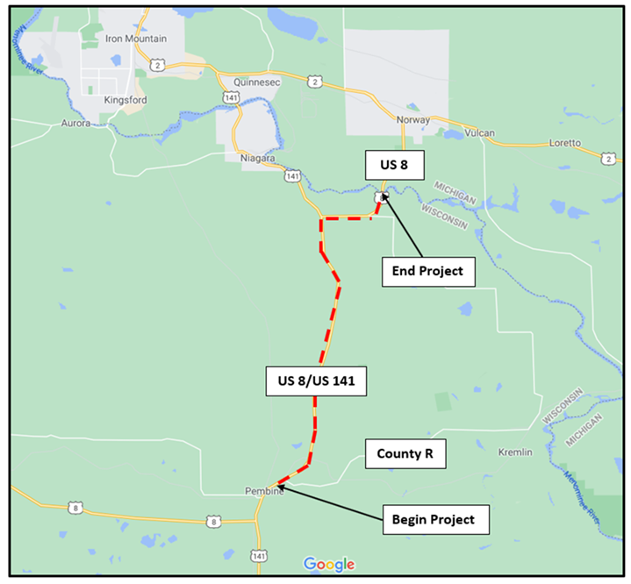
Project purpose and need
Deteriorating pavement/cracks/bad rebar/safety concern/failing culverts.

Anticipated benefits
Please be specific as possible with the benefit of the project’s various proposed improvements that people can identify with. Examples of benefit language: Provide motorists with a smoother riding surface resulting in less wear on vehicles, extend life of pavement, decrease maintenance costs, improve safety for drivers/pedestrians with wider shoulders, eliminate need for future maintenance costs saving taxpayer dollars in the future… etc. If you’re having problems with benefits, give your RCM a call.

Proposed improvements
This is a XXX-level project. Proposed improvements include:

Please use bullet points
- X
- X
- X
- X
- X

Traffic impacts
Copy or bullet points are fine. If you know the detour, please consider adding visual/image.

Schedule
- More PI?
- Environmental document?
- Project design?
- Other?
- Final Design: 20xx
- Construction currently scheduled in 20xx
  - Could be advanced to 20xx if funding becomes available
Real estate
Note if FEE/TLE or no R/E required. Note member of real estate team will contact affected property owners.

Business Resource: WisDOT’s In This Together program
WisDOT recognizes businesses located in work zones or impacted by detour routes have special needs. WisDOT's In This Together program is offered to business, organizations and community leaders as an idea source as they plan for road construction in their area. It includes promotional examples, case studies and a specially designed Business Coordination Guide with information on:
- Planning ahead
- Keeping customers informed
- Tips for businesses
- Temporary business signing during construction
  - Businesses impacted by highway closures and detours will have an opportunity for temporary business signage during construction.

WisDOT’s In This Together website is located at www.wisconsindot.gov/Together.

Public input/comments
Please submit comments to WisDOT using one of the following methods so that we receive them by the comment date to be consider during design.
- Fill out the comment form attached to this project handout and mail to WisDOT.
- Email comments or questions to the contact listed below.
- Call the contact below.

Project contact
Name, title or position
Wisconsin Department of Transportation
944 Vanderperren Way
Green Bay, WI 54304
Phone:
Email:

NOTE TO PROJECT STAFF OR CONSULTANT CREATING HANDOUT

***** HANDOUT MUST BE AN EVEN (2,4,6,8) NUMBER OF PAGES****
If the handout ends on an odd page number, simply create a blank page and put
“Page intentionally left blank”

***Document creators and editors must ensure the comment form is aligned in the middle for correct folding and US mail***

Delete this orange copy before aligning Comment Form

WisDOT Highway Project Public Comment Form

Project ID (xxxx-xx-xx)
(Project Name or Roadway)
(Project Termini or Construction Location)
(Name of County) County

Please place this form in the comment box or mail by (Date) to the address on the back of this sheet. Comments can also be e-mailed to (E-mail Address). Your comments assist us in developing a project that will serve the needs of the traveling public as well as the needs of the local community. Your input is welcome and appreciated throughout the design process.
Name: _____________________________________________________________

Address: ___________________________________________________________

Daytime Phone Number (optional): ______________________________________

Email Address (optional): ______________________________________

Please Print Comments (attach additional sheets if necessary)

The information in this document including names, addresses, phone numbers, e-mail addresses, and signatures is not confidential and may be subject to disclosure upon request, pursuant to the requirements of the Wisconsin open records law, sections 19.31 - 19.39 of the Wisconsin Statutes.

