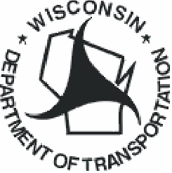 | Wisconsin Department of Transportation, SE Region Office  141 NW Barstow Street  Waukesha, WI 53187  Attn: WIS 181 Project Manager

First Name, Last Name
Street Address
City, State, Zip

Notice of North76th Street Public Meeting
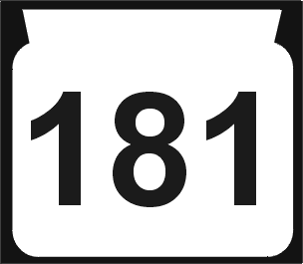
4 – 6:30 p.m., Tuesday, October 25, 2005
Uihlein Soccer Park - Meeting Room
7101 West Good Hope Road
Milwaukee, WI

Who: WisDOT

What: Conducting a public
meeting for WIS 181

Where: Uihlein Soccer Park,
7101 W. Good Hope Road

When: Tuesday, October 25,
2005 from 4-6:30 pm

Why: To give residents an
opportunity to comment
on plans and proposals
for North 76th Street
The Wisconsin Department of Transportation (WisDOT) is preparing plans for road reconstruction of N. 76th Street (WIS 181) between Florist Avenue and West County Line Road. WisDOT is conducting a Public Information Meeting to show the proposed improvements, location of right of way needs, construction staging plans and aesthetic improvements.

This is an opportunity for you to offer comments that will help shape the future of the North 76th Street corridor.

- Questions? Contact: David Barth, WisDOT Project Manager
1-800-238-5575 or david.barth@dot.state.wi.us

- Check out the project Web site at www.dot.wisconsin.gov/projects/se.htm

The meeting will have an open house format – the public is welcome
to attend at their convenience.

