**TRAFFIC CONTROL TECHNICAL COMMITTEE (TC²) MEETING MINUTES**

# 9:30 AM – 11:00 AM

# August 23, 2023

TEAMS

1. **Introductions**
2. **New Topics**
   1. **Work Zones**
      1. Connected Devices in Work Zones
         1. Many discussions at ATSSA over the last few years about connected devices.
         2. WisDOT is currently publishing a work zone data exchange feed with planned events. When we start to use connected devices, we will then provide real-time information about work zones to make them safter for the workers and traveling public.
         3. Connected Devices/Arrow Boards. Existing arrow boards can be retrofitted or can be purchased new. [See brochure](https://www.atssa.com/Portals/0/Tech%20and%20Innovation/Resources/ConnectedArrowBoardFlyer.pdf)
         4. Proposal to use on SDD 15D12 with only one arrow board.
         5. Brain DuPont asked if there will be additional tasks for contractors to do.
            1. No extra steps for the arrow board.
            2. Additional step to turn location markers on at the Road Work 1 Mile and Road Work Ends Signs.
         6. Products will be added to the APL.
         7. Also testing only 1 arrow board instead of 2. Similar to national standards.
            1. Brain DuPont asked if 1 or 2 would be used if it is not connected.

For 2024 we will still have both

For 2025 we would like to have only 1 arrow board and it should be connected.

* + - * 1. No concerns stated from contractors.
    1. Digital Speed Limit Trailers
       1. Testing about 10 projects in 2024. Dynamic speed limits are not allowed in Wisconsin so instead using the digital option. 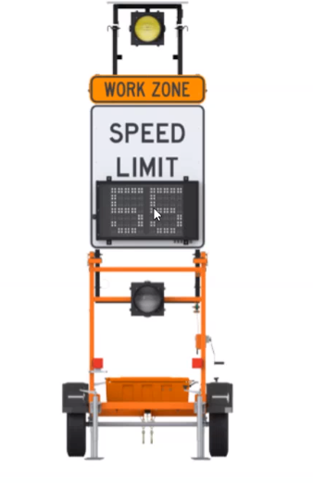
       2. Several projects will have digital speed limit signs that work together.
       3. Signs spaced every 1 mile.
       4. Matt Grove asked - Does this affect the enforceability of speed by law enforcement?.
          1. No, these are enforceable by law enforcement
       5. Looking to add more speed trailers to the APL.
       6. Tim from BFS - More connected devices are going to cost more money which is fine if it is safer. We just all need to be on the same page.
    2. Drums vs. Barricades in lane closure reassurance
       1. On our SDDs we have a note to use Type 3 barricade every ¼ mile or 1000 feet depending on roadway. Through inspections WisDOT has seen knockdown, missing, wrong direction. Would it be easier to have 3 drums every 1000 feet instead of a barricade? Still would require a lane closure barricade at beginning and after intersections.
          1. Tim Lampman said that the contractors are still going to move them because it is in the way. It will just get moved to the drum line. It doesn’t matter what you do the contractor will not reestablish it.
          2. Brian DuPont thinks a barrel has a bigger visual impact than a barricade. He feels it is safer than the barricade.
          3. Mega agreed that drums are easier to move. Contractors tend to put barricades back without the based which is worse. Drums are weighted which is safer.
          4. Amanda stated other states use drums but have it at 1 or 2 drums instead of 3. It allows more room for trucks to drive through.
          5. Tim stated that lack of knowledge is the problem. The general everyday person does not know what the chevrons mean, but we need to teach the contractors/inspectors to do it correctly. Lots of jobs have maintenance issues and lack of documentation.
          6. Most likely the 2025 timeframe.

Mike asked why does it takes so long to make a change.

Publication won’t happen until November. Then it will take 3 more months to get into a PSE. Then 3 months from PSE and LET.

* + 1. Driveway Assistance Devices
       1. Limbo period that the next MUTCD will have driveway assistance devices. It is in as a interim approval in the new MUTCD otherwise a Request to Experiment will be completed. Michigan is using these as a standard. WisDOT is looking at using these. They help control driveways within a signal corridor. It is synced with the signal heads. Looking at 5 projects in 2024.

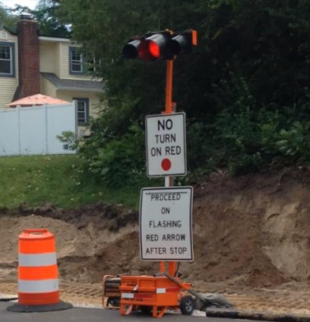

* + 1. 2025 spec updates
       1. Andy is working on 2025 spec updates to 633 and 644. Mostly are minor to address
          1. Repairing pavement surface
          2. Temporary ped accommodations repairs
       2. Create a PCMS committee to discuss how we want to handle it.
          1. Tim Lampman
          2. Nick from Mega Rentals
          3. Lance Mauel
    2. Proper PPE
       1. Reminder to always were proper Personal Protective Equipment. Class 2 or 3 ANSI/ISEA 107-2004 Type R shirt.
       2. Matt Grove asked for the document to send out to everyone.
    3. TMA Hits
       1. We were awarded a SMART Grant for ATMA’s to pilot these with county pavement marking operations. We are going to do an evaluation with the hopes of implementation in the future.
       2. Please send any TMA Hits to Erin Schwark so we can keep track of it to stress the importance and need for these devices in WI.
  1. **Pavement Marking**
     1. 2023 Temporary Markings Findings
        1. Interns are out running data.
        2. Century added to make sure to double check retrace projects.
           1. Jeannie added that we are going through the data now. And if data is off and width is greater than 4” we will verify retro readings.
     2. Using Black Epoxy to cover up markings
        1. MUCTD Section 6F.77 “Painting over existing pavement markings with black paint or spraying with asphalt shall not be accepted as a substitute for removal or obliteration.”
        2. Matt will add it to the next design teleconference that this is not acceptable.
  2. **Other**
     1. Work Zone Awareness- Appreciate what Erin and group has done has really helped. And would like to continue this effort.
     2. STH 29 by Abbotsford that say about 40 ducks were knocked down. They started to replace, and the project staff found out that the DOT officials were in the area and they could not complete the work. We do not want to be sending this message. Nick would like to make the DOT aware of this event.
        1. Erin will follow up with Nick on this item.
     3. SE region PSA will be coming up September 7th. Erin will share once the details are finalized.
     4. Mike said with 6” coming November. When will they not be SPVs. Starting in November it should be standard items.
     5. Tim L said that some projects are using one sided barricades. Andy will follow up on that.
     6. NW region is having a work zone safety event 8/24 at the Eau Claire Co Highway Shop at 1 PM.
     7. Amanda had difficulty UUSIC has been very behind on Digger Locates. ½ the jobs are not done marking signs. Engineers are waiting until 1 day before and that is not enough time to get diggers in to locate. Matt will add it to the meeting next