Project ID _________________ Parcel # _______

CREATION AND NOTIFICATION PROCEDURES FOR SURPLUS LANDS AND ACQUIRED IMPROVEMENTS

READS Entry
*This allows the system to notify the correct team members and to input the data later into the land inventory.
_____ Confirm all screens in READS parcel are filled in.
*See addenda for key information that is transferred.

Create Offer
*The agency must offer to purchase all uneconomic remnants.
*Creating the offer in READS allows the agent to make the appropriate offer. It will also ensure the proper information is transferred into the land inventory.

_____ Create an Alternate Offer in the Offer/Negotiation Screen
_____ If the entire parcel is being acquired, select Alternate Offer A
_____ If only portions of the remainder are being acquired as uneconomic remnants, select Alternate Offer B
_____ Offer is based on Existing Offer 1 – Offering Price.
_____ In the Allocations screen, add new and select Remnant. Add the size and value of the remnant. The BTS review appraiser will verify that information.
_____ Notify the BTS review appraiser that the region is requesting an alternate offer be approved.
_____ Request an email be sent to you after the offer is approved.

Generate Forms
_____ Generate Alternate Offers to Purchase (RE1975) in Reads Offer/Negotiation Screen (Documents tab).
_____ Enter your name in “compiled by”
_____ Select Alternate A or Alternate B
_____ Verify information is correct or revise.
_____ Explain reason for purchase of remnant. Provide as much detail as needed for a quality control analyst to understand.
_____ Describe support for purchase. Typically, this is the appraisal, but may include other factors.
_____ Generate the Property Improvements / Remnant Report (RE1961) in Reads Offer/Negotiation Screen (Documents tab).
_____ This form should be provided to the property owner at Initiation of Negotiations
_____ Generate the Property Inventory / Disposition Report (RE1949) in Reads Offer/Negotiation Screen (Documents tab).
_____ In the Word Document, list any improvements to be acquired. The rest can be left blank.
_____ Upload a copy to READS parcel log.

Close Parcel
*This informs property management of the surplus parcel and any improvements that must be razed or maintained. It also creates a surplus land parcel in the land inventory for future disposal.

Complete the following steps AFTER closing with the parcel owner

_____ In the Offer/Negotiation screen (Negotiation Details tab), click the Close Parcel button. A second screen will pop up.
_____ Enter the date of closing.
_____ Click on send notification emails
_____ If no improvements were acquired, there will be a link to notify the surplus land specialist about remnant. Click the link to send.
_____ If improvements were acquired, an option to email the property management specialist and an option to notify the surplus land specialist will be available. Click on each to send.
_____ Click close parcel
_____ A notification will pop up asking if you wish to create a land inventory record. Click ok.

Final Notifications
_____ At the top of the READS screen is a link to Property Management Land Inventory. Click on this link
_____ Enter the project id and parcel number into the search parameters. You should see a record of the surplus lands from the parcel.
_____ You should have received carbon copies of the email notifications sent to the property management specialist and/or surplus land specialist.
_____ Send an email to the property management specialist and/or surplus land specialist with the completed Property Improvements / Remnant Report (RE1961) and Property Inventory / Disposition Report (RE1949).

READS Entry

Items with a star are key components

Parcel Information Screen:
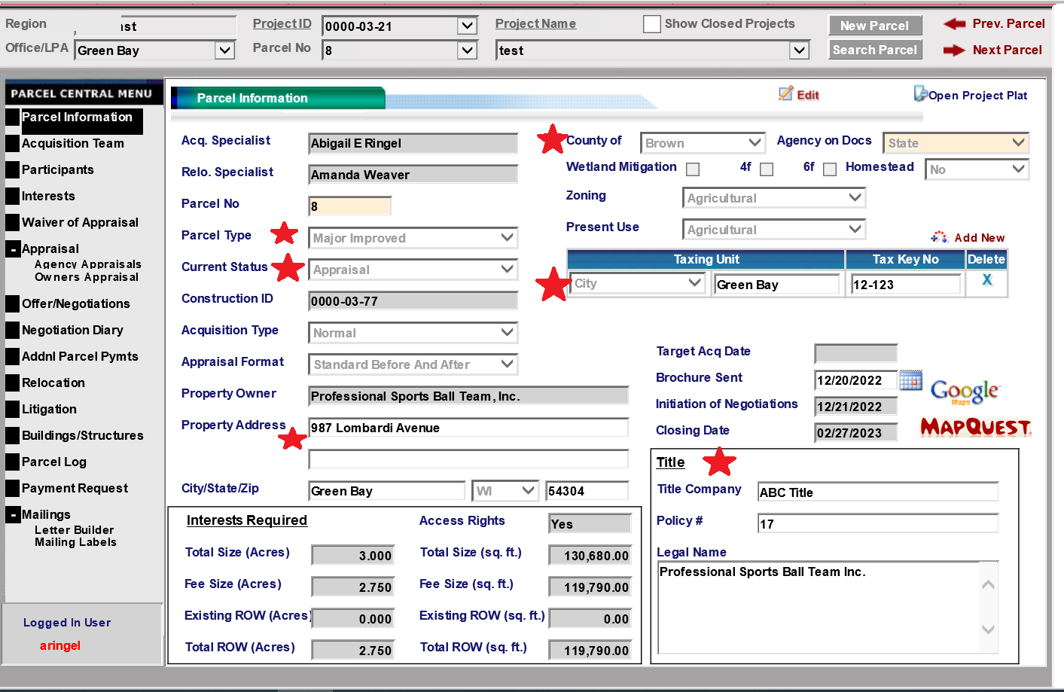

Back
Acquisition Team Screen

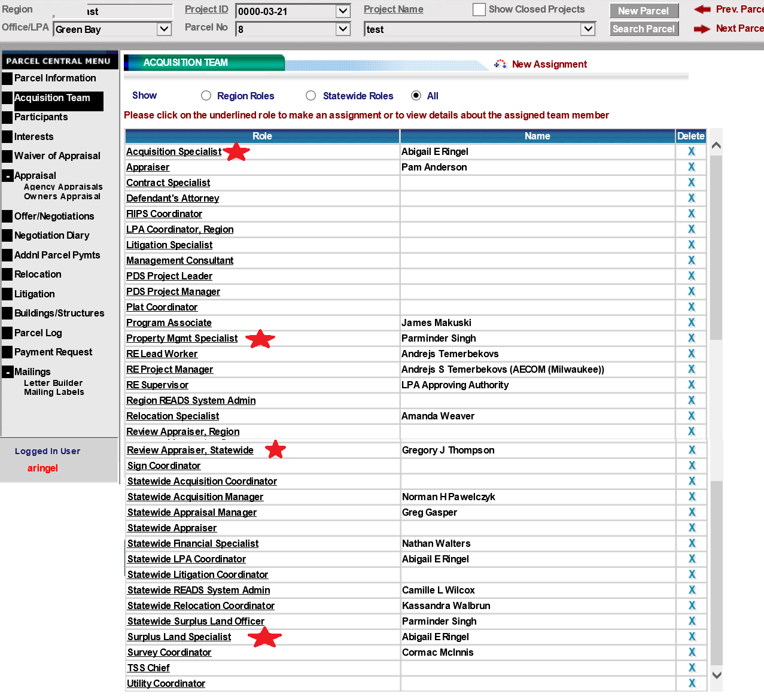
Back
Interests Screen

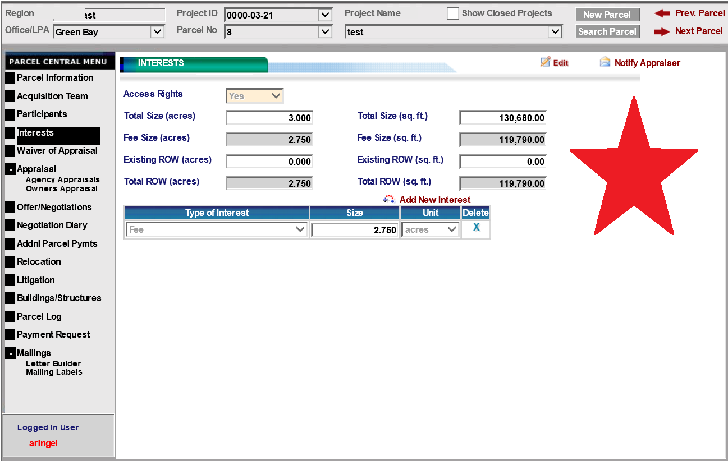

Back
Appraisal Screen

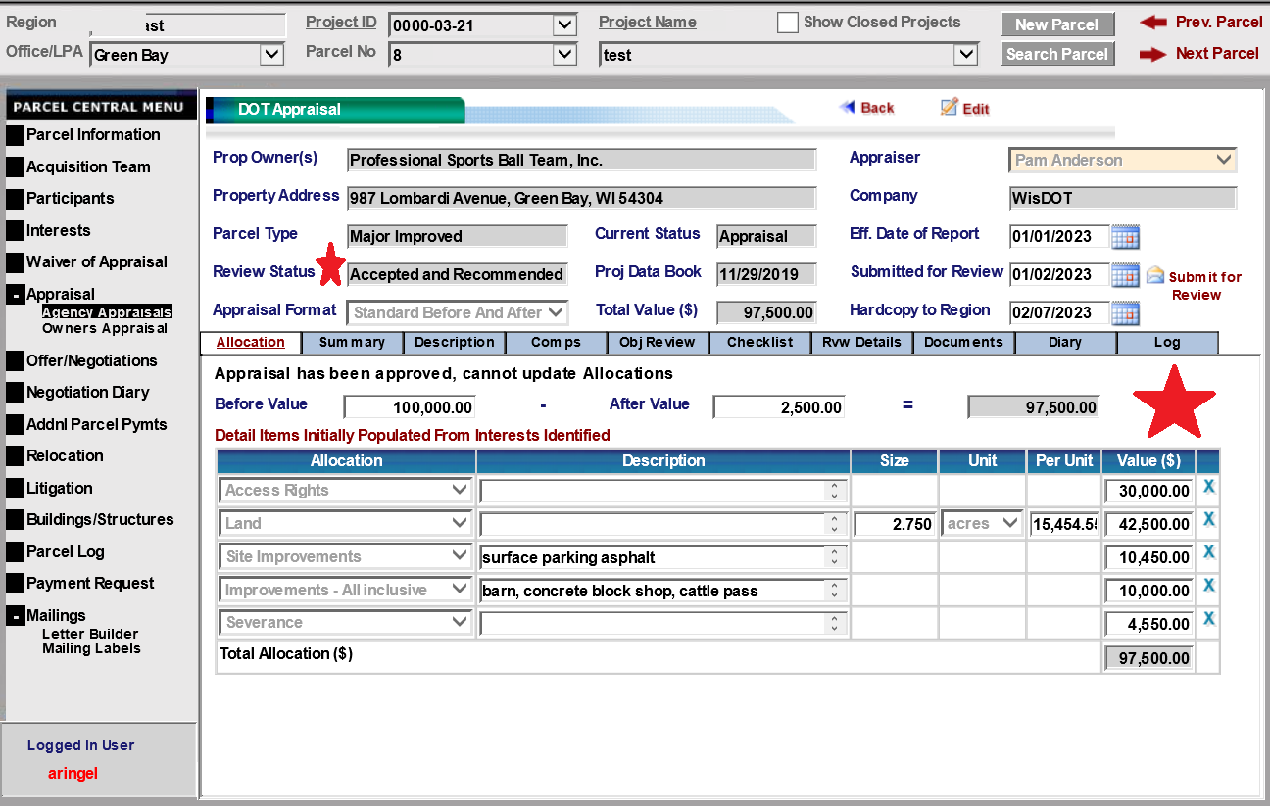
Back
Create Offer
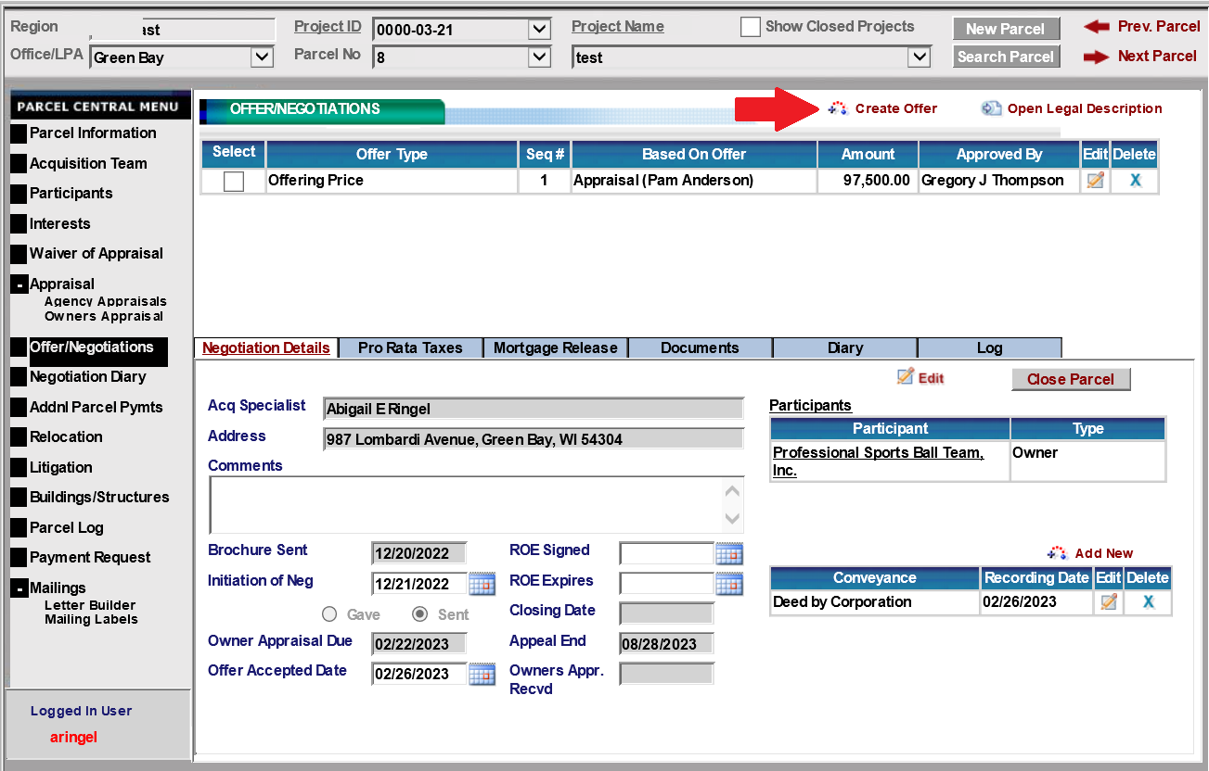

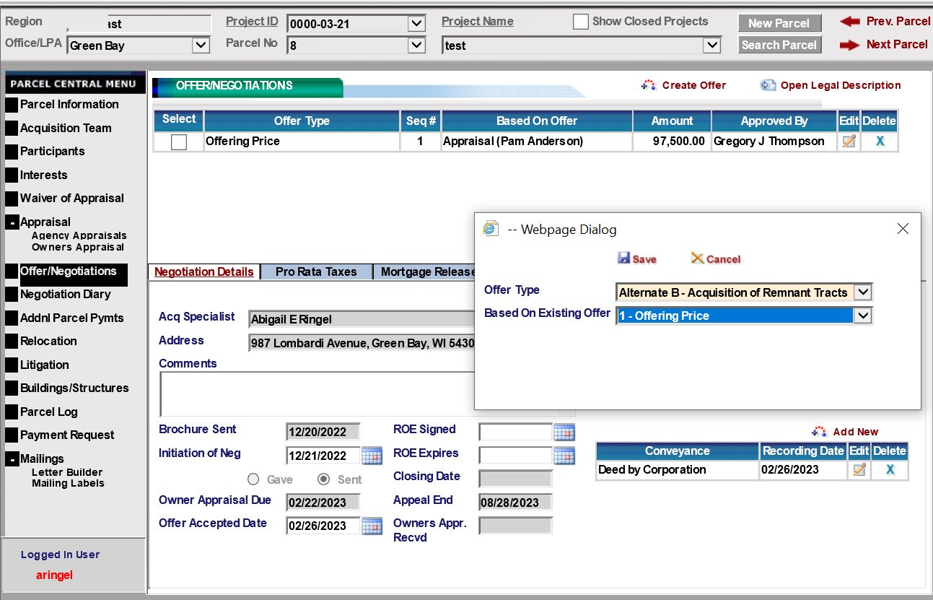
Allocation Screen

- Click “Edit” in Allocation tab”
- Select “Remnant”
- Describe remnant or remnant location on parcel.
- Enter REMNANT size
- Enter REMNANT value
- Click Save

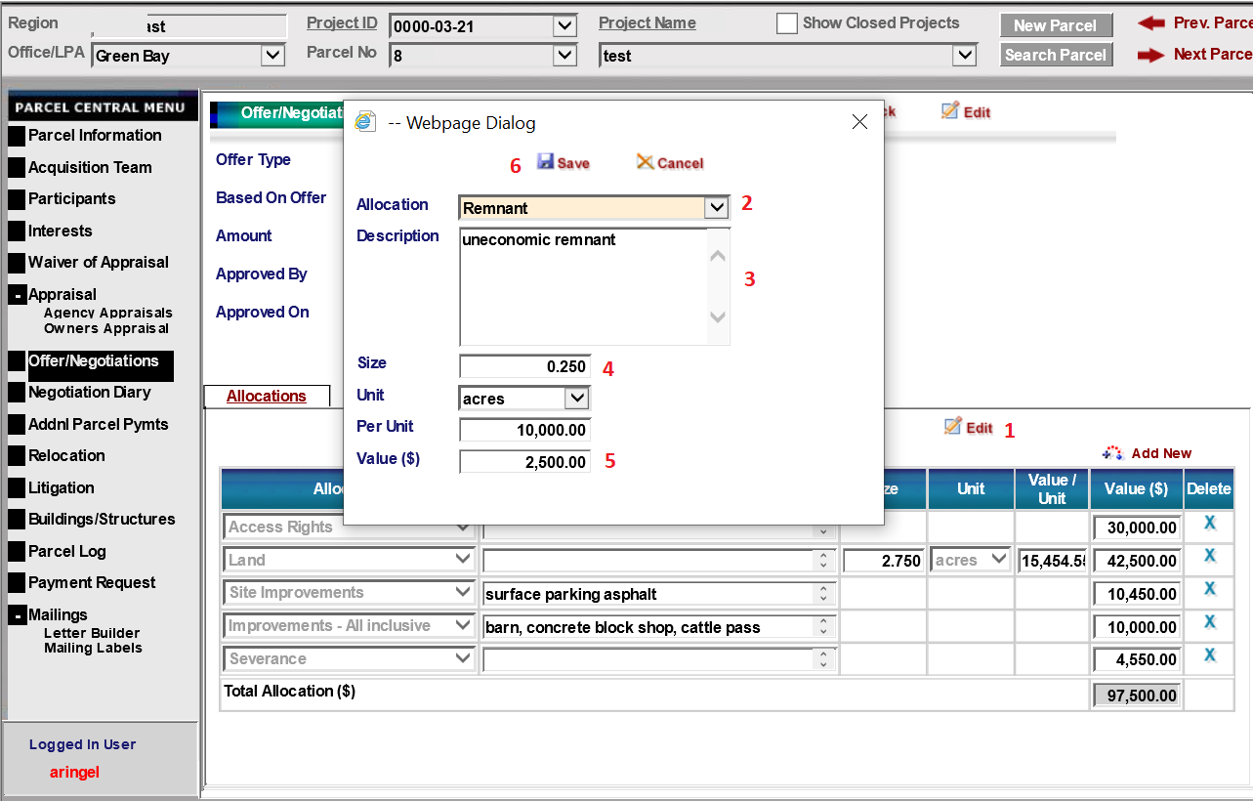

Back

Generate Forms

Alternate Offer to Purchase

- On Offer/Negotiation Screen (Documents Tab):
- Select “Alternate A or Alternate B”
- Click “Documents”
- Scroll to “Alternate Offers to Purchase (RE1975))”
- Click “Generate”
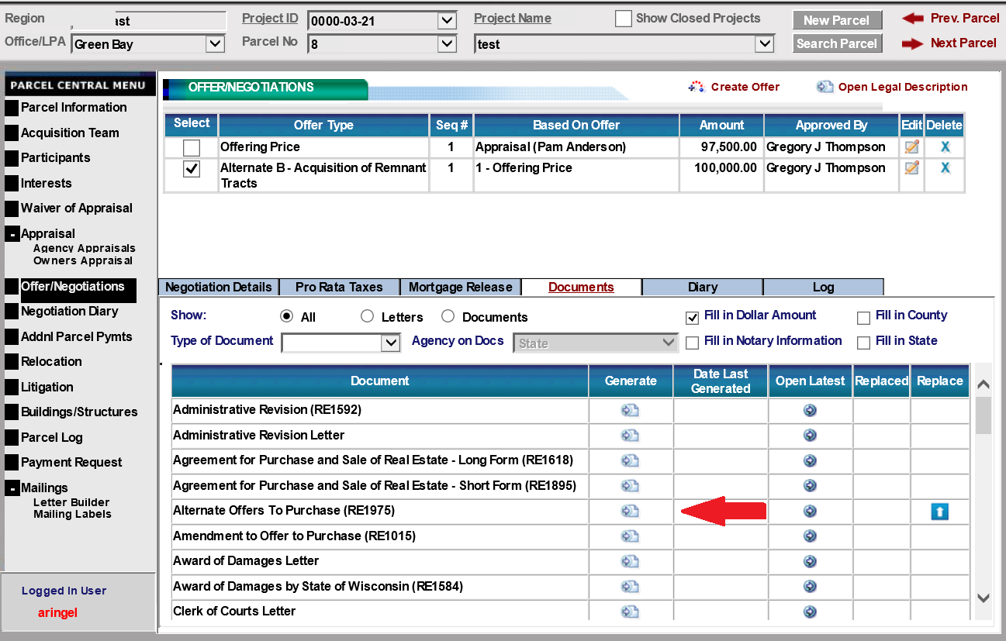

- Enter your name in “compiled by”
- Select Alternate A or Alternate B
- Verify information is correct or revise.
- Explain reason for purchase of remnant. Provide as much detail as needed for a quality control analyst to understand.
- Describe support for purchase. Typically, this is the appraisal, but may include other factors.
- Click “Generate Document”

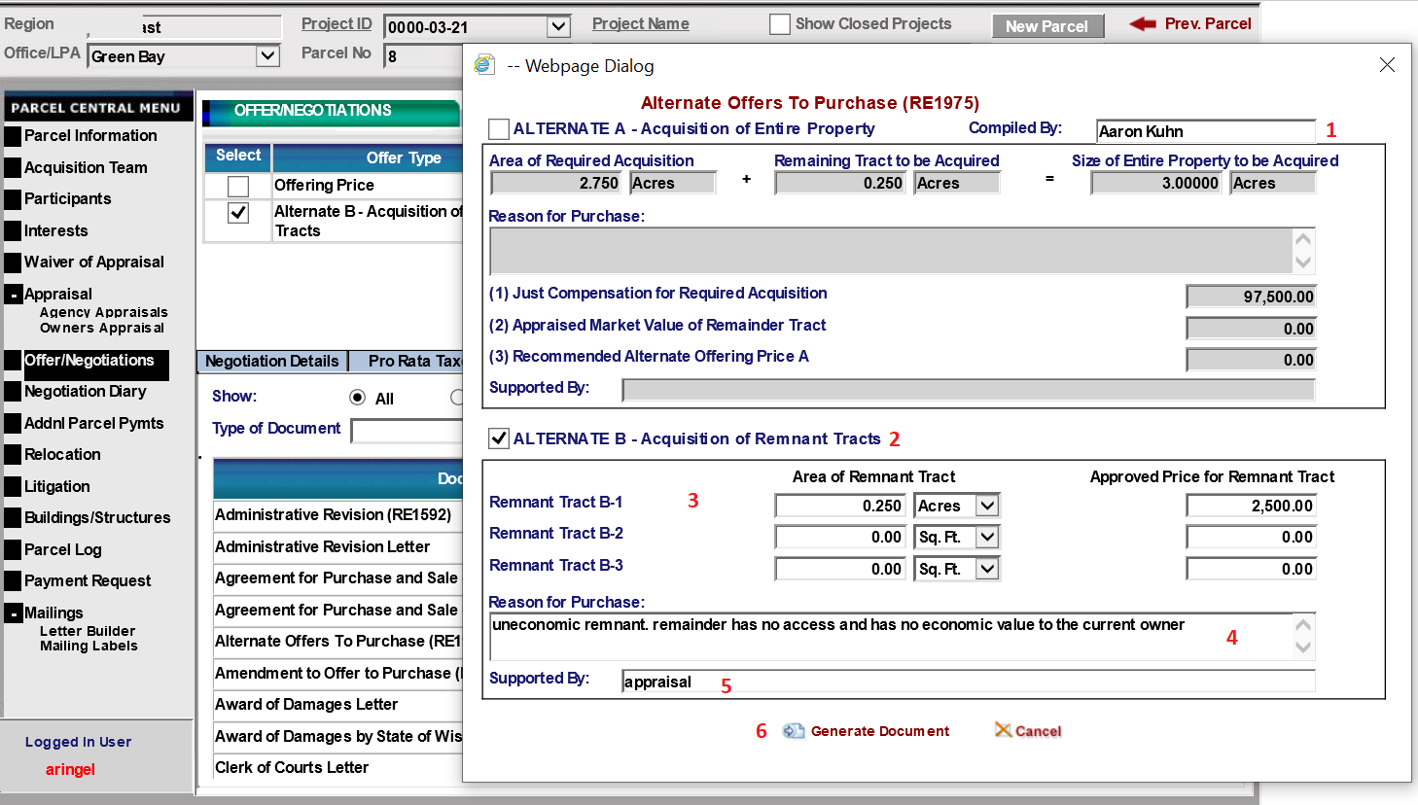Back

Property Improvements / Remnant Report & Property Inventory / Disposition Report (RE1949)

- On Offer/Negotiation Screen (Documents Tab):
- Select “Alternate A or Alternate B”
- Click “Documents”
- Scroll to “Property Improvements / Remnant Report (RE1961) & Property Inventory / Disposition Report (RE1949)”
- Click “Generate”

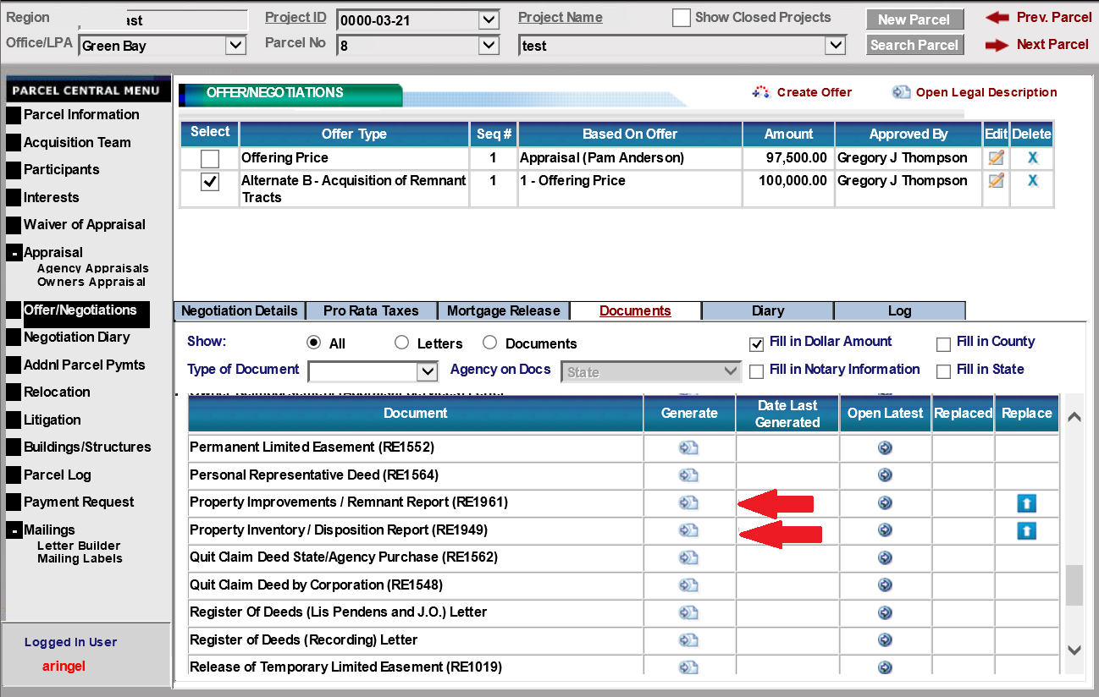
Back

SAMPLE PROPERTY IMPROVEMENTS / REMNANT REPORT
RE1961 01/2023

Improvements Retained by Owner |  |  |  |  |  |  |  |  |  |  | Retention Value
 |  |  |  |  |  |  |  |  |  |  | $
 |  |  |  |  |  |  |  |  |  |  | $
 |  |  |  |  |  |  |  |  |  |  | $
 |  |  |  |  |  |  |  |  |  |  | $
 |  |  |  |  |  |  |  |  |  |  | $
 |  |  |  |  |  |  |  |  |  |  | $
Retention Value: |  |  |  |  |  |  |  |  |  |  | $
Remnant Purchased: |  |  |  |  |  |  |  | Primary Land Use
 |  |  |  |  |  |  |  | Residential (single family)
Acres acquired |  | 2.75 |  |  |  |  |  | Residential (multi-family)
Acres required |  | 2.50 |  |  |  |  |  | Commercial
= Remnant |  | 0.25 |  |  |  |  |  | Industrial
 |  |  |  |  |  |  |  | Specialty (church, lodge, park)
Acquisition cost of remnant |  | $2,500.00 |  |  |  |  |  | Farm (non-residential)
When the owner has stated during negotiations that they want the Agency to acquire the uneconomic remnant and/or wants to retain improvements at the approved retention value(s) shown above, this agreement shall be executed prior to the time the conveyance is signed, or the Award of Damages is approved.

I want to retain the above-designated improvements at the indicated retention value, and I agree to remove the same from within the right of way acquired for the project by ; and, upon failure to do so, agree that said improvements shall become the property of the Agency, to be disposed of as the Agency deems necessary;

In the event, the acquisition is by Award of Damages, the following shall also be executed:

The land area designated as an "uneconomic remnant" be acquired by Award of Damages;

X |  |  |  |  |  | X 2/27/2023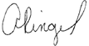
Owner Signature Date |  |  |  |  |  | Agency Real Estate Agent Signature Date
 |  |  |  |  |  | Abigail E Ringel
Print Name |  |  |  |  |  | Print Name
Agent/project manager (print name)  Abigail E Ringel |  |  | Date  2/27/2023 |  |  |  |  |  | Former Owner  Professional Sports Ball Team, Inc.
 | Project ID  0000-03-21 |  |  | Highway  HWY 123 |  |  |  |  |  | County  Brown |  | Parcel No.  8

Back

SAMPLE PROPERTY INVENTORY / DISPOSITION REPORT
RE1949 01/2023

List buildings, structures, etc., and items to be acquired with a description of size, construction, condition, etc. Submit with voucher for payment. |  |  |  |  |  | Estimated Sale Price
Wood barn  Concrete block shop  Cattle pass |  |  |  |  |  | $
Total number of buildings / structures / items to be acquired: three
The estimated sale/salvage/retention values were established in accordance with the provisions of the Wisconsin Real Estate Program Manual / Chapter 6.
Disposition of Buildings Acquired (submit upon completion of site clearance)
The buildings acquired were: |  |  |  |  |  | Specify Date
Sold amount $
Public sale
Private sale
Razed under construction contract
Razed under razing contract
Razed under county day labor contract
Razed/removed (other than above)
Agent/project manager (print name)  Abigail E Ringel |  | Date  2/27/2023 |  | Former owner  Professional Sports Ball Team, Inc.
 | Project ID  0000-03-21 |  | Highway  HWY 123 |  | County  Brown |  | Parcel No.  8

Back

Close Parcel
Select Close Parcel Button
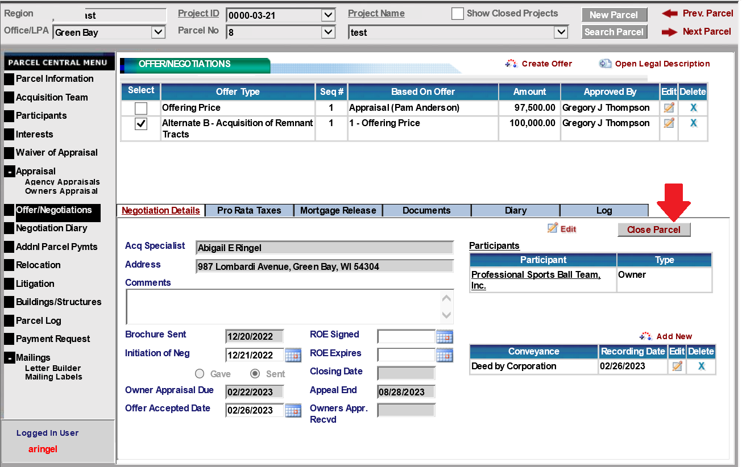

Remnant Acquisition Information
- Enter the date of parcel closing
- Click “notify property management specialist about structures”
- Click “notify the surplus land specialist about remnant”
- Click “Close Parcel”

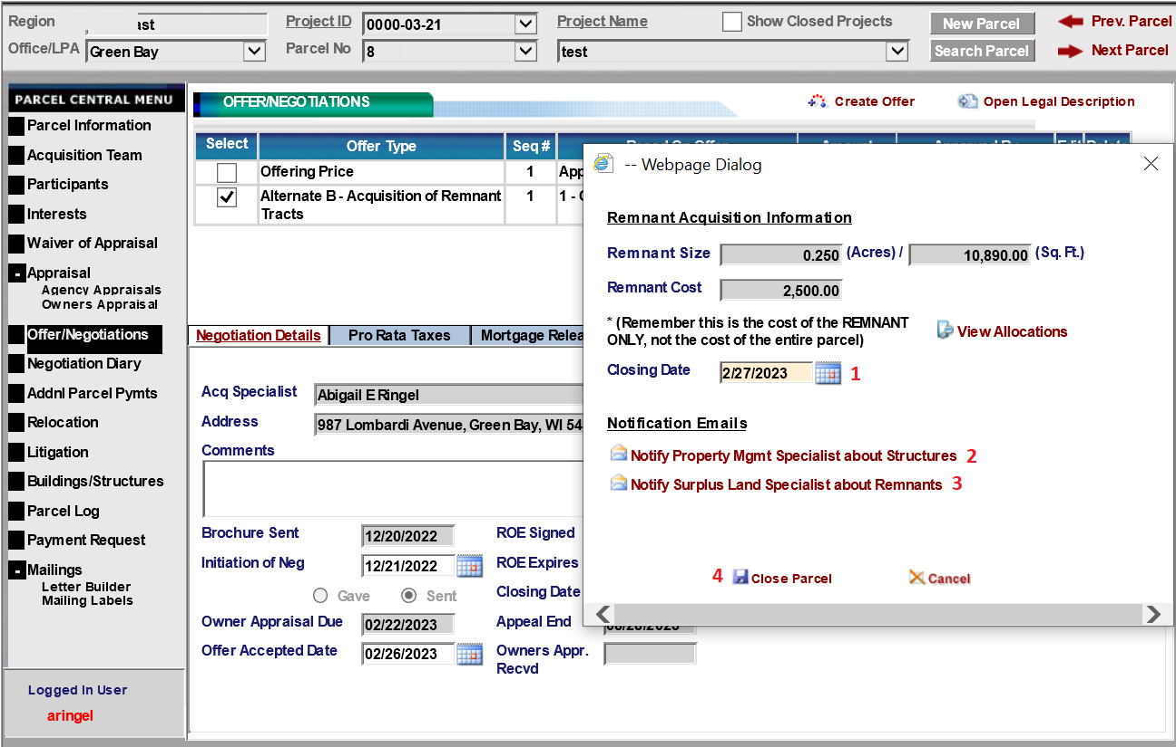
Back

Closing
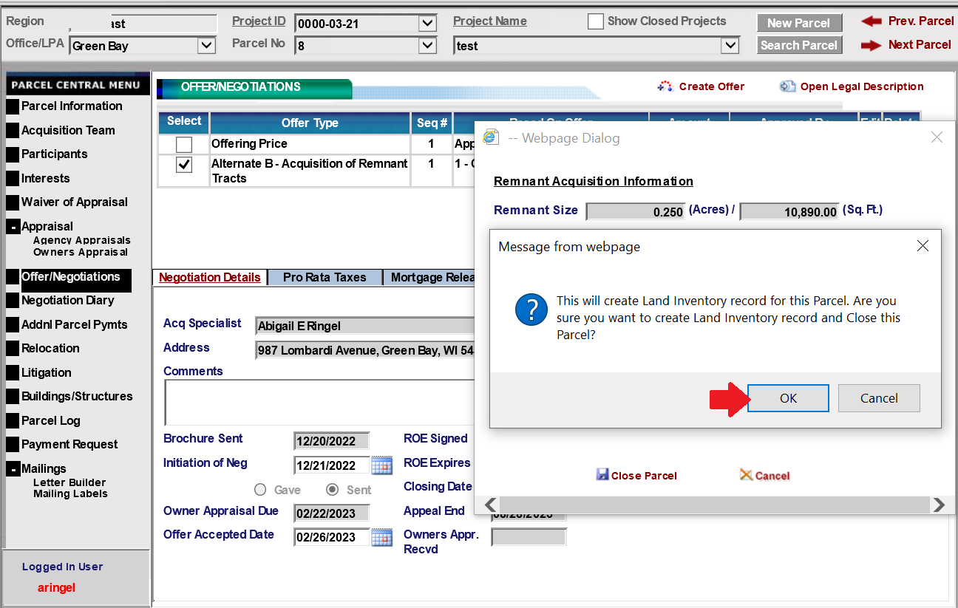

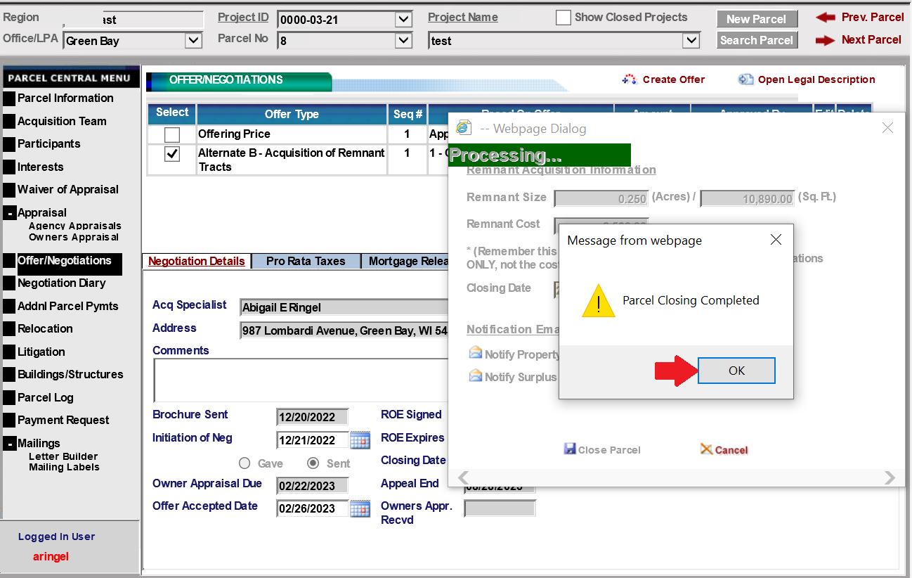
Back
Final Notifications

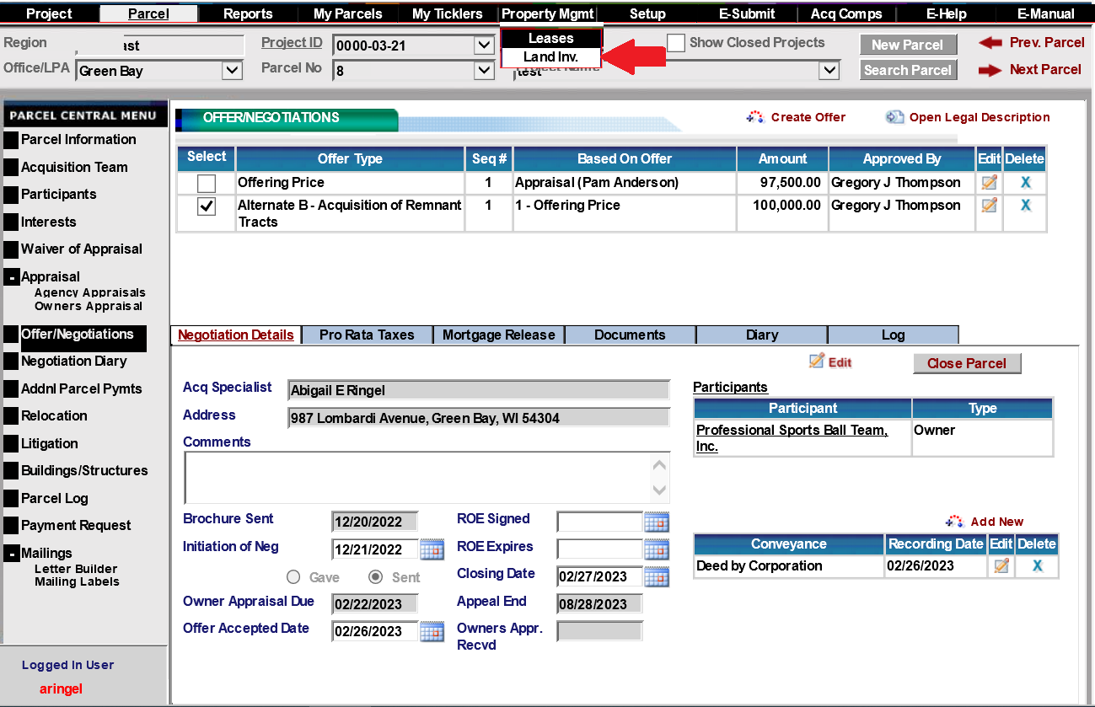

On Property Management Land Inventory Screen:
- Enter Project ID
- Enter Parcel Number
- Click “Refresh”
Surplus Parcel should be shown on screen.
Back

