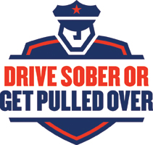 | Holiday  Drive Sober or Get Pulled Over  MEDIA OUTREACH  From the Wisconsin Department of Transportation (WisDOT)  Division of State Patrol  Bureau of Transportation Safety

Local news outlets play an important role in the success of the holiday Drive Sober or Get Pulled Over campaign. We rely on the media to help us educate the public about the consequences of impaired driving.

Television and radio messages about the dangers of impaired driving will be broadcast statewide starting December 13, 2023 and law enforcement agencies will begin stepped up enforcement on December 15. Although paid advertising is a major part of the enforcement strategy, it is also critical that you encourage local news outlets to help convey our message.

To help with media outreach efforts, the Wisconsin DOT Bureau of Transportation Safety created the following materials that you are encouraged to customize:

- Two sample (fill in the blank) news releases to announce your agency’s participation in this year’s crackdown and to report enforcement results after the annual initiative. (To meet weekly newspaper deadlines, you may need to submit your news releases several days before the publication date).

- Sample (fill in the blank) letter to the editor, which you may distribute along with or after the news release announcing your participation.

- Fact sheet, which may be distributed to the media or used as talking points for media interviews and other outreach events.

- Social media messages for outreach and engagement with your community.

These media materials are also available on the WisDOT website.

If you have any questions or comments, please contact your BOTS Regional Program Manager or Law Enforcement Liaison.

