WisDOT Design Model Implementation
Designer Task Force Report

Prepared by: Methods Development Unit,
Wisconsin Department of Transportation

September 17, 2014
Report Version 1.1

Table of Contents
Introduction 3
Design Model Content 4
Designer Task Force Activity 6
Designer Task Force Findings 8
Surface Model Detail 8
Preliminary Design Model Submittal 10
Identifying and Quantifying Level of Effort for Design Model Delivery 11
Extra work element characteristics 13
Glossary 14
Appendix A: Surface Model Diagrams 16
Appendix B: Preliminary Design Model Form 18
Report Attachment: Designer Task Force Estimates-2014-0917.pdf

Introduction
Wisconsin DOT is implementing design model content requirements on July 1, 2014. FDM 15-5-7 defines a design model as "the information extracted from the Civil 3D roadway design project data that fully defines the 3D geometry of a design effort." These design delivery requirements will affect projects with solicitation dates after July 1, 2014 or with FIIPS Life Cycle set to 11 after July 1, 2014. Affected projects are required to include all the traditional PS&E deliverables in addition to design models. The design model content requirements are in addition to the information included in the final design delivery, they do not remove any of the information traditionally included with a finished design.
Design models are intended to be used primarily by road construction contractors. WisDOT's Methods Development Unit (MDU) worked with the road construction contractor community in the fall of 2013 to develop design model content standards. Following design model content determination activity, MDU partnered with ACEC of Wisconsin to form a Designer Task Force, whose mission was to:
- confirm design model content requirements are understandable and achievable
- qualitatively identify additional work elements introduced by development and delivery of design models
- develop method of quantifying effort associated with additional work elements
- explore costs and benefits of delivering interim (30%, 60%, 90%) models
This report contains the results of the Designer Task Force efforts. In this report we will:
- review design model content
- review designer task force activities and findings
- discuss characteristics of additional work elements
MDU would like to thank ACEC of Wisconsin and the Designer Task Force volunteers for their contributions to WisDOT's design model implementation. Their willingness to share their thoughts, ideas, and practical experiences were critical to the development of these requirements.
Note the glossary at the end of the report. Modeling tools and processes are not the only things evolving, the terminology associated with these topics is not standardized. Some of these terms have very different meanings for different people. The glossary will help prevent misunderstandings of report content.

Design Model Content
This section is a summary of design model content as defined by WisDOT, and the reasons for requiring these objects and their file formats. The reader should refer to FDM 15-5-7 and FDM 19-10-43 for actual design model content requirements.
Surface Models (LandXML and Basic AutoCAD DWG): A design model contains surface models representing Top, Datum, EBS, Sub-bases, Pavement, Base Course, and Existing Ground. Details concerning the definition of each of these different types of surface models is found in FDM 15-5-7.2. Surface models may be directly used by contractors as the construction model in their AMG operations. In some instances contractors may supplement or modify the surface models in their process of developing their AMG construction model. Surface models will be delivered in 2 different formats, LandXML and AutoCAD DWG. LandXML format is nonproprietary and allows for quick and effective data transfer, however with the LandXML format there is some risk of the surface not importing into contractor software with triangulation identical to what is seen in Civil 3D. For this reason a Basic AutoCAD DWG file of the surface is also included in the design model package, the DWG file contains a graphical representation of the surface model exactly as it appeared to the designer in Civil 3D, and can be used by contractors as a check of their LandXML surface import.
Surface Outer Boundaries (Basic AutoCAD DWG): There will be a surface outer boundary delivered for each surface model in the design model package. The boundaries are included to help contractors eliminate unwanted external triangulation that can occur when surface models are imported into their software.
Proposed Surface Longitudinal Breaklines (Basic AutoCAD DWG): Longitudinal breaklines are a key component of surface definition for proposed roadway surfaces. Contractors who choose not to use the delivered surface models as their construction model for AMG can use the longitudinal breaklines to reduce the amount of work needed to develop their construction model.
Reference Line (LandXML): Also known as the construction reference line or horizontal alignment, the reference lines are required for all roadways in the design model that have elements of proposed work associated with them.
Reference Profile (LandXML): Also known as the profile or the vertical alignment, the reference profiles are required for all roadways in the design model that have elements of proposed work associated with them.
Superelevation Transitions (CSV): CSV reports of superelevation transition stations are required for all reference lines in the design model that have superelevation.
Right of Way and Easements (Basic AutoCAD DWG): Project right of way and easements linework will be represented as 2D polylines, and must be included for all areas of the project for which right of way location was established as part of the project's design process.
Proposed Roadway Features (Basic AutoCAD DWG): Features of proposed roadway represented by 2D polylines will include: proposed travel lane edges, shoulder pavement edges, shoulder edges, curbs, islands, sidewalk, barrier, and structures. Roadway features will be helpful in construction model development for those contractors who choose not to use the design model surfaces.
Existing Condition Mapping (Basic AutoCAD DWG): Also known as topographic mapping, existing condition mapping consists of 2D linework and points which represent features present on the existing terrain.
Metadata file (docx): inventory of design model files and their contents.

Designer Task Force Activity
The American Council of Engineering Companies of Wisconsin (ACEC) worked with WisDOT to form a group of experienced roadway designers which was called the "Designer Task Force". This group was made up of 3 designers from ACEC membership firms, 1 designer from a non-ACEC consulting firm, 4 WisDOT designers, and 2 MDU members. Autodesk contributed 3 members to the designer task force to participate in the workflow discussions and serve as technical resources. The full Designer Task Force membership was as follows:
- Fred Schunke, DAAR Engineering
- Benjamin Oitzinger, Gremmer and Associates, Inc.
- Jim Blackwood, R.A. Smith National, Inc.
- Christopher Dry , EMCS, Inc.
- Craig Ausen, WisDOT
- Brandon Schwenn, WisDOT
- Jacob Rosbeck, WisDOT
- Lance Parve, WisDOT
- Rick Larson, Autodesk Inc.
- Dave Simeone, Autodesk Inc.
- Mychal Brosamer, Autodesk Inc.
- Keith Sowinski, WisDOT MDU
- Brad Hollister, WisDOT MDU
The task force met 4 times from Jan 2014 to March 2014. The first meeting was a full day, in person meeting that:
- established task force goals, and planned activities
- reviewed design model content standards, and arrived at a consensus that the design model is achievable (can be delivered with the tools available today)
- began developing a list of extra work elements introduced by design model development
- determined the design model content standard needs more information regarding level of detail in surface models
Task force members were assigned homework at the first meeting's end. They were asked to continue building their list of the extra work elements and bring it to the next meeting. In addition, they were asked to develop a list of all the surface model level of detail questions they could think of.
The second meeting was held in webconference format, and lasted a half day. At the second meeting the task force reviewed the level of detail questions members had developed, and made decisions regarding surface model detail and content. The discussion on extra work elements continued also.
As Task Force members considered each level of detail question, they focused on the idea that the design model is intended for contractor use in AMG and staking operations. The decision criteria was to ask "is that information necessary for AMG operations given today's state of the practice". For example, one of the questions was "Do we need to accurately model intersection islands in the TOP surface?" The decision was NO, because that information won't be used in AMG operations for paving, earthwork, or base placement. The designer may still decide to include the islands in the TOP surface model though, perhaps to better convey design intent in the surface model and in the plan's cross section sheets. Or, the design process might require a 3D clearance analysis of over size over weight vehicles navigating an intersection, in which case the islands may need to be accurately modeled for that analysis. So from the design model perspective, the answer to the intersection island question was NO, but the task force could envision different scenarios where a designer would decide to include the islands in their surface models for design purposes rather than construction purposes.
The third Task Force meeting was also in webconference format, and lasted a half day. At this meeting the task force was able to complete the extra work elements list, and discuss the means of quantifying the list. The homework assignment following this meeting was to individually develop an estimate of hours for each extra work element, and be prepared to discuss the rationale used to generate estimates at the next task force meeting.
The fourth Task Force meeting was a full day, in person meeting. The focus of this meeting was the estimates of the extra work tasks. Because of heavy workload, two consultant task force members and two WisDOT task force members were not able to develop estimates of the tasks and chose not to participate in this final meeting. The remaining task force members who contributed estimate values to the extra work elements consisted of 2 consultant designers, 2 WisDOT designers, and 2 WisDOT MDU members. As the Designer Task Force talked about the extra work estimates, each person gained a better understanding of the different perspectives and rationale each person used in estimating the tasks. Each member made changes to estimates as a result of what was learned during the discussion. Some of the tasks started out with a wide variance of estimated hours values, and these values would pull closer together through the course of discussion. Individual final estimate values from the six task force members are found in the Designer Task Force Estimates-2014-0917.pdf document attachment accompanying this report. These values reflect the changes made as a result of the final Task Force meeting discussions.

Designer Task Force Findings - Surface Model Detail
Following is a compilation of the designer task force discussion about the appropriate level of detail for surface models. It is unlikely the FDM language regarding design model content will address every level of detail question project staff will be confronted with, so this section of the report will convey the thought processes used to determine whether or not a specific item needs to be represented in the surface models.
In general, 2 questions should be considered when considering level of detail questions.
- Will the item in question be utilized in contractors' AMG operations the way AMG is currently being used, or be used in contractor staking operations?
- Will exclusion of the item in question introduce the possibility of misinterpretation of design intent?
The item in question does not need to be represented in surface models if the answer to #1 is NO, and the answer to #2 is NO. Any other response to the questions above indicates the item in question should be designed into the surface models for the project.
As the task force talked about detail in surface models, it was decided to classify these objects into 3 categories: Yes, it is required; No, it is not required; and Optional. The optional classification indicates the item in question isn't required to be included in models, but designers may find there is good reason to model the object regardless, so the decision should be made considering project characteristics. When determining design model scope for a project, intent for optional object modeling should be defined.
Here is a summary of the designer task force level of detail discussion:
Staged Design Models: Sometimes referred to as 4D models, staged design models are representative of the sequencing of work as shown in the traffic control detail sheets, or other contract documents which contain construction staging information. Developing a staged design concept requires more work than developing an ultimate design concept. Whether or not the design should be developed in stages is a project decision to be made by project staff, staged design and/or staged design models are not mandated by design model content requirements. Developing design models for temporary roadways that will carry traffic is required however. Depending on project complexity, project staff may decide to develop a staged design delivery for the project. When staged design is chosen, design models can be developed to reflect the staging scheme. In these cases, contractors will get more value from an ultimate design model delivery than they will from the staged model delivery. Even when the contractor constructs the project using staging exactly as shown in the plan, most contractors will prefer the ultimate design model delivery over staged model delivery. They can easily use the ultimate models in their AMG operations, the staged models mean more surface models and more files in general - leading to potential for confusion with no benefit in return. When doing staged design for a project, if the ultimate design is being developed as part of the design process, the ultimate model delivery should be sufficient in all but the most complex of projects. There will still be benefit in developing staged design models, many types of model-based constructability analysis requires staged models. Staged model development benefits the design process, but does not benefit contractor's AMG operations. To summarize these thoughts on staged models:
- staged models are not required to be submitted by design model content standards
- staged design requires more effort than ultimate design delivery only
- complex projects may benefit from staged design and the development of staged design models, but it is the design process that benefits.
- Contactors do not need staged design models for their AMG operations, ultimate models are sufficient. Contractors generally prefer the ultimate model over staged models.
- If doing staged design, and ultimate models will be developed as part of the logical progression of the project's design process, the ultimate models should be delivered in the design model package. Project staff can decide whether or not staged models will be included in the design model package. It is acceptable to deliver ultimate models only.
- If doing staged design and ultimate models will not be developed as part of the logical progression of the design development, project staff have the authority to decide whether or not to expend the additional effort to deliver an ultimate design model in addition to the staged models. It is acceptable to deliver staged design models only, but not preferable.
Rural Driveways: Yes, rural driveways should be included in the design model, there should be a driveway surface model dedicated to showing the rural driveway's top surface. Rural driveways should be represented in the Top surface model.
Curb Ramps: No, not a requirement, but should be added in an optional details list. Curb ramps pass the 2 question litmus test and thus is exempted from surface models, curb ramp models will not be used in AMG operations. However, modeling curb ramps is worth consideration. There is an increased focus nationally regarding curb ramps and compliance with ADA requirements. WisDOT intersection detail plan sheets don't generally give the contractor enough information to guarantee construction will be ADA compliant, the roadway design may be compatible with an ADA compliant curb ramp construction, but the same roadway design may also be compatible with a non-ADA compliant curb ramp construction. Using the curb ramp modeling workflow in the WisDOT Civil 3D training to represent curb ramps accurately in Top surface ensures the contractor has enough information to build the curb ramps in compliance with ADA standards. Designers should consider these facts when deciding whether to model some or all curb ramps on their project.
Back of curb: The question was "Do we include a back of curb surface so it can be displayed on cross sections?" The answer is NO, not needed. Note: using a code set style that displays links or shapes from your corridor sections in your plan production section views will give you back of curb and other pavement structure graphics without the need to develop special surfaces.
Barrier wall transitions between height changes, etc.: No, not required. Note: the designer might opt to model these transitions correctly if in the designer's judgment the transition area of the model might affect sight distance analysis.
Median Noses: No, not a requirement. Should be classified as an optional detail.
Transitions between rural and urban sections: (meaning transition between curb and ditch section). No, not a requirement. Should be classified as an optional detail.
Retaining wall: The wall itself doesn't need to be in the model, but the earthwork around the wall should be modeled correctly, at least to the same level of detail as corridor frequency, plus special points like kinks in the wall, etc. Earthwork transitions at the ends of retaining walls will require design attention to model correctly.
Beam guard EATs: Yes. At a minimum these areas should be modeled correctly at corridor frequency plus the special stations identified in the standard detail drawing. There is a workflow for modeling earthwork at beam guard EATs in WisDOT's Civil 3D training.
Grading around Urban driveway behind sidewalk: needed in some cases, but maybe not all driveways. Should be classified as an optional detail.
What frequency should gore areas be modeled at?: 2.5 feet. This will be added to design model content requirements in FDM
Should frequency guidance be established for ponds and/or stormwater swales (not parallel to roadway)?: must capture key points of geometry in the Design Model, horizontal and vertical . not sure how else to capture in language of requirements. Second question is how to depict in the plan (are contours acceptable)
Modeling earthwork at culver inlet/outlets?: No, not required. Fine earthwork detail like this isn't likely to be used in AMG operations. Could be added to optional details list.
Slope rounding: No, not required.

Preliminary Design Model Submittal
WisDOT will require a preliminary design model submittal at the time of the 60% preliminary plan submittal. Preliminary design models will consist of 3 elements:
- Surface models - Civil 3D DWG
- Reference Lines - LandXML
- Preliminary Design Model Form signed and dated by the person primarily responsible for delivery of the design project (See FDM 15-5-7.3 or Appendix B)
Preliminary design models will not be used as part of the design review process, at least not initially. Instead, the requirement of a preliminary design model submittal is for the benefit of the designer. MDU has learned through experiences with the model sharing pilot program that if the roadway design workflow presented in WisDOT's Civil 3D training is followed, there is a good likelihood the design effort will result in a design model of acceptable quality. When designs have had trouble delivering design models, it typically has been because key elements of WisDOT's roadway design workflow were not adhered to. The preliminary design model form is a checklist of those key elements. Requiring the form to be reviewed and signed by the designer at the 60% stage of design development will stress the importance of these workflow elements in the designer's priorities. A mandatory process of preliminary design model submittal will help identify projects which are at risk of failing to deliver acceptable design models. By identifying these at risk projects at the 60% design complete stage, corrective measures can be taken with sufficient time remaining to correct the problems before final project delivery is due.

Identifying and Quantifying Level of Effort for Design Model Delivery
This report's attachment, Designer Task Force Estimates-2014-0917.pdf, contains a list of the extra work elements identified by the designer task force. The list of estimated hours based on the unit of measurement for the new tasks associated with 3D model delivery are the raw estimate values delivered by the Task Force members after the estimate discussion meeting. These values are not an estimate of the total work for the task, just the amount of extra work for the task that is introduced by design model development. Some tasks are listed in the attachment as not requiring additional effort. These tasks were placed in the worksheet as an indicator that the Task Force discussed them and identified them as work that is already being completed with the 2D design deliverable.
At the estimate discussion meeting the Task Force discussed these work elements, the different workflow options available to do the work, and some of the experiences of the Design Task Force members doing the work associated with a particular work element. Through the process of these discussions everyone gained a better understanding of the different perspectives and rationale used in estimating the tasks. Each individual made changes to some of their estimates as a result of what was learned from the others. Some of the tasks started out with a wide variance of estimate values, and those values pulled closer together through the course of the discussion. The estimates did not become identical though, there is still variance in the estimate values. The differences in values do not represent a range in project complexity, but instead, differences in opinion across the Task Force.
Design Task Force members used these assumptions while developing their unit estimates for extra work elements:
- Estimate values are the additional work design model development introduces into the design process, not the total effort for a given task. The comparison is between a traditional 2D PS&E delivery developed in Civil 3D and the new 3D delivery (with all the traditional 2D delivery items plus the Design Model content) developed in Civil 3D.
- The person doing the work is an experienced roadway designer.
- The person doing the work is an experienced Civil 3D user who is knowledgeable about WisDOT Civil 3D workflows and deliverables requirements. The intent of this Task Force assumption was to not include in the estimates the "learning curve" aspect of becoming familiar with Civil 3D and WisDOT's corresponding workflows. (MDU discussed this assumption after the Designer Task Force meeting activity was finished. We observed that although it is an appropriate assumption to make, the Designer Task Force members' estimate of hours values logically must reflect the estimator's current level of knowledge and proficiency in the use of Civil 3D and WisDOT workflows.)
- Estimate values are for a single iteration of the modeling work
- Extra work element is of average complexity.
MDU feels there is some risk that report readers might misinterpret the iteration assumption (letter d.). The roadway design process is inherently iterative, assumption d is not referring to the ordinary iterations of design improvement. Many designers have reported to MDU that the development of design models leads to faster iteration assessment and less iterations overall because of the quality of feedback provided by the design model. Furthermore, WisDOT designers' experiences indicate that the dynamic object relationships within Civil 3D allow designers to work through the ordinary iterations of design development in a more efficient manner than our past workflows in non-dynamic design systems. Rework associated with design iterations can be kept to a minimum by using proper workflow and leveraging the dynamic relationships established in Civil 3D.
The type of iteration intended for assumption d can perhaps be described better as design concept changes which require significant modifications to assembly structure or corridor structure to see the change in the model. A good example of design activity that would require modeling rework is changing the location of an intersection after the intersection design has been previously developed. Iterations of this type are difficult to forecast, and usually are easier to identify after they occur. For this reason MDU believes that in many cases it may be easier to deal with these iterations with design contract changes rather than including them in an estimate of design effort before design work starts. For iterations that do require additional modeling effort, it usually is not a doubling of the total effort for the task as often times the designer can salvage work that has been previously completed. In the moved intersection example, many of the assemblies and the corridor region structure can be reused, resulting in saved effort on the second iteration.
The recommended process for estimating the design effort for a project required to deliver design models is this:
- Develop a project estimate of the design effort for the traditional 2D deliverable, using the same estimating processes used in the past.
- Using the Designer Task Force Estimates-2014-0917.pdf, review each line item, considering whether or not each work element will be needed on the project. This decision is made by considering the scope of the project being estimated. Each project will not need all extra work elements, but every project with design model delivery will need some of these extra work elements.
- Based on what is known about the project scope, estimate a quantity for each extra work element identified as being needed on the project. Consider the necessity of the model elements – For example, not all curb ramps may need to be modeled. A project-specific decision should be made regarding which curb ramps, if any, are to be modeled.
- Considering the following factors, determine a unit estimate value (estimate of effort to do a quantity of 1) for each extra work element based on an appropriate level of effort for the project:
  - Unit estimate values of Task Force members, found in Designer Task Force Estimates-2014-0917.pdf
  - Extra work element repetition – Acknowledgement that as tasks with high quantities become repetitive, there are efficiency gains. It is possible to have values lower than the range indicated by the Designer Task Force.
- (design model extra work element estimate) = (unit estimate) * (quantity) * (design iteration factor)
- Add the design model extra work element estimate values to the appropriate tasks in the original 2D estimate. The results are a 3D design estimate for the project.
Note that some of the extra work elements require Civil 3D roadway design experience to properly quantify, forecasting the number of corridors to be used in the design is an example. If the estimator does not have Civil 3D design experience, mdu recommends working with an experienced Civil 3D roadway designer to generate estimate quantities.
Project complexity adjustments are built into the structure of work elements for those elements that are sensitive to changes in project complexity. An example is work element #1, Corridor and Refinement Surface Model Development. This work element is intended to capture the idea that 3D surface models contain more design detail than the traditional 2D plan sheets only. This detail must be developed by the designer, thus requiring extra design effort. The Designer Task Force felt that different improvement concepts lead to varying degrees of project complexity, and more complex projects will result in a higher level off effort to develop and refine the added design detail. So work element #1 was broken out into 10 categories of improvement concepts (1a through 1j), and categories were estimated individually be the Designer Task Force. Work elements that are not sensitive to changes in project complexity received a single estimate value. An example is element #9, Beamguard EAT Grading development.

Extra Work Element Characteristics
Upon review of the list of extra work elements identified by the Designer Task Force, MDU recognized the tasks could be categorized into two types:
- tasks that add meaningful engineering information and detail to the design concept
- tasks that exist only for the process of creating design model objects in Civil 3D or design model files in the required formats.
The project directly benefits from the work elements that add engineering information and detail to the design concept since this type of task will help prevent design issues that lead to unnecessary construction delays and costs. The other type of tasks could be viewed as overhead added to design effort by Design Model development, they don't improve the design concept yet they are a necessary step in the delivery of design models.
The reader may notice that in the attachment Designer Task Force Estimates-2014-0917.pdf, MDU identified which category each extra work element belongs to.

Glossary
3D Model: see Surface Model.
4D Model: collection of surface models sequenced in an order to represent construction staging.
ACEC of Wisconsin: American Council of Engineering Companies of Wisconsin members are designing and protecting Wisconsin’s future with professional engineering solutions. It is the only organization in the state that represents the business side of the professional engineering industry. ACEC WI represents 80 premier engineering firms, with more than 160 offices across Wisconsin and nearly 20 affiliate members that provide support to the industry. Founded in 1958, ACEC WI supports member firms that employ more than 3,700 engineers, architects, planners, geologists, soil scientists, hydrologists, surveyors and other professionals.
Assembly: typical section object in Civil 3D corridor design.
AutoCAD DWG: also referred to as 'Basic AutoCAD DWG', it is the native file format used by AutoCAD, consisting of AutoCAD elements only (lines, arcs, polylines, etc.)
Automated Machine Guidance (AMG): Automated Machine Guidance (AMG) links sophisticated software with construction equipment to direct the operation of machinery with a high level of precision, improving the speed and accuracy of highway construction processes. [2]
Civil 3D: the formal title being AutoCAD Civil 3D, it is civil engineering software developed by Autodesk, Inc. WisDOT uses AutoCAD Civil 3D for roadway design.
Civil 3D DWG: native file format used by Civil 3D containing AutoCAD objects (lines, arcs, polylines, etc.) and Civil 3D objects (alignments, profiles, surfaces, etc.)
Civil 3D Project: collection of data files native to Civil 3D, organized and structured as per WisDOT FDM standards, that together represent the total Civil 3D design effort performed for a Civil 3D design project. The delivered Civil 3D project must contain all files that contribute to final PSE deliverables.
Construction Model: Model used by the contractor in construction operations, primarily AMG or Staking related. The construction model may be identical to the design model, but not necessarily in all cases.
Contractor Data Package: required deliverable of WisDOT design projects, contractor data packages contain Design Model and staking information for construction contractors. See FDM 19-10-43.11.
Design Model: the information extracted from the Civil 3D roadway design project data that fully define the 3D geometry of a design effort. The design model, at the time of initial implementation in 2014, is primarily intended for use by road construction contractors in their AMG and staking operations. The principal component of Design Models are its surface models and supporting data. See FDM 15-5-7.
Designer Task Force: a group of roadway design experts assembled by ACEC and Wisconsin DOT to help in WisDOT's effort to implement design model content requirements. The designer task force was formed to: 1. confirm design model content requirements are understandable and achievable, 2. qualitatively identify additional work elements introduced by development and delivery of design models, 3. develop method of quantifying effort associated with additional work elements, 4. explore costs and benefits of delivering interim (30%, 60%, 90%) models
LandXML: a non-proprietary data format standard for data exchange among the land development, civil engineering and surveying communities.
MDU: Wisconsin DOT's Methods Development Unit is part of the Roadway Standards and Methods section of the Bureau of Project Development. MDU is leading the Design Model implementation effort for WisDOT.
Staged Design Model: see 4D Model.
Surface: also called a DTM surface or a TIN surface, a surface is an object commonly used in Civil Engineering software to represent terrain.
Surface Breakline: 3D line used as input into surface triangulation definition. When surface triangles are defined, no triangle edge may cross a breakline. Breaklines in roadway DTM surfaces are often used to represent longitudinal features such as crown, ditch flowline, shoulder edge, etc.
Surface Model: principal component of the Design Model, a surface model consists of the DTM surface, its outer boundary, and the breakline/point surface definition objects. Surface Models represent existing or proposed terrain in the WisDOT design model.
Ultimate Design Model: a Design Model in which the surface models represent the entire completed project as if it were constructed in a single stage.

[2] AASHTO Technology Implementation Group on Automated Machine Guidance http://tig.transportation.org/Pages/AutomatedMachineGuidance.aspx

Appendix A: Surface Model Diagrams
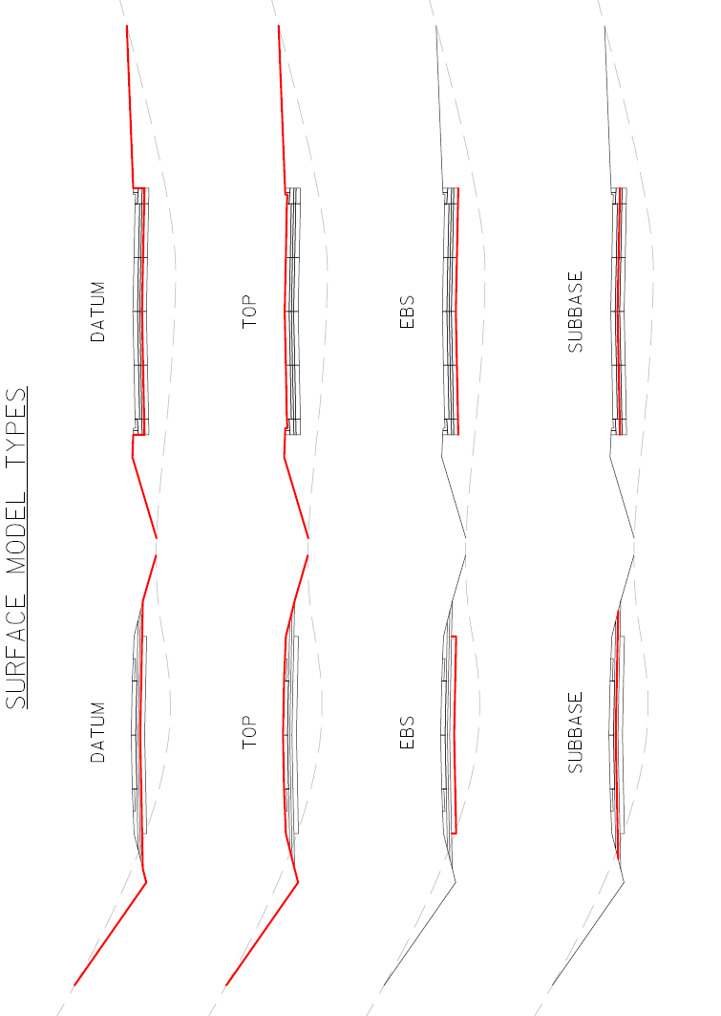
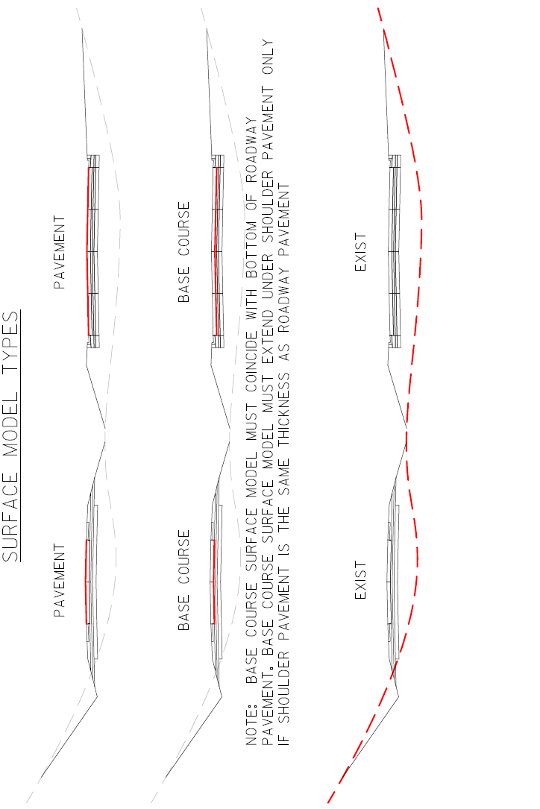
Appendix B: Preliminary Design Model Form
Wisconsin Department of Transportation
Preliminary Design Model Form
Design Project ID:

Construction Project ID:

By signing this document I certify the following best practices are present in the Civil 3D project data used to develop the preliminary design model:
- The Civil 3D corridor surfaces used in development of proposed work surface models are defined by corridor feature lines only.
- The Civil 3D surface models, referred to as the refinement surfaces in WisDOT Civil 3D workflow, are used to produce proposed work graphics in the section views used for the 60% plan cross section sheets.
- All Civil 3D corridors, feature lines, and gradings used in the development of the preliminary design model comply with proposed work surface model definition density requirements in FDM 7.2.2.1.

X:________________________________________________

Printed Name:______________________________________

Date:_____________________________________________

